Dear Colleagues,

Greetings to you in the Lord!

Merry Christmas and Happy New Year!

The January 2021 Sermons from Science are being sent early because many important issues about the November election have not been settled. We pray that God will finally bring justice to the election.

I now bring you some updates of the election. WeChat does not allow me to transfer either texts or photos to my computer. However, I can use screenshots to pick some interesting facts. Because screenshot limits only one page at a time, only a limit number of pages or photos can be transferred here. There are some overlaps with last month’s collection of links, but they reinforce the contents of the subject matter. This letter has 155 pages. Over 100 pages contain screen-shot color photos. But Yahoo removes all photos. If you want to read the original letter, please go to the following link and download this letter.
The link is http://christcentergospel.org/SermonsFromSciencePowerPointSlides.htm

Select the January 2021 Letter and download the 24-MB letter. You’ll be glad you did!

If you want your name deleted from my mailing list, please type your name on the Subject line, and click reply to Sender only. Alternatively, mark this email as spam.
--------------------------------------------------------------------------------------------------------------------------------------
Generous Man
In 1986 a farmer, Lenard Hill, took his own life on the morning his farm was to go to a courthouse auction, believing his life insurance would pay enough to save the cotton & soybean plantation in his family over 100 years. A complete stranger in Queens N.Y. read about this story & paid off the remaining $77,000.

A USMC Sergeant spent 7 months in a Mexican prison for accidentally crossing the border with a firearm. He was beaten & tortured in jail. Once he was released, the man from Queens sent him a check for $25,000 "To get you started."

In 2013 A black bus driver saves a suicidal girl from jumping off a bridge. Our Queens man sends him a check for $10,000.

A Rabbi's critically ill son needs to go from NYC to California for specialty care treatment in 1988. No airline will fly him.
A generous man in Queens pays for a private flight for the child.

In 2017 after Army Corporal Dillon Baldridge was killed in Afghanistan, a generous man in Queens sent his father a check for $25,000.

This kind-hearted man from Queens has committed many other "quiet acts of random kindness."

A wise man once said, "If a man's heart is good, Nothing else matters, & if a man's heart is bad, Nothing else matters."

Who is this kind man?...

President Donald J. Trump

- a man with a good heart.
Danielle 妲妮雅新品活动中 9:24 PM
轉：誏數字來說話
《The Economist》指出：
1、黑人失业率：
布什：8年中最低是7.9％
奥巴马：8年中最低是8.1%
川普：3.5年中最低是5.6％
2、股市指数（以布什期间为基准）：
纽约证交所综合指数：
奥巴马增长7.28％，
川普增长34.93％
道琼斯指数：
奥巴马增长32.32％，
川普增长104.88％
道琼斯期货：
奥巴马增长28.04％，
川普增长101.38％
纳斯达克指数：
奥巴马增长85.79％，
川普增长243.26％
PHLX半导体行业：
奥巴马增长14.12％，
川普增长173.67％
3.5年的川普经济远好于奥巴马的8年，这是一个简单而不可否认的事实。-
3、疫情
如果奥巴马、拜登是当今执政者，他们强烈反对年初1月31日发布的旅游禁令，因为当时民主党实际上是反对旅游禁令的。由于美国是联邦制，涉及交通、医院、警察等大多数日常措施的权力属于州和地方政府，一些民主党州长在3月份还在反对川普总统的检疫措施，因此他们遭受的打击最大。与新冠相关的死亡人数，民主党领导的州是共和党领导的州的2.48倍。
对川普的喜好，是個人選擇，但他对美國的貢献，是有目共睹、不可否認的。
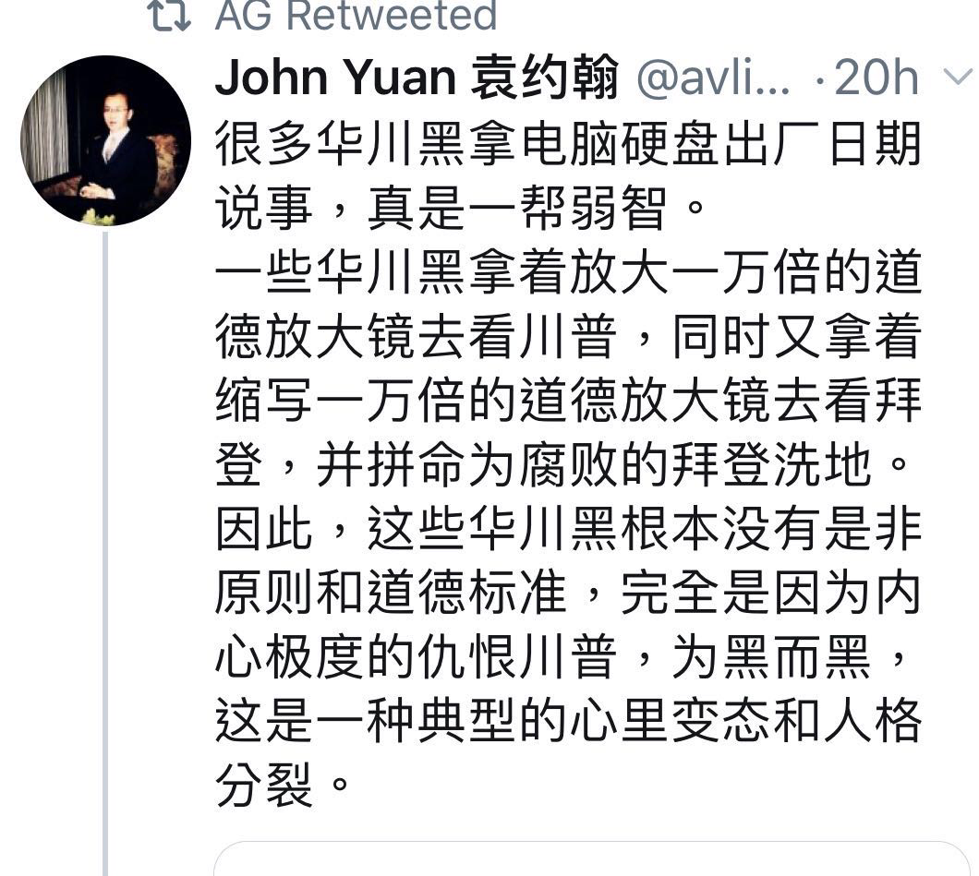---------------------------------------------------------------------------------------------------------------------------------------
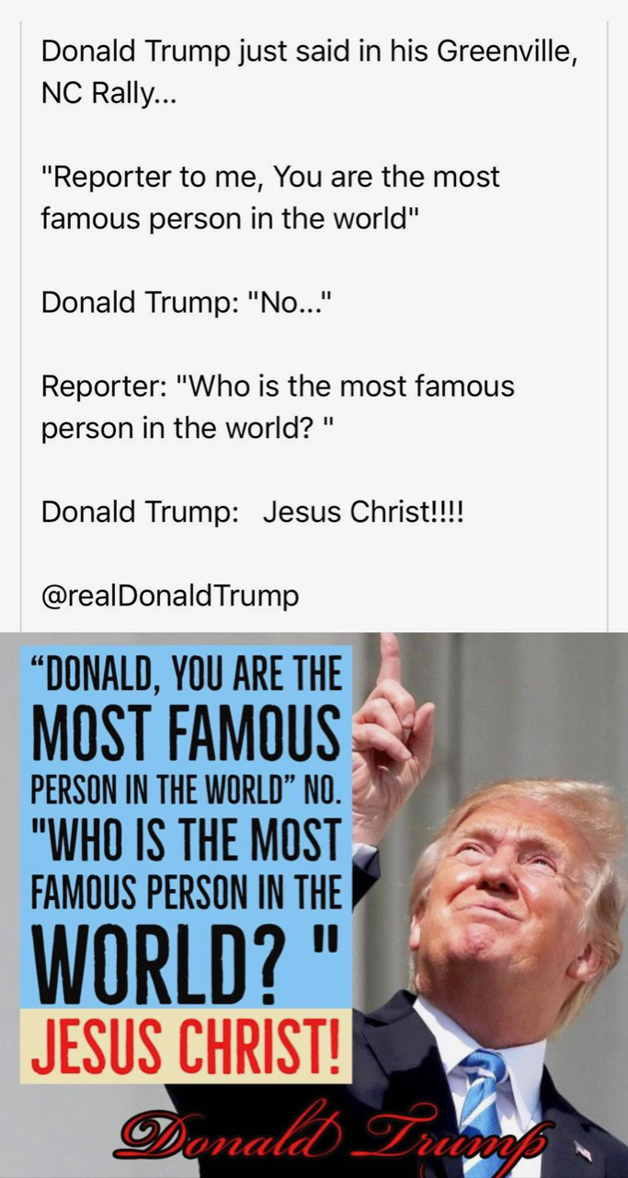

----------------------------------------------------------------------------------------------------------------------------------------
http://nacr.info/WordPress/index.php/2020/10/31/trump_11_achievements/

川普总统第一任期的11项成就
义工十月 31, 2020
作者：Joel B. Polla 翻译: 杰克
作者乔尔·B·波拉克（Joel B.Pollak）他最新的电子书是《川普的美德：唐纳德·川普总统任期的教训与传承》。 他最近的著作《十一月红色》从保守派的角度讲述了2020年民主党总统大选的故事。 他是2018年Robert Novak新闻界校友奖学金的获得者。 在Twitter上通过@joelpollak关注他。
唐纳德·川普总统担任了美国历史上最重要的总统任期之一。总统传记作者康拉德·布莱克（Conrad Black）写道：在美国的45位总统中，只有“三到四位”的前任总统可以声称做得更多，其中包括亚伯拉罕·林肯。除了林肯上任之初就面对内战之外，没有总统比川普更需要面对来自政治反对者和媒体的坚决反对。当他在2016年竞选总统时，批评家们预测川普会引发核战争； 他将导致股票市场崩溃并“永远不会”恢复； 他将是希特勒的再世。然而所有这些都没有实现-反而事实与他们的预测相反。
川普总统的成就清单将涵盖许多方面。 我们的好莱坞编辑杰罗姆·哈德森（Jerome Hudson）已出版了一本关于它们的书，总结一下，以下是川普的11大成就：
1. 历史上增长最快的经济。 2020年第三季度，美国经济增长33.1％，创历史新高。经济反弹，因为川普通过减税，放松管制和强调就业为增长奠定了基础。
2. 五十年来最低的失业率。美国失业率降至3.5％，为50年来最低。黑人、拉丁裔和亚裔美国人的失业率是有记录以来最低的。贫困率创下历史新低，对少数民族和整个美国人来说都是如此。
3. 战胜伊斯兰国和激进伊斯兰主义恐怖分子。美国粉碎了所谓的“伊斯兰国”并击毙了其领导人阿布·巴克尔·巴格达迪。尽管法国最近发生的事件使我们意识到需要保持警惕，但川普压抑了恐怖威胁。
4. 边界墙和移民执法。川普政府在南部边界修建了400英里的新墙并且替换了旧墙。他还实在地执行了移民法，结束了拆散非法移民家庭的政策，并制止了非法移民的“大篷车”进入美国。
5. 开拓与朝鲜外交。川普使美国摆脱了与朝鲜频临战争边缘的危机，与金正恩会晤，并为朝韩全面无核化的谈判奠定了基础。
6. 中东和平。 川普将我们的大使馆迁至耶路撒冷，承认以色列在戈兰高地的主权，结束了与伊朗的极其无理的核交易，并消灭了卡塞姆·索莱马尼。 他在以色列和阿拉伯国家之间建立了和平，并保护了我们免于战争。
7. 最高法院的三名法官和破记录的任命各级法官。 川普提名三位原旨主义的保守派法官进入最高法院，并在第一任期内确认了比四十年来任何总统任命得多的联邦法官，尤其是在上诉一级法院。
8. 改善美国黑人族群的历史性成就。 除了经济繁荣以外，川普还创建了“机会区”，实施了监狱改革，为HBCU（Historically black colleges and universities）提供了资金，并结束了对宗教HBCU和神学院的资金限制。
9. 创建USMCA来代替NAFTA。 川普制定了《美国-墨西哥-加拿大贸易协议》（USMCA），这是一项自由贸易协议，对美国工人的保护要比北美自由贸易协定（NAFTA）强，NAFTA造成了美国工作机会的大量流失。
10. 面对中国。 在贸易，阿片类药物和外交政策方面，川普总统是50年来第一个坚决面对中国企图统治美国经济和世界的野心的美国总统。 他还通过中国旅行禁令减缓了冠状病毒的传播。
11. 强大的军事力量和太空部队。 川普通过重建军队来恢复美国的国际领导地位。 他还创建了一支新的武装部队，即太空部队。 然后，他启动了“神速行动”来提供冠状病毒疫苗。
他还有一项总体成就：川普支持美国历史，英雄，执法和宪法的主张，反对在我们的国家街头散播破坏性活动的激进势力。
只有川普能做到！
原文链接：https://www.breitbart.com/politics/2020/10/29/pollak-11-shining-successes-of-president-donald-trumps-first-term/
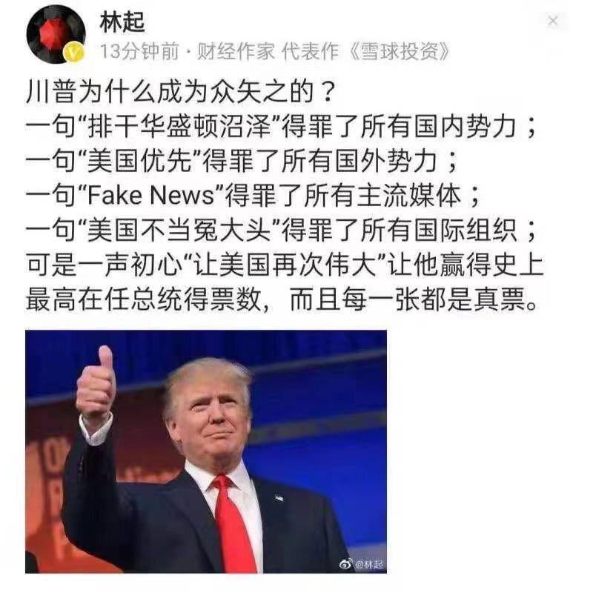
----------------------------------------------------------------------------------------------------------------------------------------- The author obtained data that has been passed around that was reportedly captured by the New York Times on election night.
By examining the data the author was able to locate an instance where votes were switched from Trump to Biden so he decided to perform an analysis on the entire data set, starting with the states where Dominion voting machines are used.
The author also claims that the data is from Edison Research and it is the same data that is used for election coverage by at least ABC News, CBS News, CNN and NBC News.
It is also used for the website of the NYT, and probably others as well.
Advertisement - story continues below
Here are the (unaudited) results by state:

The Chart Lists Votes Switched from Trump to Biden and Votes That Were Lost by Trump
 | Switched Votes | Lost Votes
Dominion Systems
Pennsylvania | 220,883 | 941,248
New Jersey | 80,242 | 20
Florida | 21,422 | 456
Michigan | 20,213 | 21,882
New York | 18,124 | 623,213
Georgia | 17,407 | 33,574
Ohio | 14,965 | 5,102
Virginia | 12,163 | 789,023
California | 7,701 | 10,989
Arizona | 4,492 | 0
Minnesota | 2,766 | 195,650
Tennessee | 2,330 | 0
Louisiana | 2,322 | 0
Illinois | 2,166 | 54,730
Wisconsin | 2,078 | 3,408
Colorado | 1,809 | 0
Utah | 1,627 | 0
New Hampshire | 973 | 116
Iowa | 938 | 477
New Mexico | 268 | 4,610
Missouri | 0 | 20,730
Nevada | 0 | 0
Alaska | 0 | 0
Washington | 0 | 0
Hawaii | 0 | 0
 | 434,889 | 2,705,228
Kansas and Texas use Premier Election Solutions, Owned by Dominion
Texas | 14,954 | 30,557
Kansas | 1,674 | 2,154
 | 16,628 | 32,711
Election Systems & Software
Nebraska | 30,086 | 50
Kentucky | 8,129 | 23,849
Arkansas | 3,664 | 20,748
South Carolina | 2,779 | 2,119
Montana | 2,330 | 1,276
South Dakota | 1,347 | 1
North Dakota | 234 | 681
Maryland | 203 | 0
North Carolina | 0 | 15
District of Columbia | 0 | 0
 | 48,772 | 48,739
Unknown Systems
Connecticut | 3,834 | 272
Massachusetts | 3,613 | 51
Oregon | 2,557 | 0
Alabama | 1,170 | 408
Mississippi | 355 | 0
Maine | 271 | 35
Rhode Island | 6 | 13
West Virginia | 0 | 78,300
Idaho | 0 | 0
Oklahoma | 0 | 0
Indiana | 0 | 0
Delaware | 0 | 0
Vermont | 0 | 0
 | 11,806 | 79,079
OVERALL TOTALS | 512,095 | 2,865,757
Based on this initial analysis over 500,000 votes were identified that were switched from President Trump to Joe Biden.
Advertisement - story continues below
In addition to this another 2,865,757 votes were deleted.
Note that these numbers have not yet been audited by us.
We also have not performed this exercise by county in these states which could impact the countrywide vote totals even more. More needs to be done. But what is clear, there are some very questionable transactions occurring within the voting machines and applications which need to be reviewed further because of apparent material issues in reporting.

We know there was a tremendous amount of fraud in the 2020 election.
Advertisement - story continues below

Nobody was following Joe Biden and he had zero support, and yet his vote count surpassed the greatest campaign in US history led by President Trump.

We are supposed to believe Joe Biden defeated President Trump and at the same time lost seats in the US House and state legislatures. This is highly improbable.

It looks like the Democrats did everything imaginable in their attempt to steal this election.

The problem was they never expected President Trump to lead a record breaking campaign and they got caught.
Advertisement - story continues below

More will be exposed.

----------------------------------------------------------------------------------------------------------------------------------------- Election Fallout Reveals Battle Between Freedom and Communism
A choice that transcends the political Right and Left

Editorial Board

November 13, 2020 Updated: November 13, 2020

Print
When the founders of our newspaper fled a communist regime to come to America, they never expected that this great nation would one day become the focal point of the battle between communism and freedom.
Many Americans believe communism is an abstract concept, something that only affects faraway nations, without realizing that it has already arrived at our doorstep.
Communism has spread in America under names such as socialism, progressivism, liberalism, neo-Marxism, and so on, in a slow process over decades of systematic subversion by first the Soviet Union, and now the Chinese Communist Party (CCP).
This cumulative battle for the future of America—and with it, the rest of the world—is now coming to a head in the U.S. presidential election.
This is a conflict that transcends partisanship and party affiliation.
Belief in God has always been fundamental to America. The early colonists fled to the United States so that they could practice their religion freely. The United States was founded on the belief that we are all created equal by God and endowed by the Creator with our rights. The U.S. motto is “In God we trust.”
Belief in God and the principles derived from that belief are the fundamental reasons why the United States can enjoy freedom, democracy, and prosperity, and why the United States has become the nation it is today.
In this great tradition, voting is a sacred duty in which each citizen may take responsibility for who governs. This year, a record number of Americans voted to choose their next leader.
We have since learned that this process has been subverted. Numerous credible allegations of voter fraud have emerged, pointing to a systematic effort to change the outcome of the election.
The far-left and the communist devil behind it—the same force that Karl Marx once described as haunting Europe—are using lies, fraud, and manipulation in an attempt to deprive the people of their rights and freedoms.
One of the two major U.S. parties, the Democratic Party, is no longer the political party it used to be. Over the decades, it has gradually been infiltrated by the same Marxist ideology that has created the most brutal and repressive communist regimes in history.
Communist ideology, including socialism and its associated ideas, is not a normal ideology. It is the ideology that has caused the unnatural deaths of at least 100 million people.
The communist ideology uses seemingly righteous concepts, such as “equality” and “political correctness,” to confuse people. Its ideology has infiltrated all fields in our society, including education, media, and art. It unscrupulously destroys everything that is traditional, including faith, religion, morality, culture, family, art, education, law, and so on, and leads people to fall into moral depravity.
This is the ideology of totalitarianism, one that drives once thriving nations such as Venezuela into the abyss and that was able to destroy 5,000 years of culture in China, where people went from a belief in the divine to a devotion to the state.
It is the systematic undoing of all that is good that humankind stands for. It is diametrically opposed to goodness, fairness, truth, and compassion.
This has not only undermined people’s spirits and their righteous faith in God, but has dragged the American people and all of mankind to the brink of danger.

A Choice Between Good and Evil
This is a conflict that transcends party lines, a battle between whether we as Americans can stay true to our founding principles and follow God’s will, or whether we will be subjected to forces that seek to control and destroy our most fundamental rights.
This is not something we say lightly; because our founders lived through communist totalitarianism, they understand its destructive force.
As a media organization, we are independent and don’t take positions on political issues or candidates, but rather stand for truth and justice.
America has now come to the brink of falling into a communist abyss.
At the center of this battle is now President Donald Trump, who has clearly said no to socialism and communism and ended decades of appeasement of the Chinese regime by enacting a nation-wide effort to counter its influence and infiltration.
Trump has confronted the CCP at this critical moment in history.
To communist China, the trajectory has been clear: Trump is an American president who values tradition and opposes communism, and as long as he leads, the Chinese regime knows it won’t succeed in its decades-long objective to overthrow America and with it the rest of the free world.
We have communist China at our gates, ready to take over. The CCP has carefully studied the U.S. system over the decades and now has successfully taken advantage of our open society and infiltrated our country.
Internally, we have far-left groups such as Black Lives Matter and Antifa organizing protests and riots. The movement is similar to the CCP’s Cultural Revolution, which destroyed the cultural heritage and traditions of the nation. It is an anti-American movement, just like the Cultural Revolution was anti-Chinese. The core of the movement’s ideology is no different from that of the communist movement in China, and it goes hand in hand with the CCP, ready to subvert America.
The impact of this election is far reaching. It has made clear to people, governments, and organizations around the world that they must decide whether they stand with the communist devil or with tradition and universal values.
More and more people are realizing that the 2020 U.S. election is not a two-party fight, not a dispute between Trump and Joe Biden, but a battle between tradition ​​and socialism, a battle between good and evil, a battle between the divine and the communist devil.
To learn more, read the special editorial series “How the Specter of Communism Is Ruling Our World.”
Support an independent outlet at a time when it's hard to find factual news.
Share this article with your friends, and let more people know about The Epoch Times.

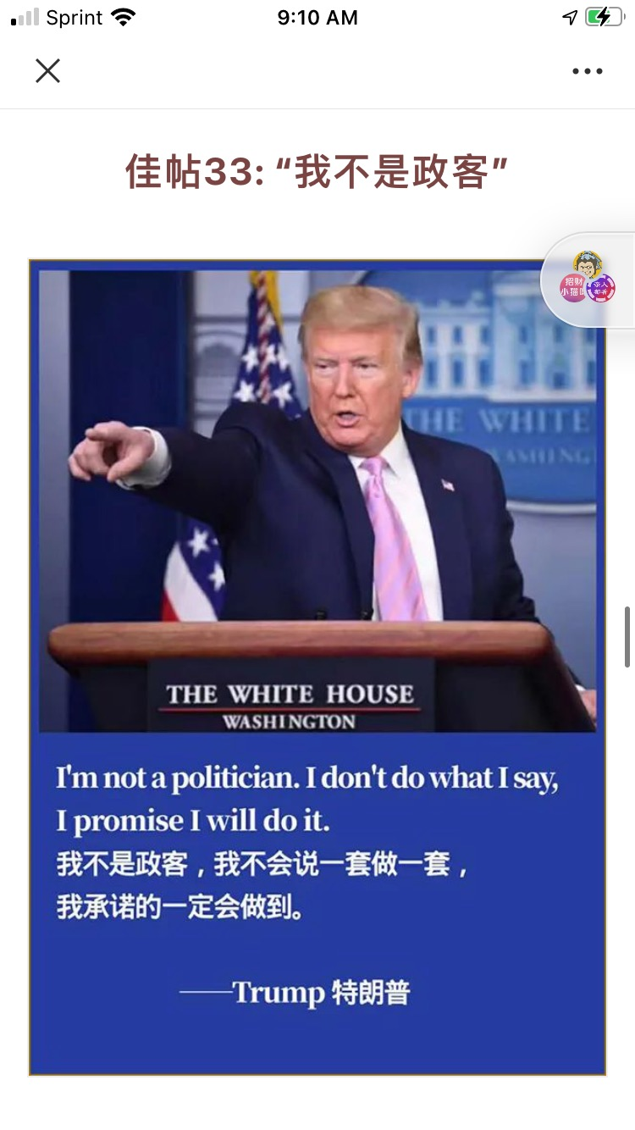
-----------------------------------------------------------------------------------------------------------------------------------------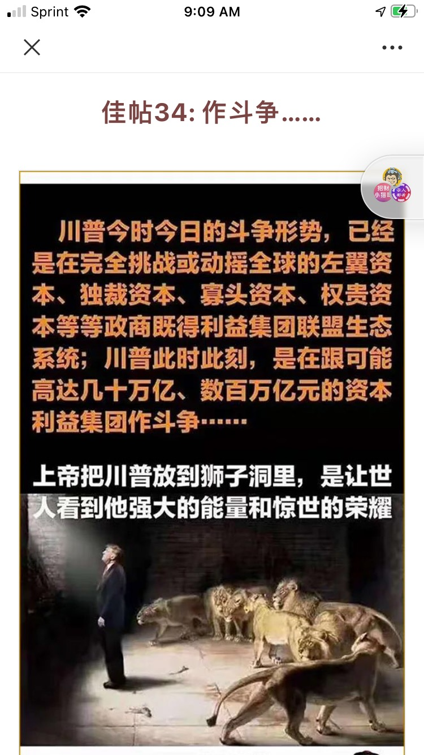
-----------------------------------------------------------------------------------------------------------------------------------------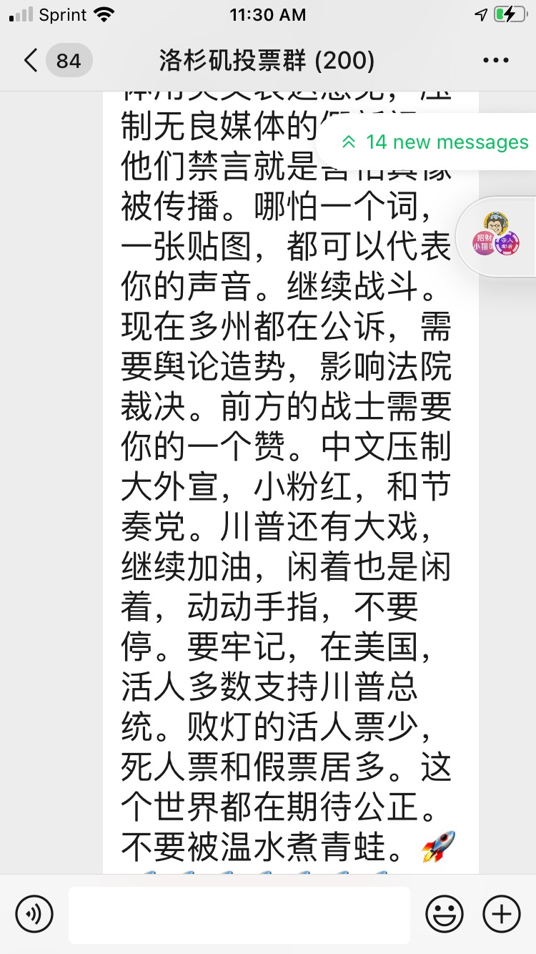
----------------------------------------------------------------------------------------------------------------------------------------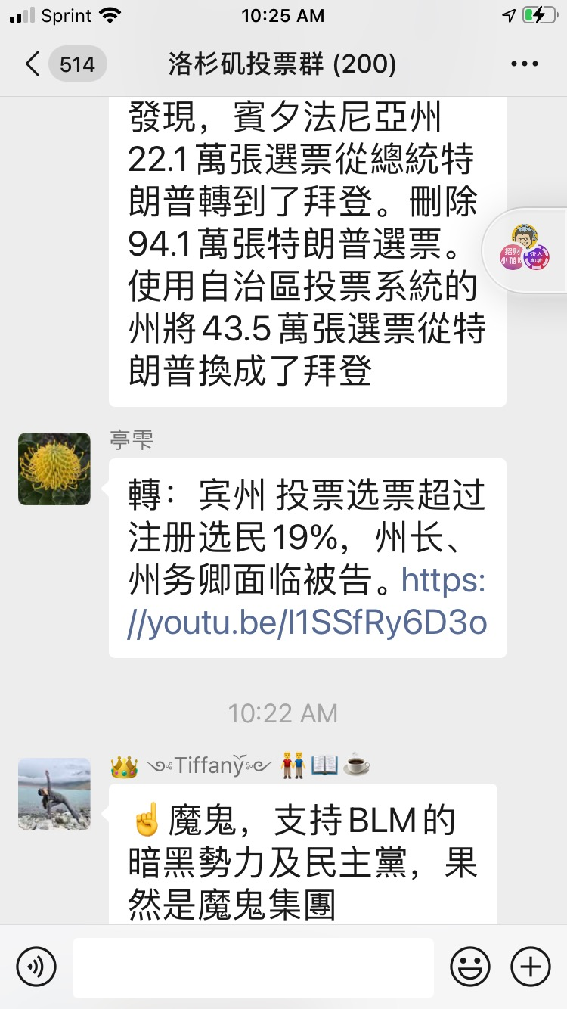
----------------------------------------------------------------------------------------------------------------------------------------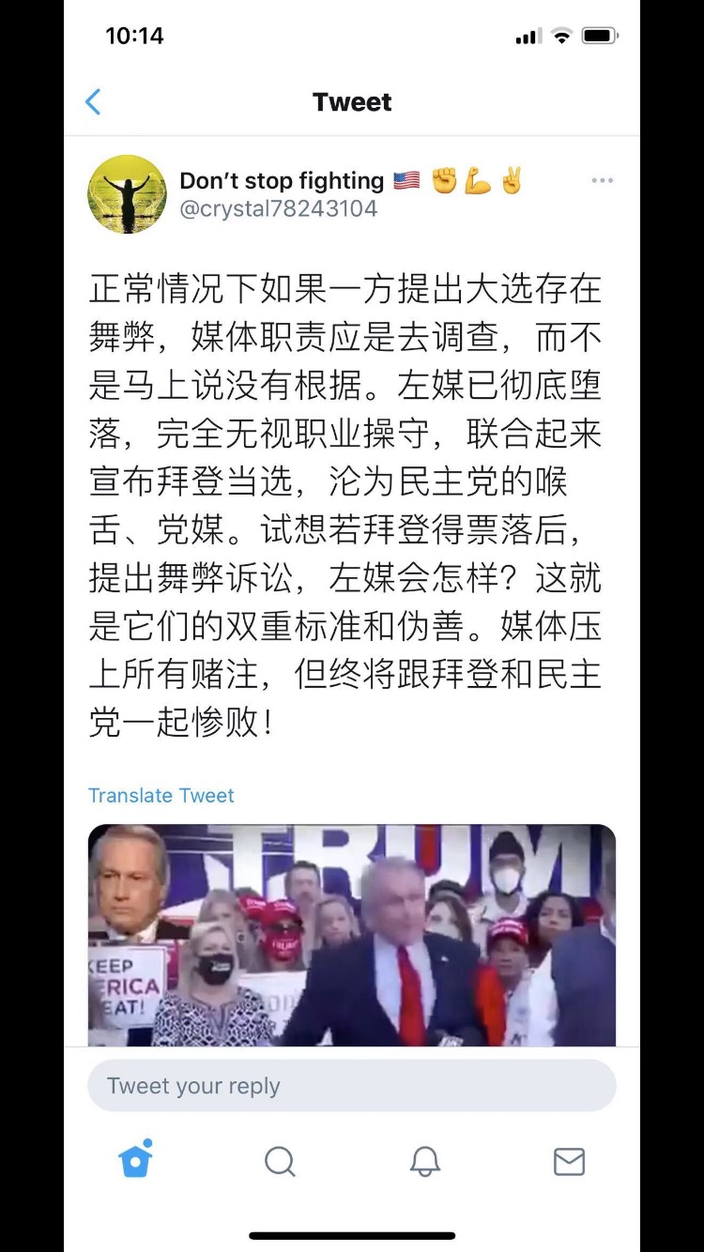
----------------------------------------------------------------------------------------------------------------------------------------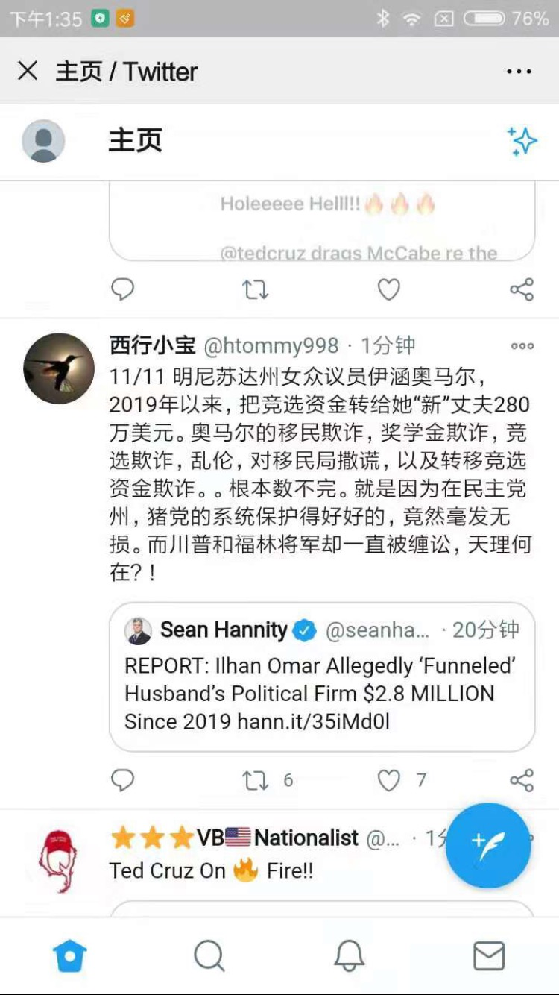
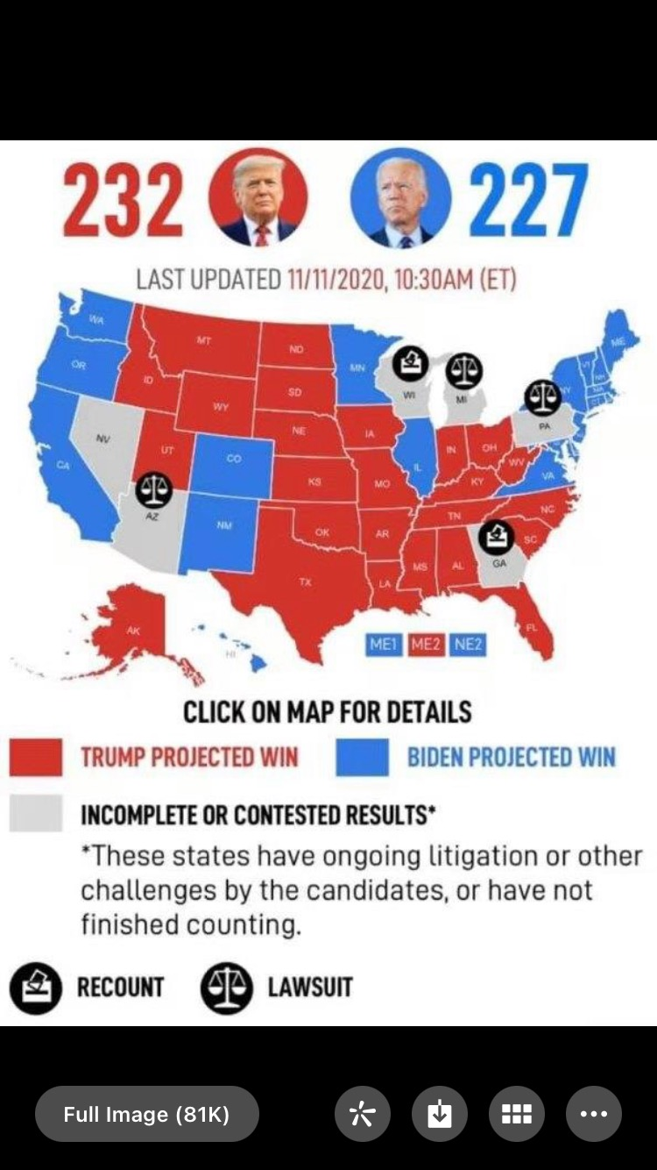
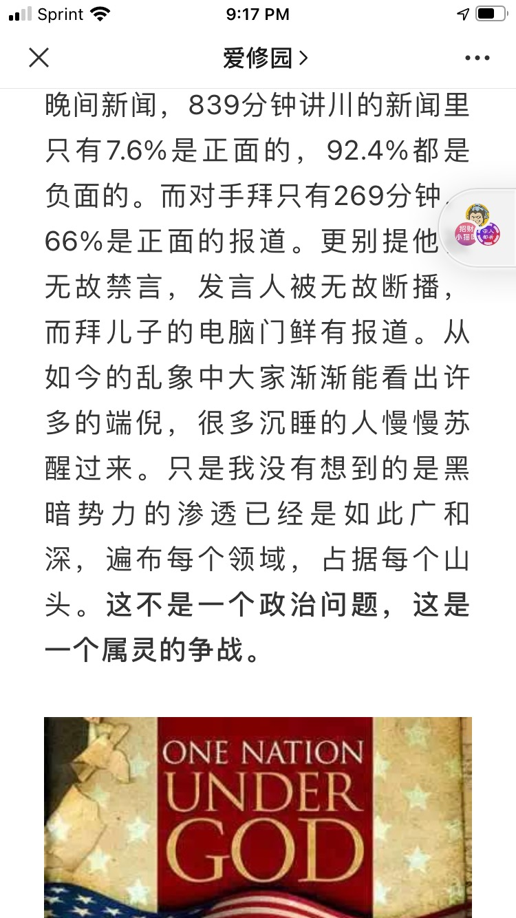
----------------------------------------------------------------------------------------------------------------------------------------

----------------------------------------------------------------------------------------------------------------------------------------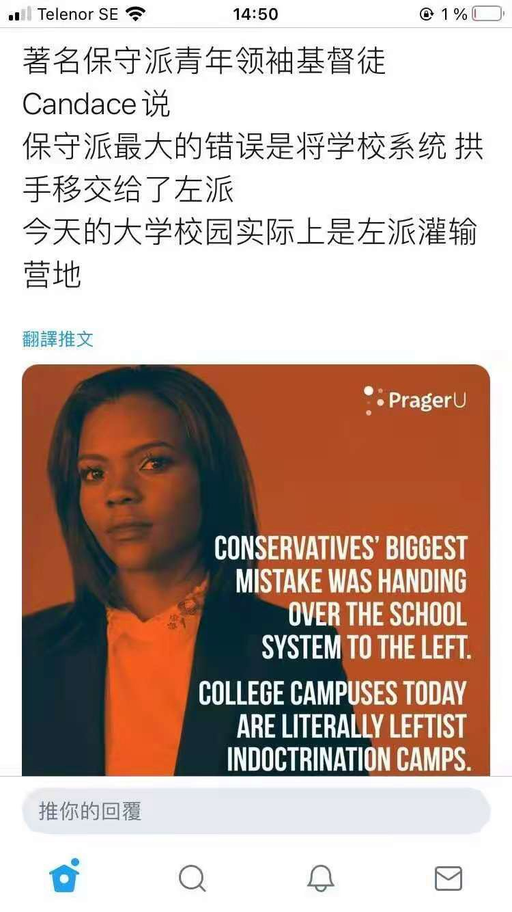
----------------------------------------------------------------------------------------------------------------------------------------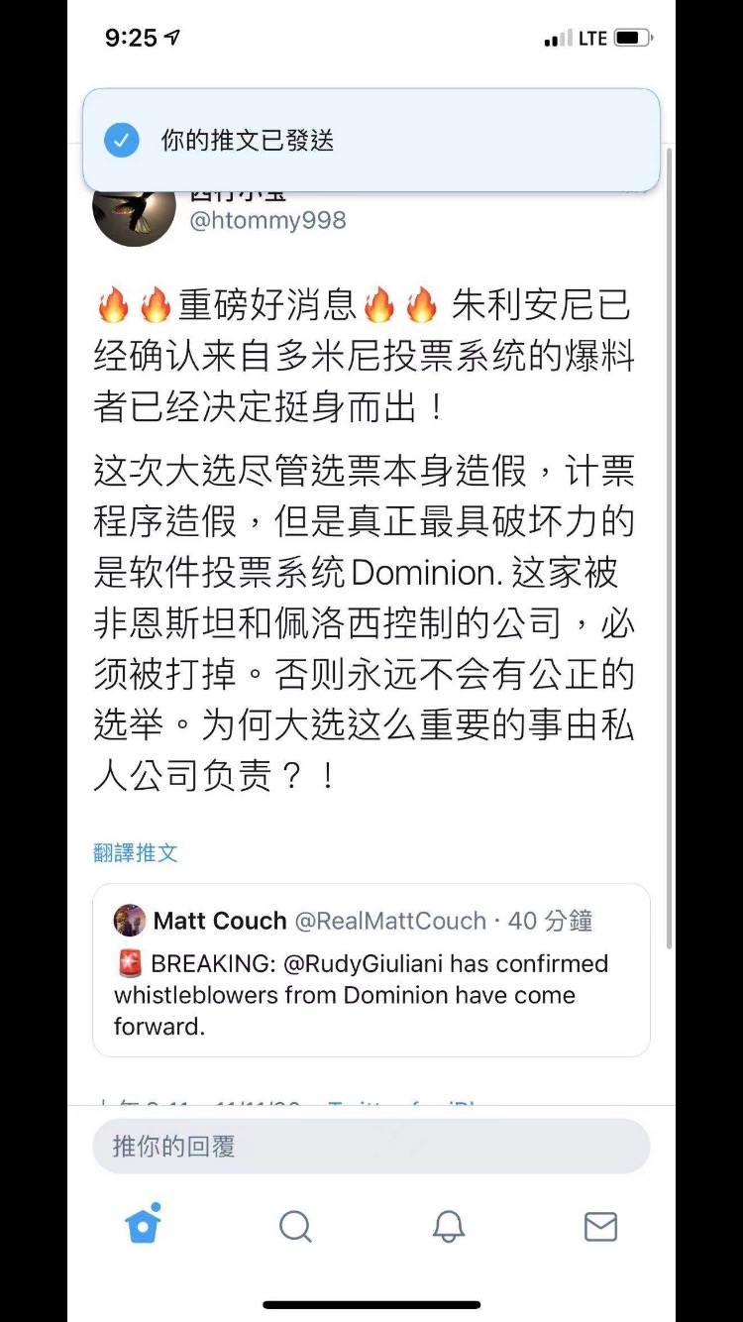
----------------------------------------------------------------------------------------------------------------------------------------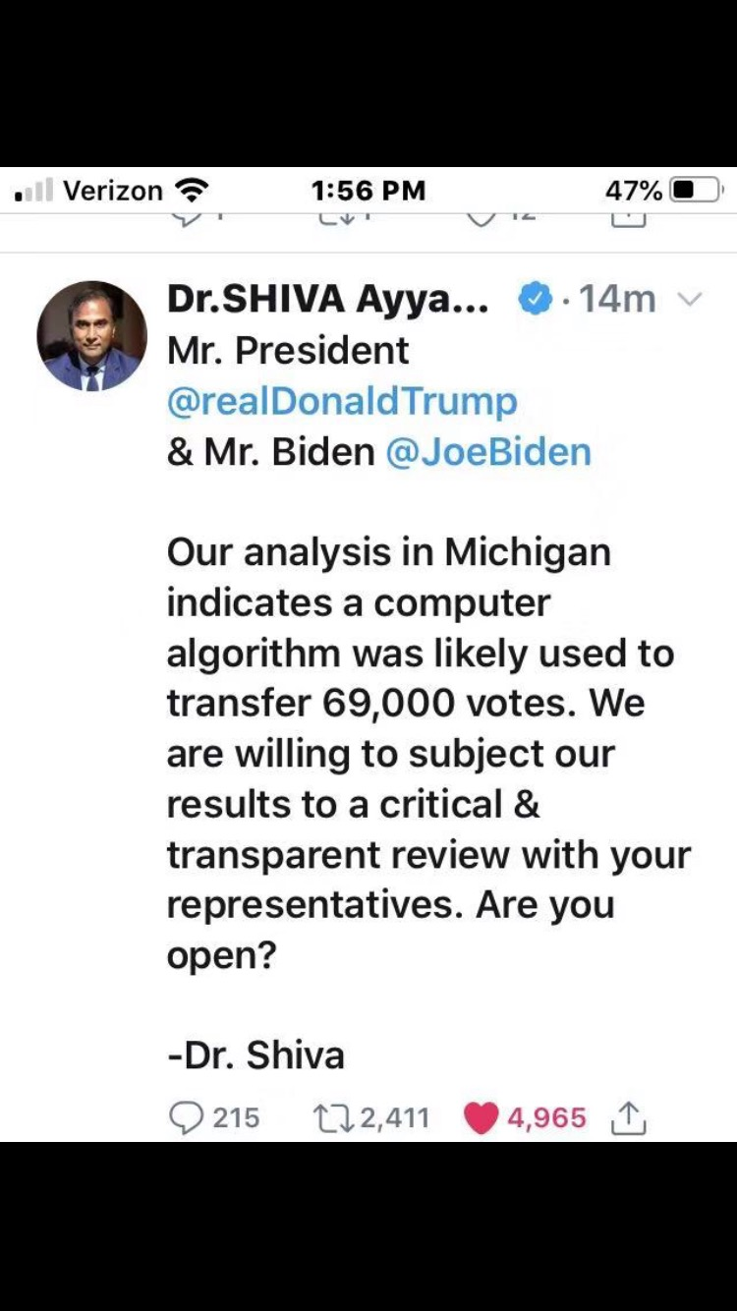
----------------------------------------------------------------------------------------------------------------------------------------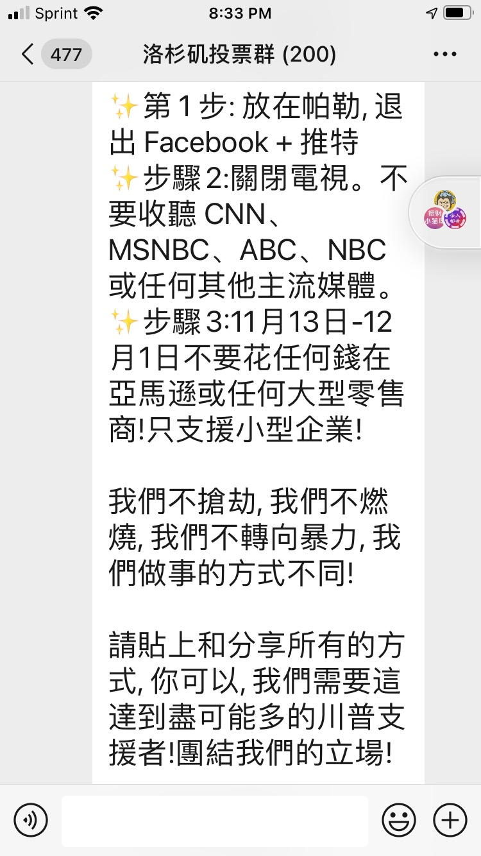
----------------------------------------------------------------------------------------------------------------------------------------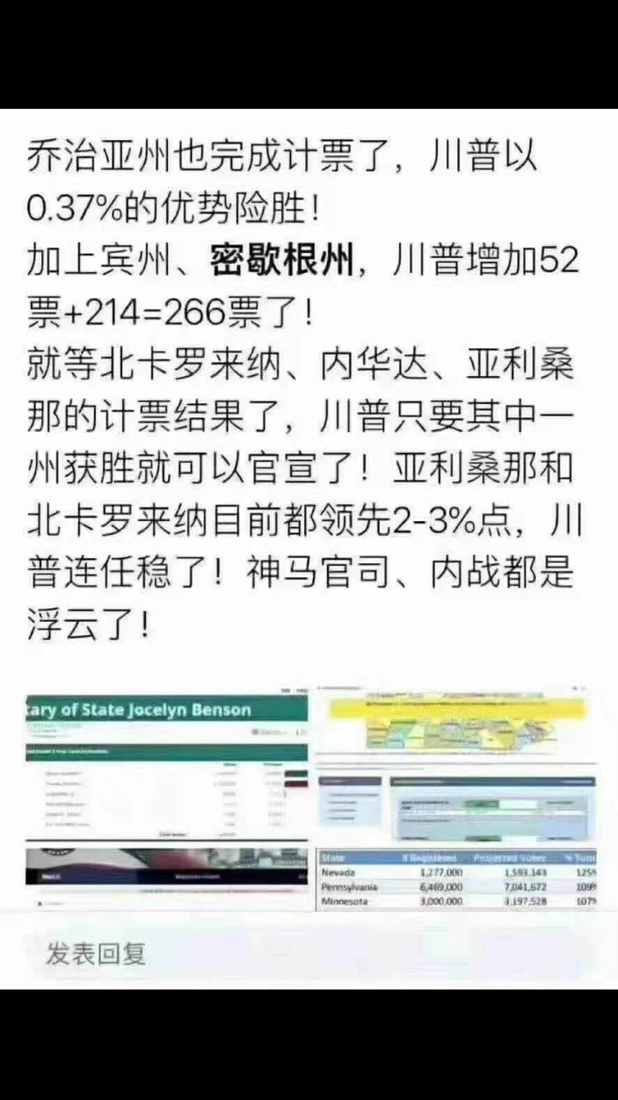
----------------------------------------------------------------------------------------------------------------------------------------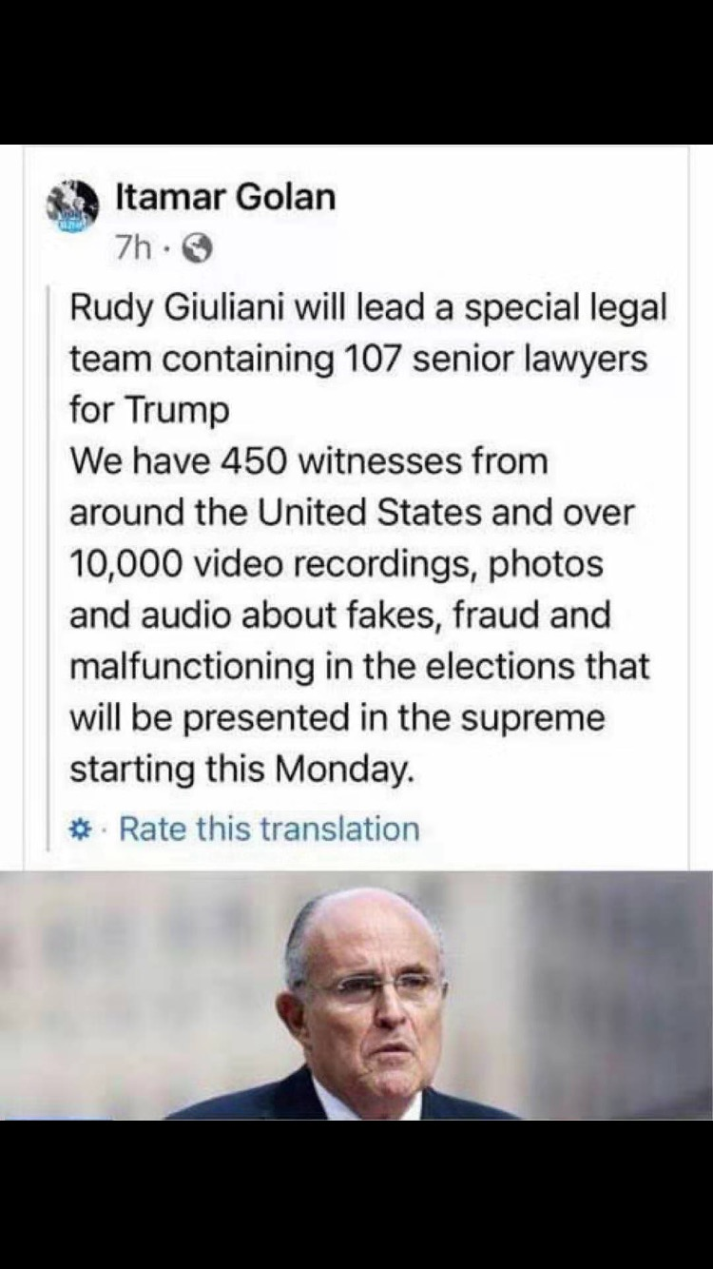
----------------------------------------------------------------------------------------------------------------------------------------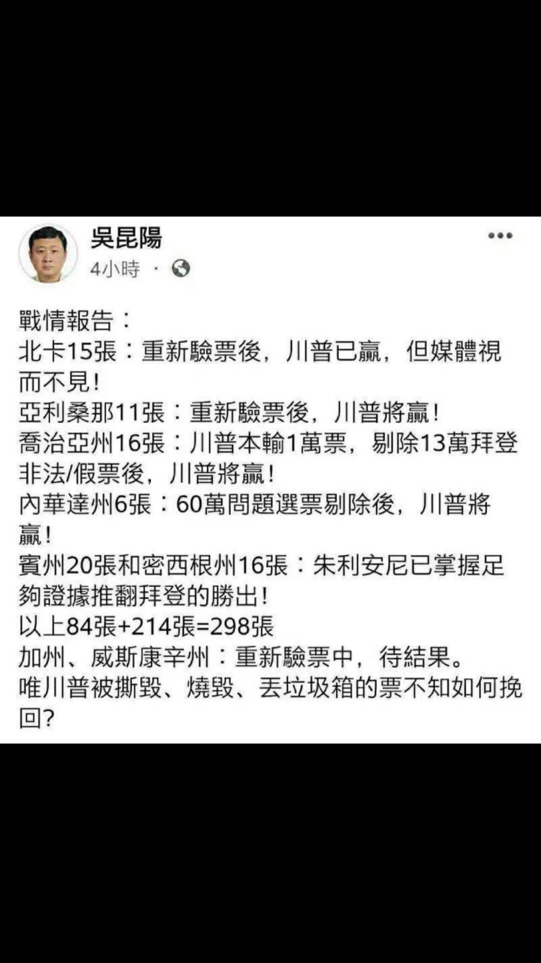

----------------------------------------------------------------------------------------------------------------------------------------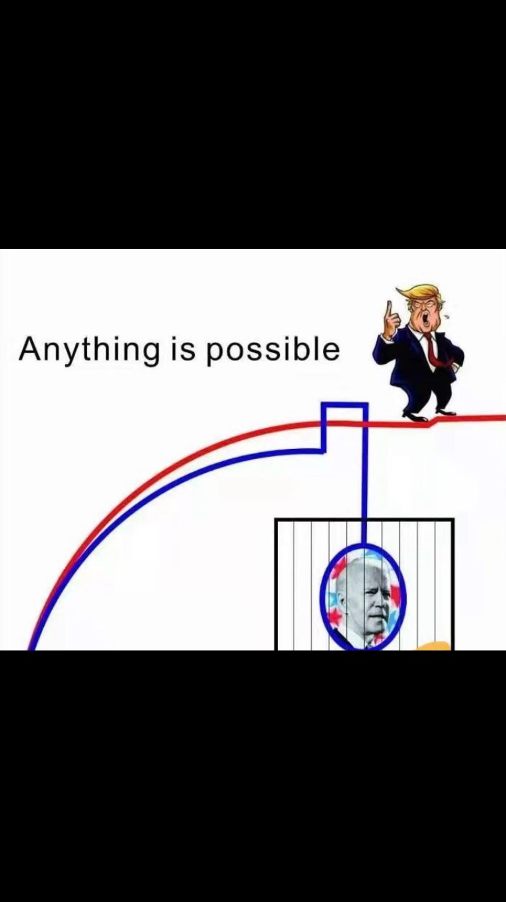
----------------------------------------------------------------------------------------------------------------------------------------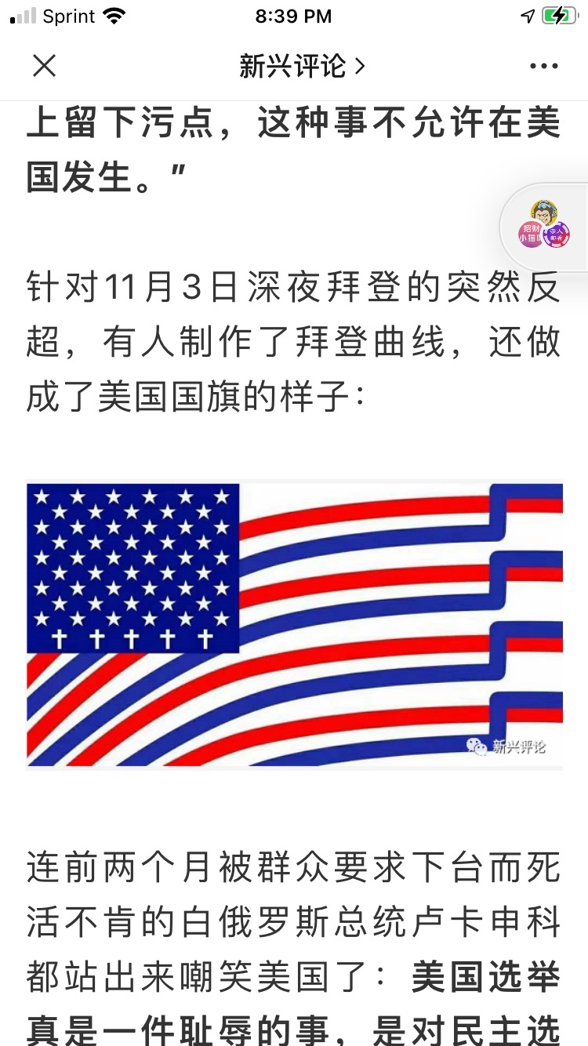
----------------------------------------------------------------------------------------------------------------------------------------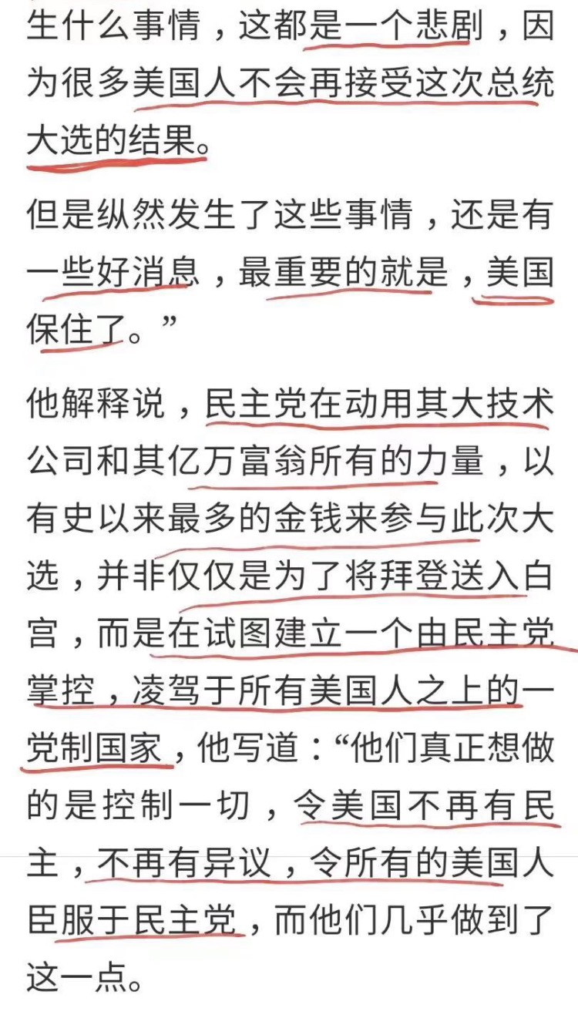
----------------------------------------------------------------------------------------------------------------------------------------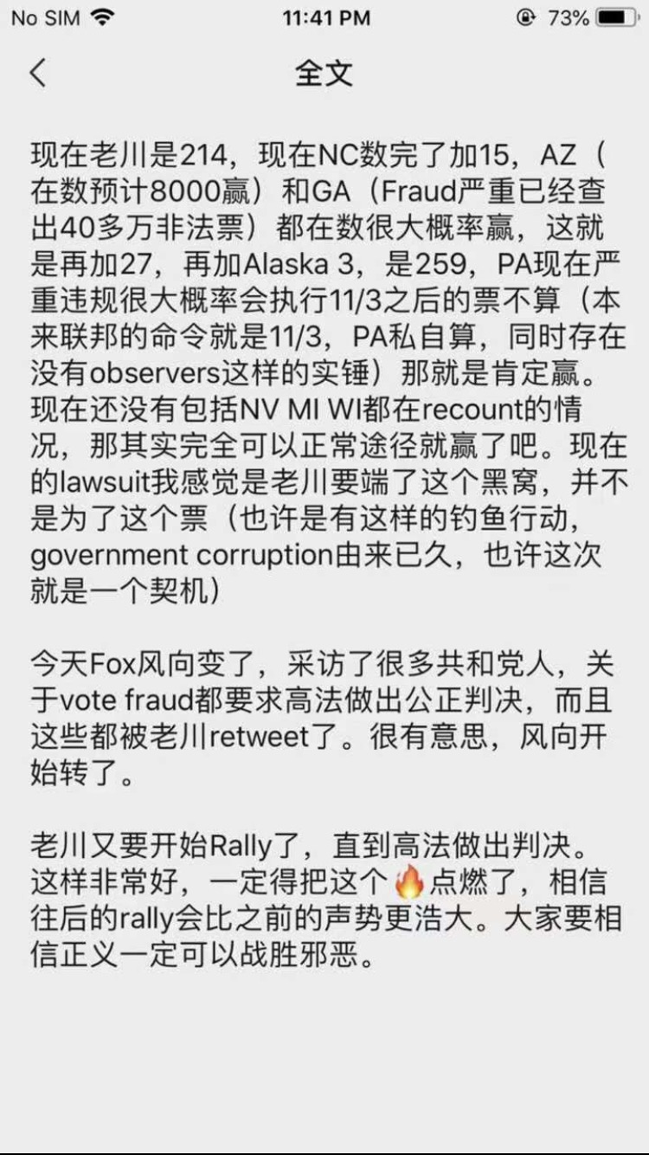
----------------------------------------------------------------------------------------------------------------------------------------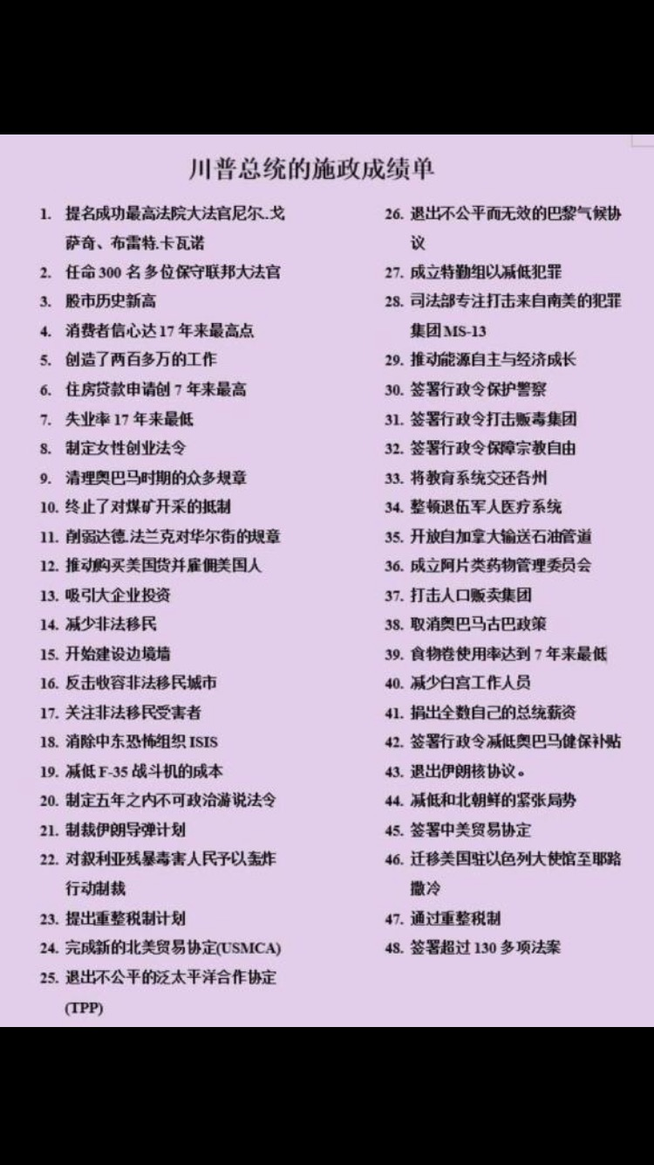
----------------------------------------------------------------------------------------------------------------------------------------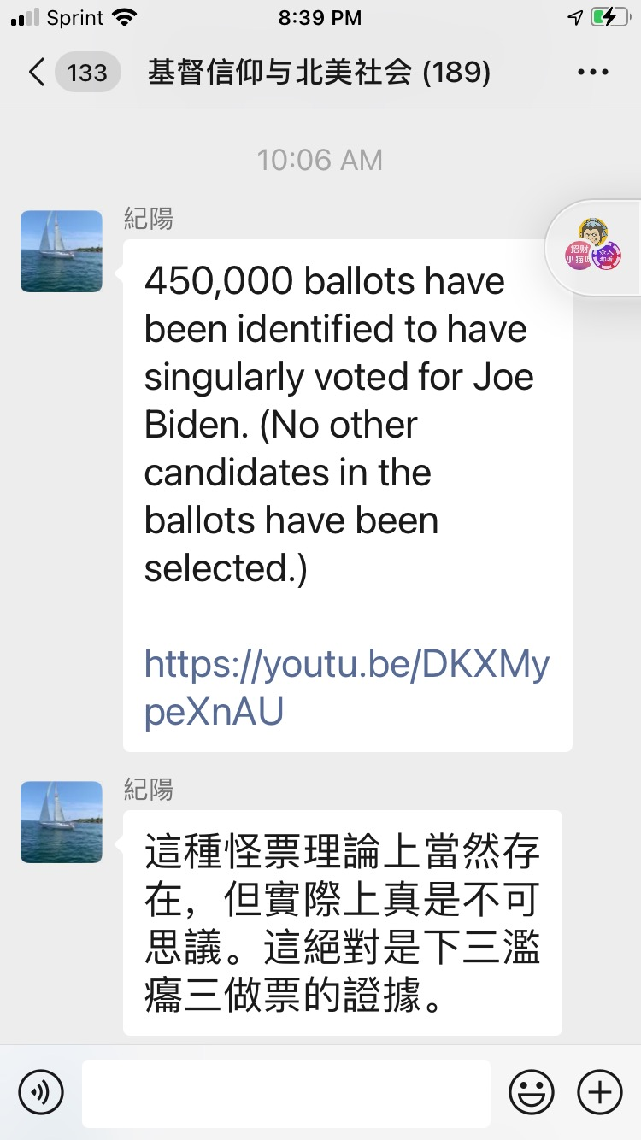
----------------------------------------------------------------------------------------------------------------------------------------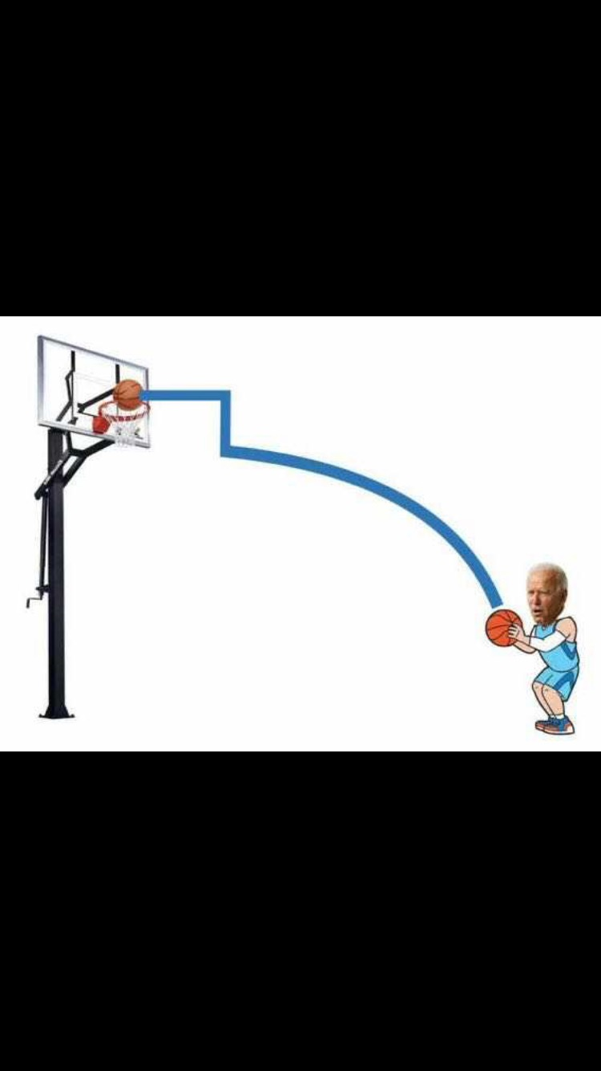
----------------------------------------------------------------------------------------------------------------------------------------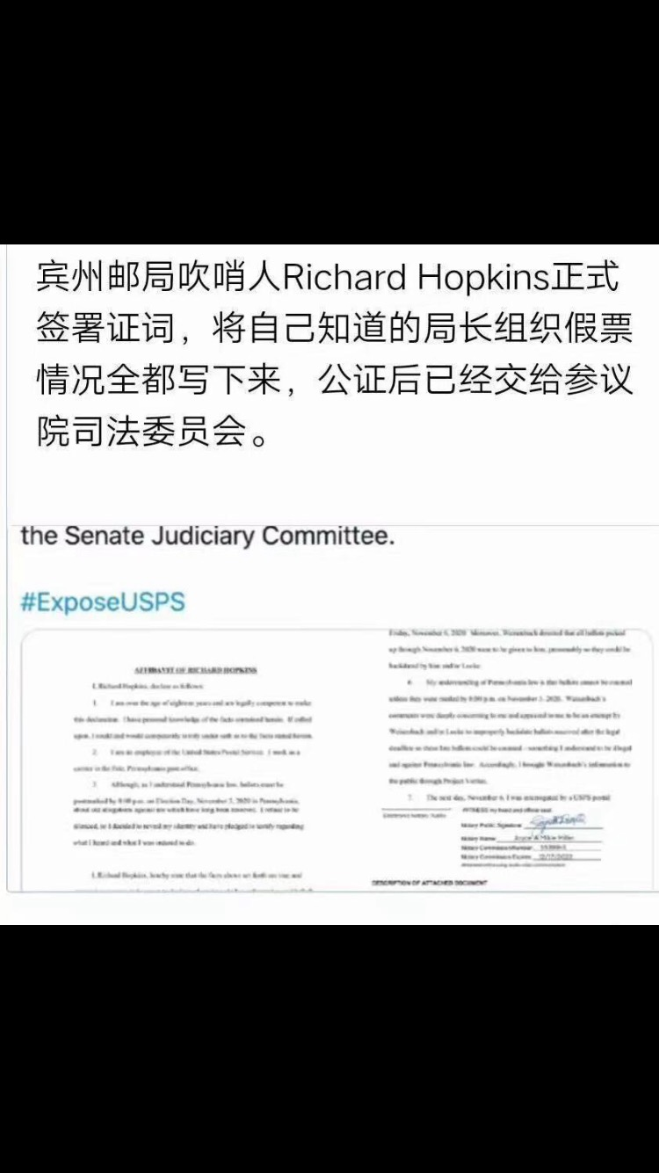
----------------------------------------------------------------------------------------------------------------------------------------
----------------------------------------------------------------------------------------------------------------------------------------
----------------------------------------------------------------------------------------------------------------------------------------
----------------------------------------------------------------------------------------------------------------------------------------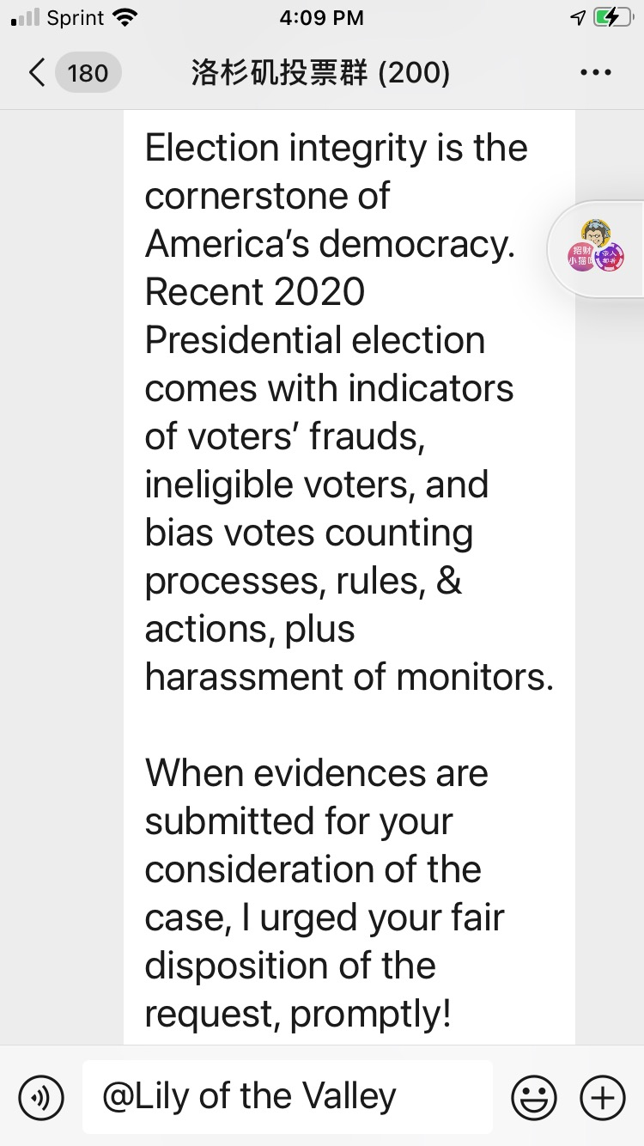
----------------------------------------------------------------------------------------------------------------------------------------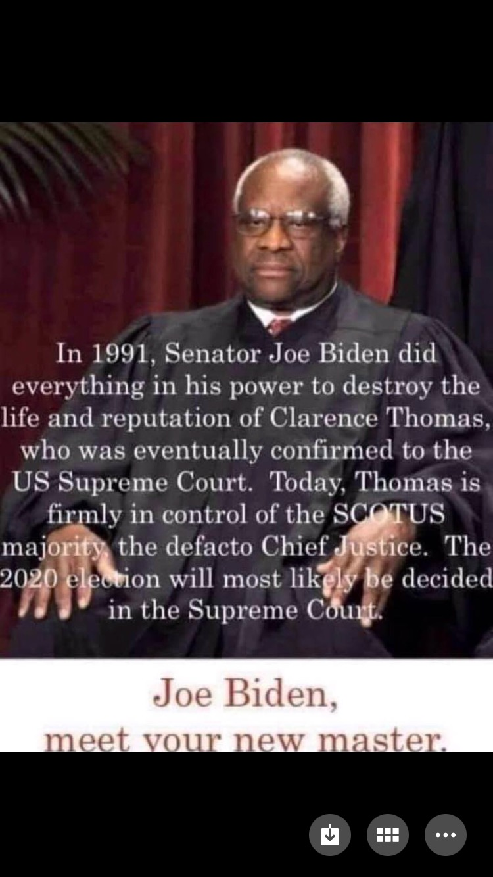
----------------------------------------------------------------------------------------------------------------------------------------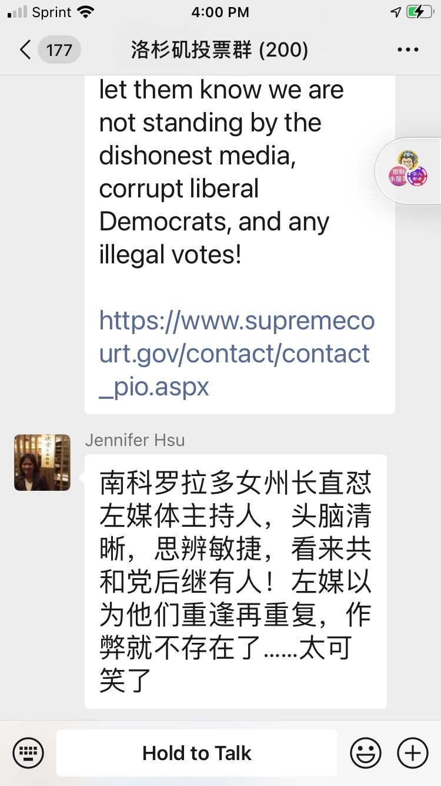
----------------------------------------------------------------------------------------------------------------------------------------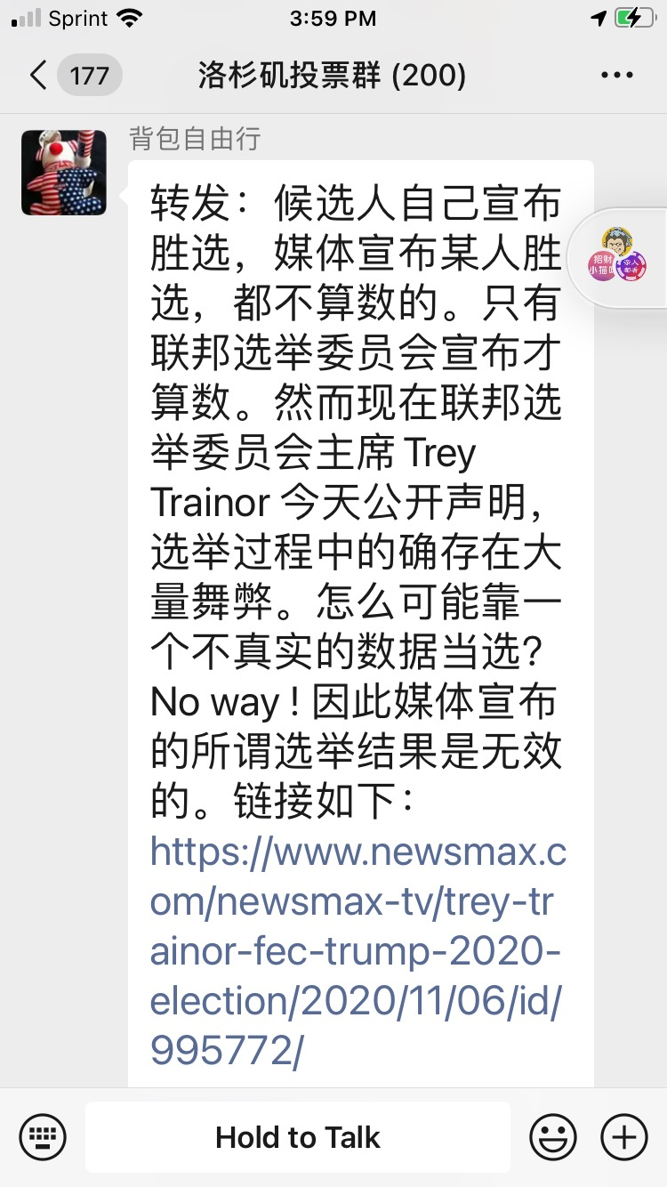
----------------------------------------------------------------------------------------------------------------------------------------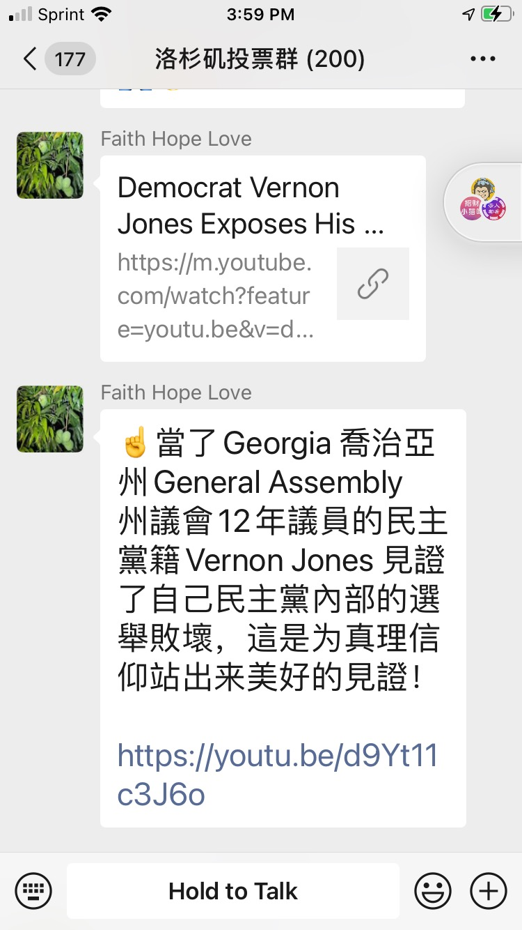
----------------------------------------------------------------------------------------------------------------------------------------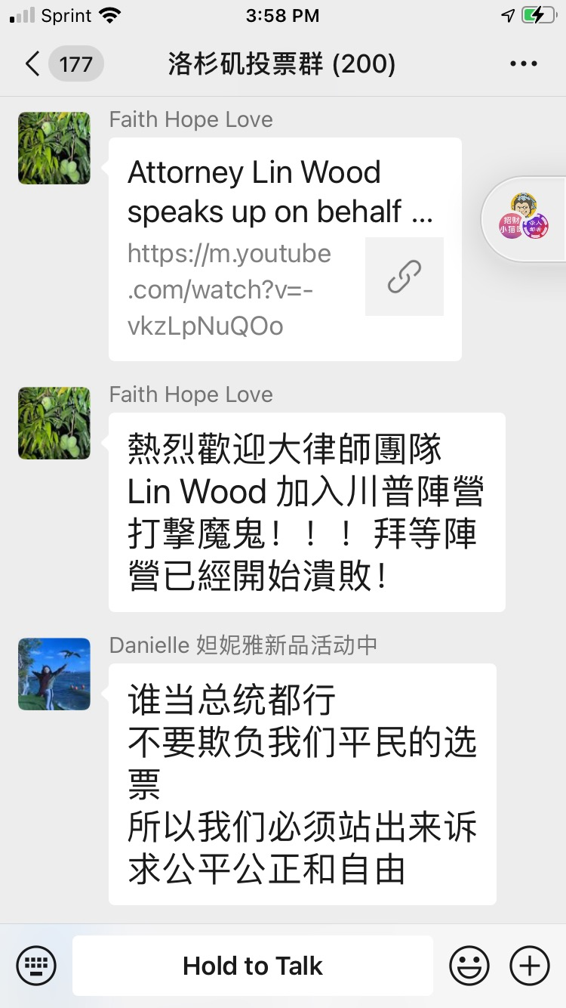
----------------------------------------------------------------------------------------------------------------------------------------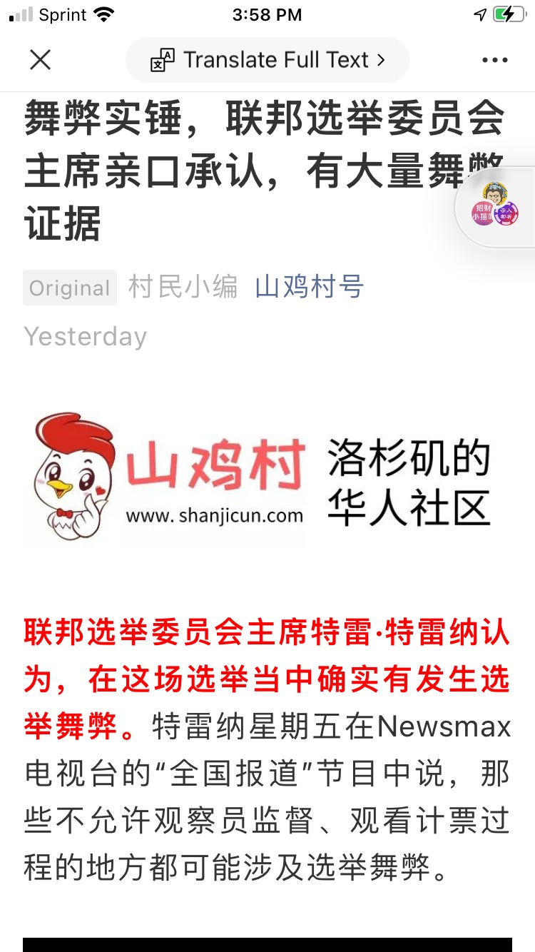
----------------------------------------------------------------------------------------------------------------------------------------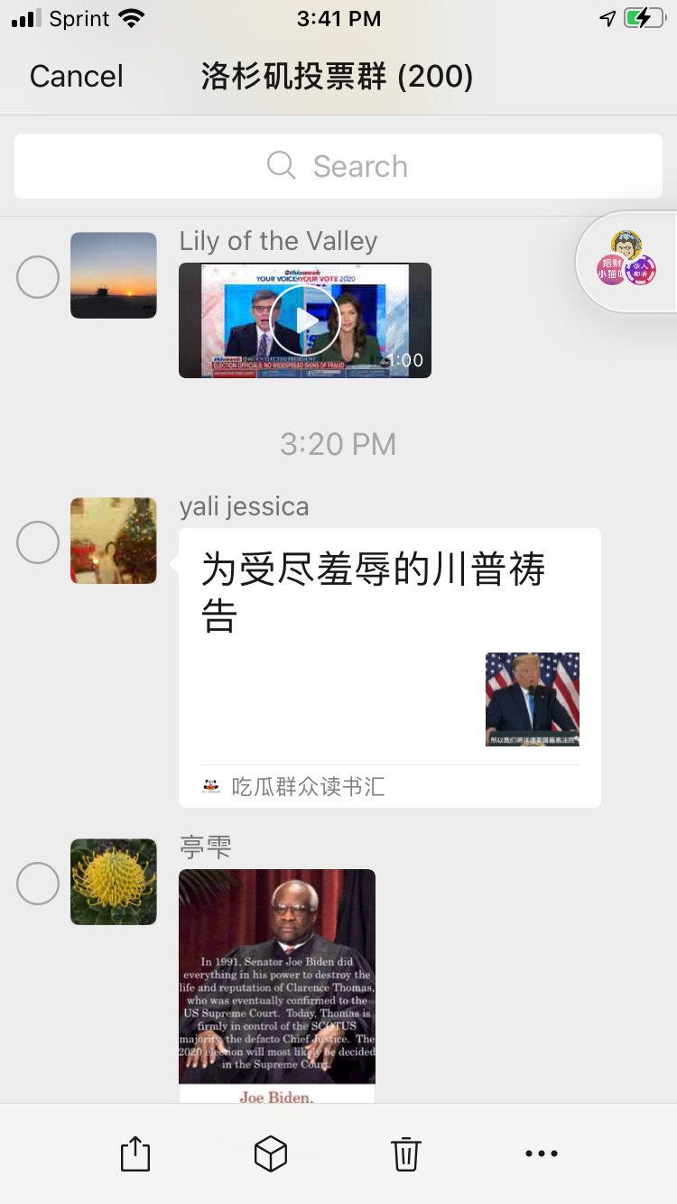
----------------------------------------------------------------------------------------------------------------------------------------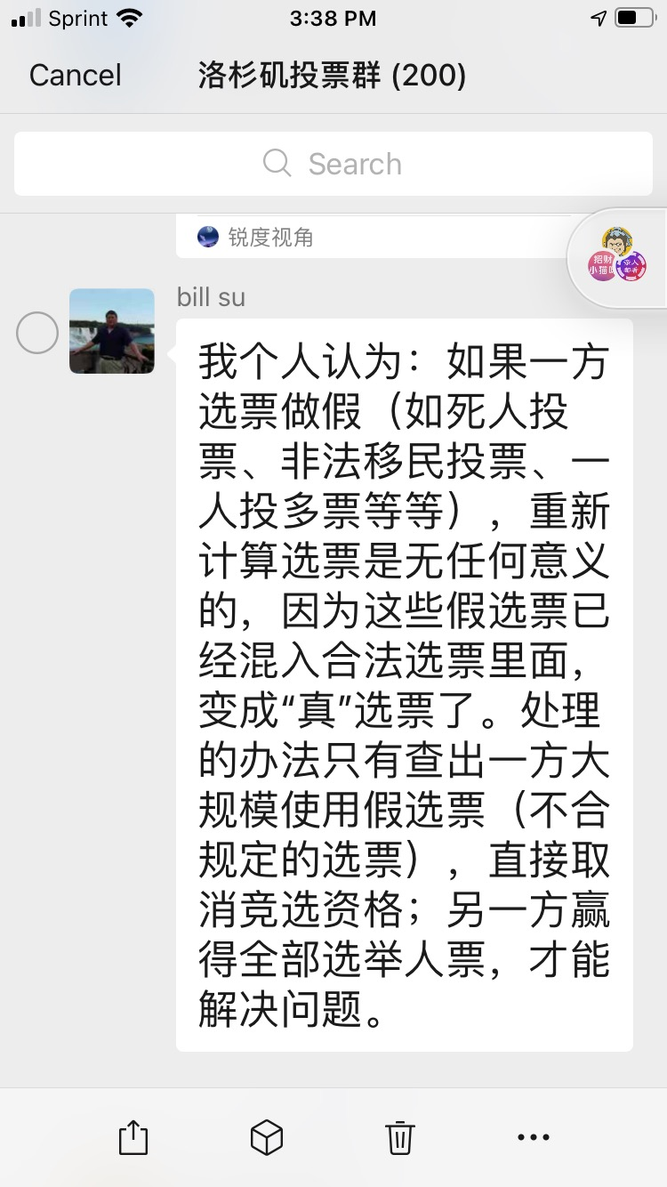
----------------------------------------------------------------------------------------------------------------------------------------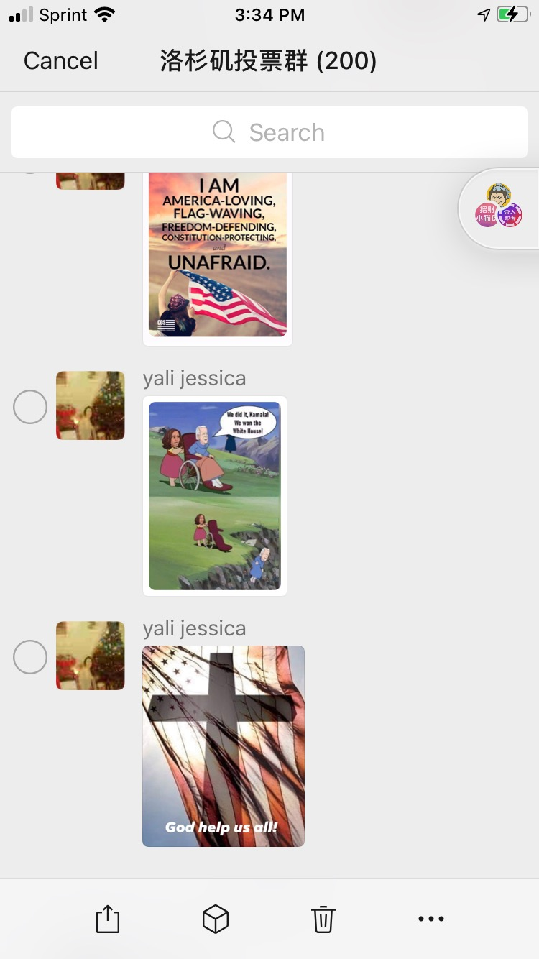
----------------------------------------------------------------------------------------------------------------------------------------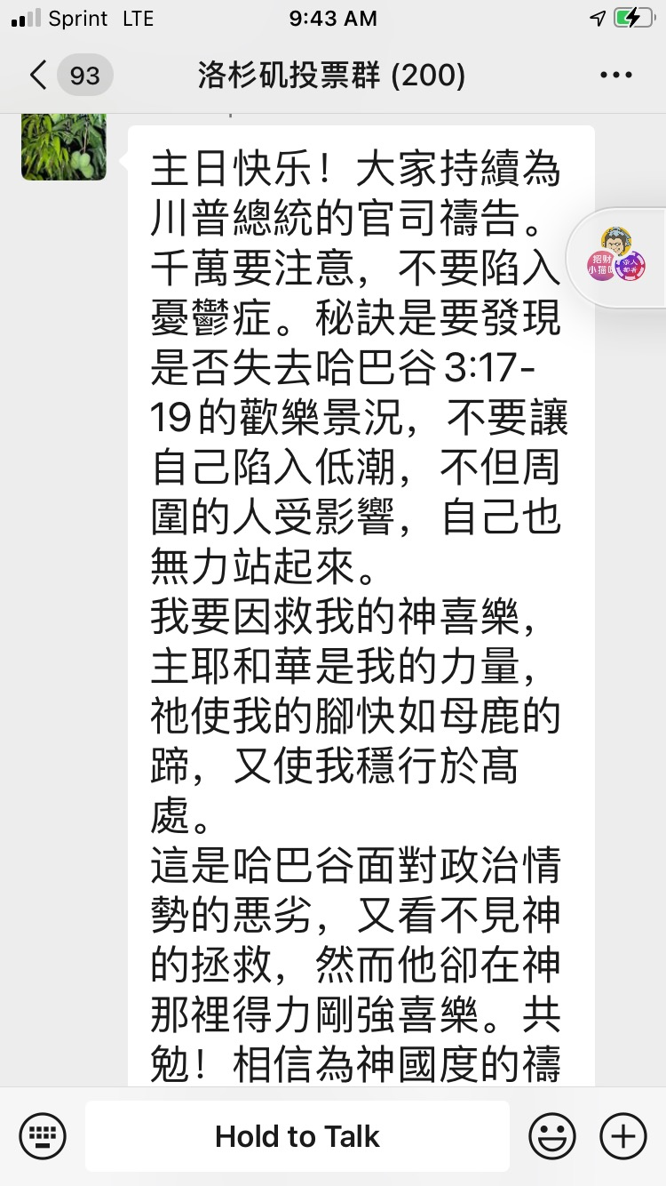
----------------------------------------------------------------------------------------------------------------------------------------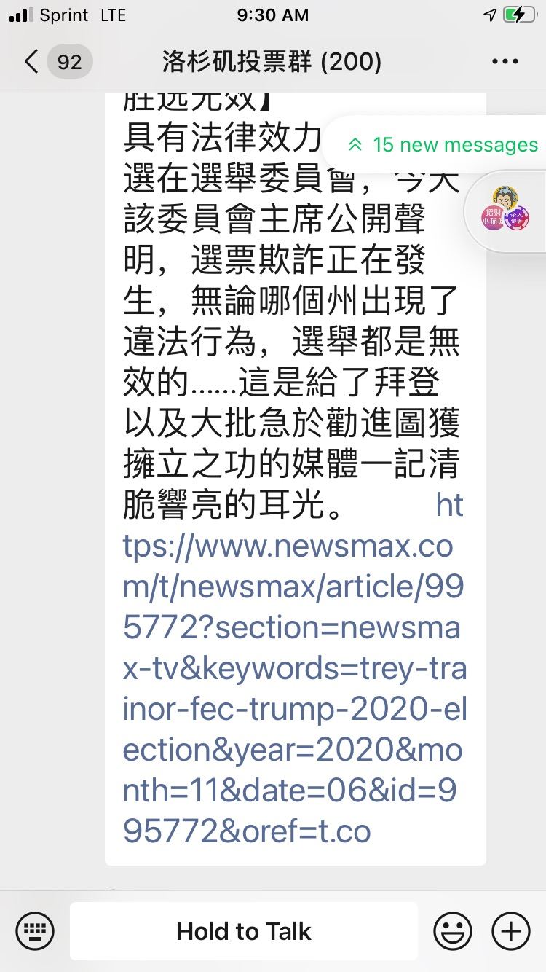
----------------------------------------------------------------------------------------------------------------------------------------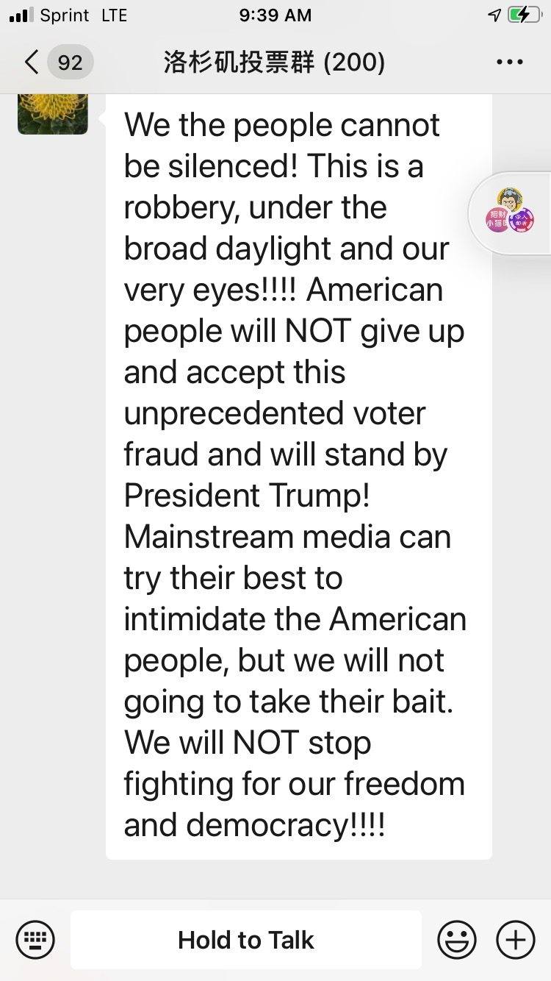
----------------------------------------------------------------------------------------------------------------------------------------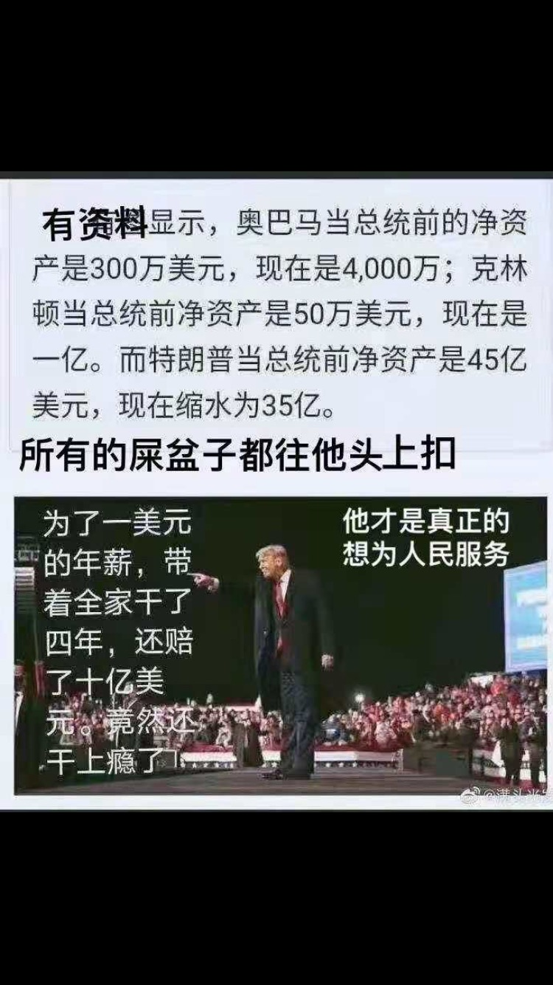
----------------------------------------------------------------------------------------------------------------------------------------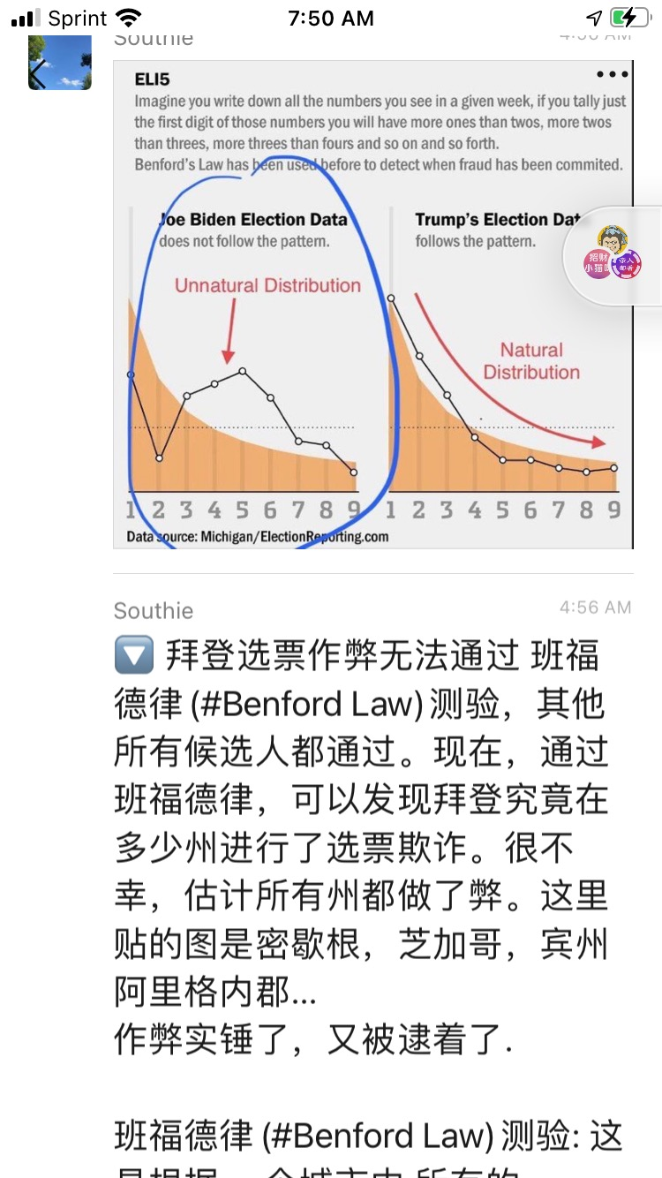
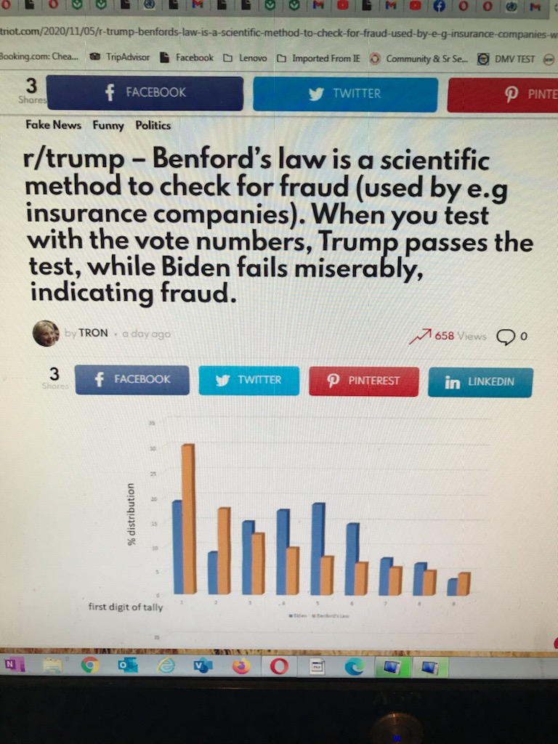
----------------------------------------------------------------------------------------------------------------------------------------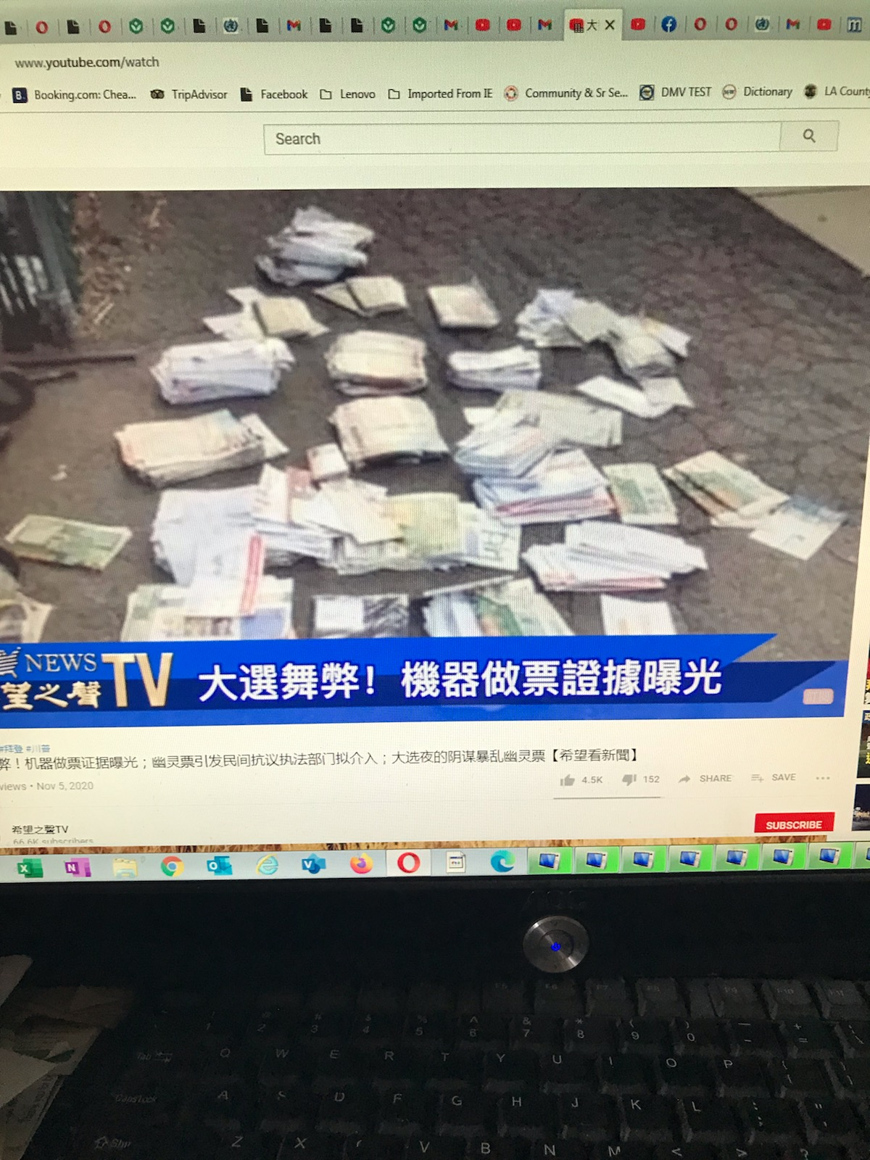
----------------------------------------------------------------------------------------------------------------------------------------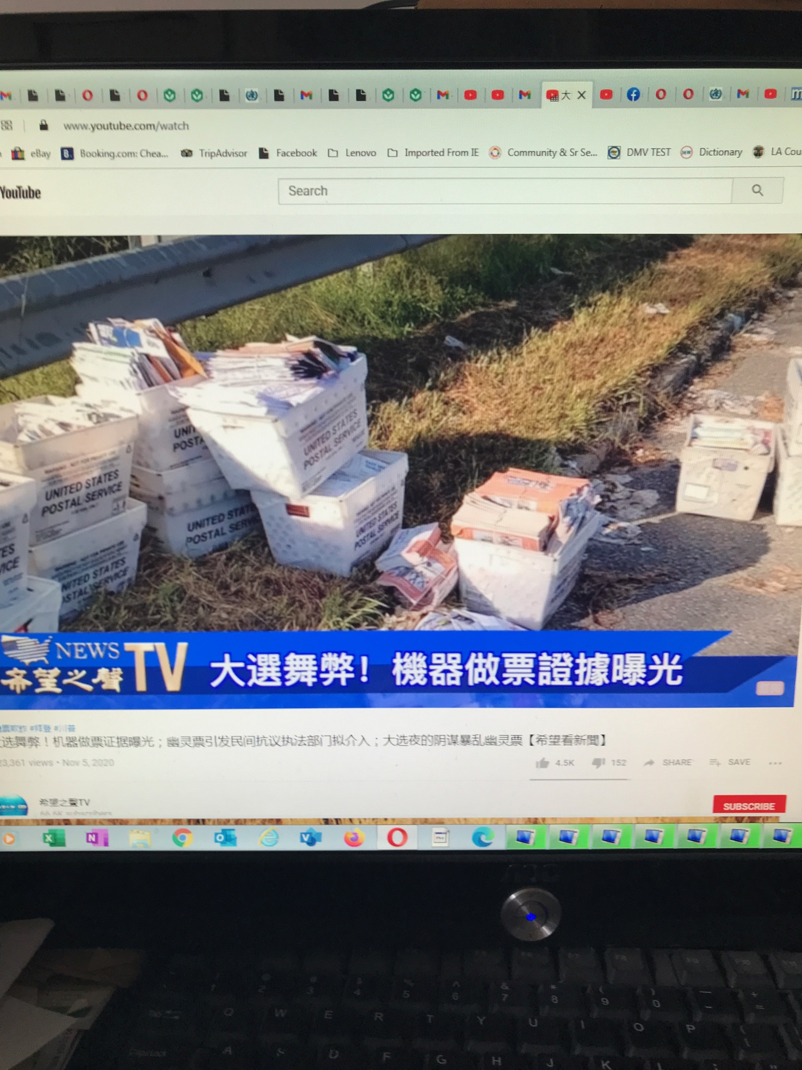
----------------------------------------------------------------------------------------------------------------------------------------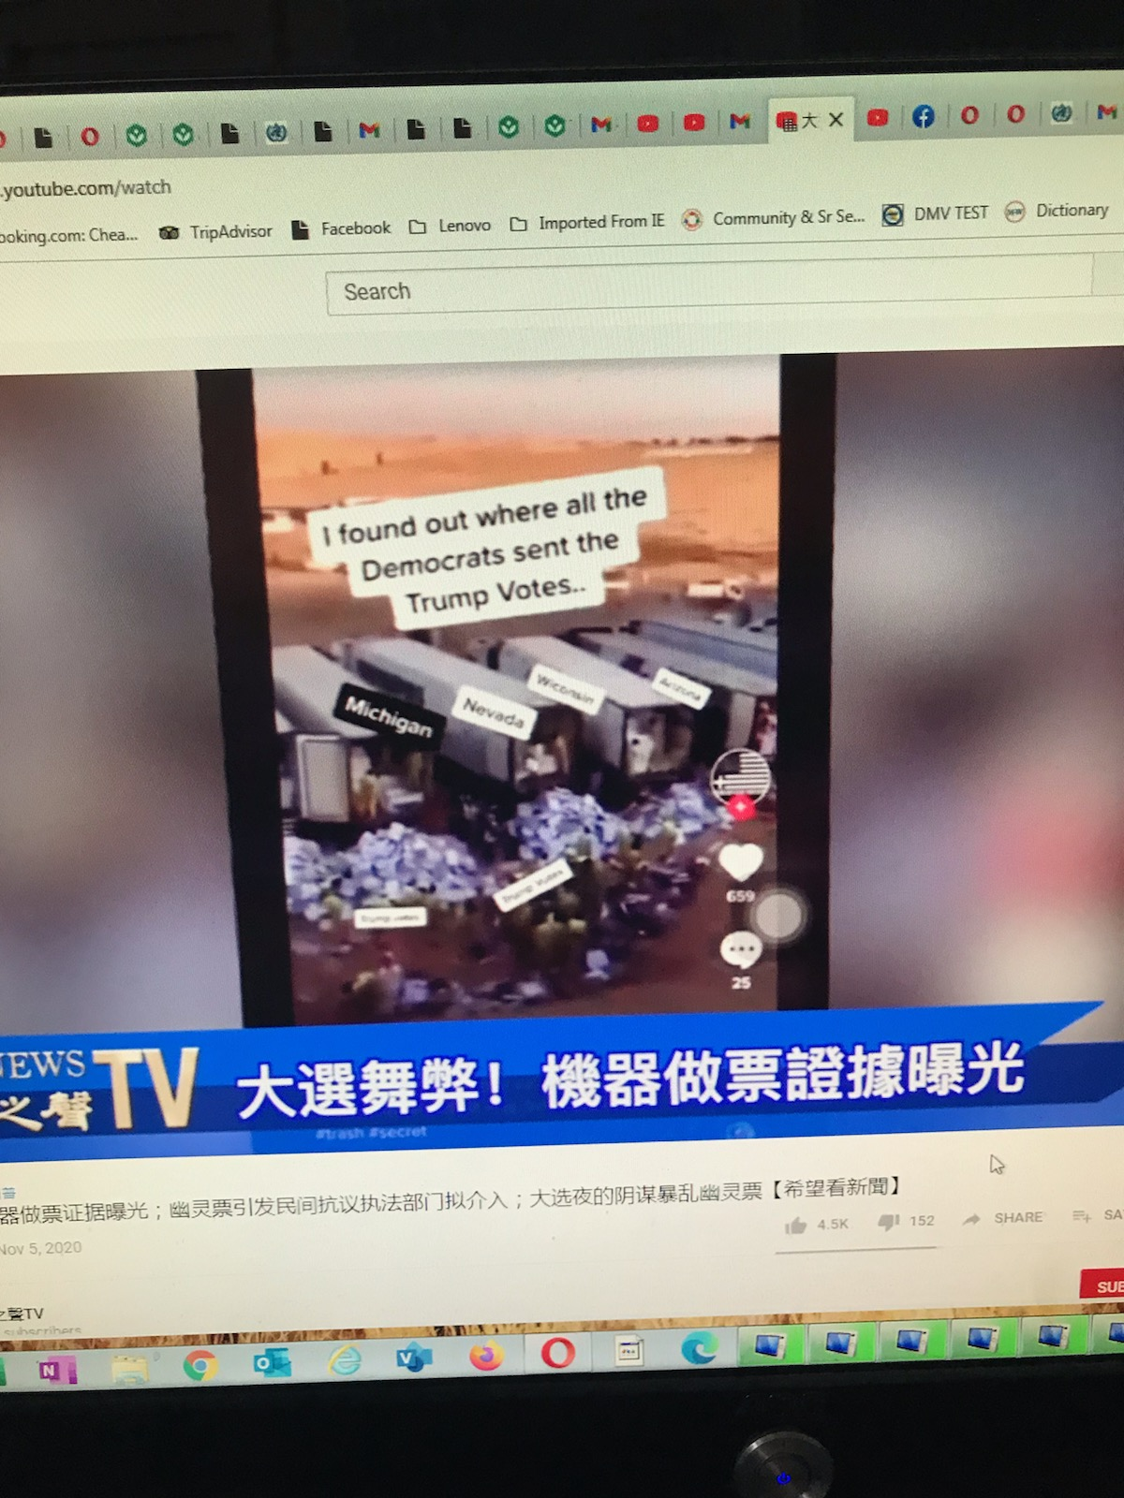
----------------------------------------------------------------------------------------------------------------------------------------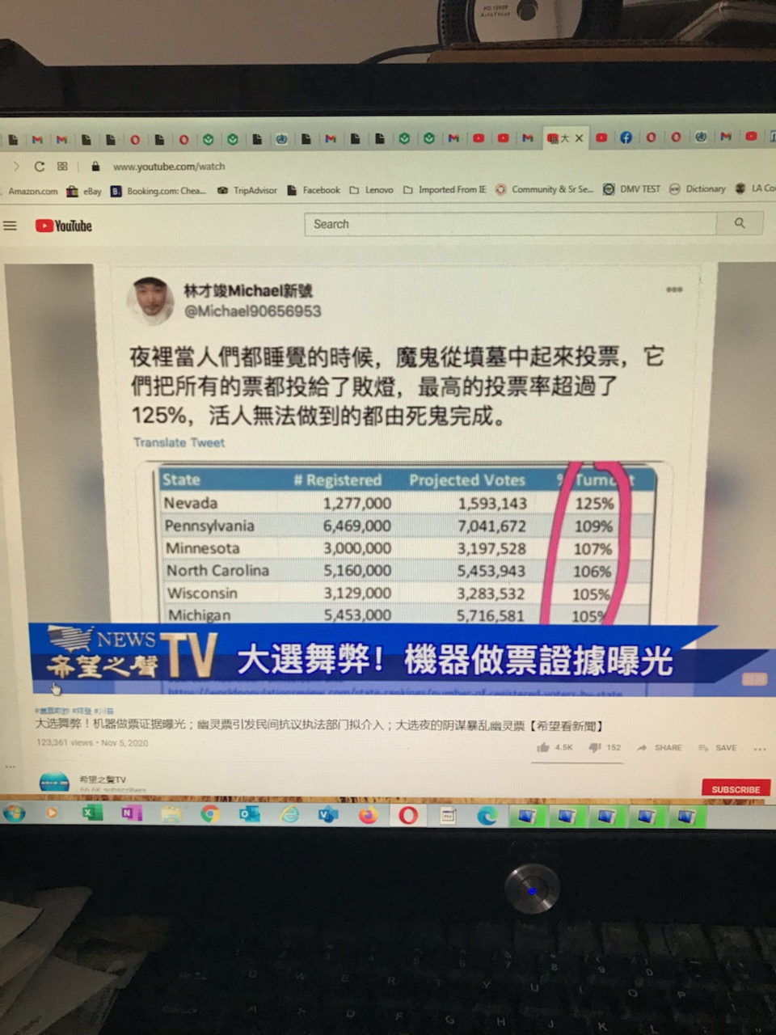
----------------------------------------------------------------------------------------------------------------------------------------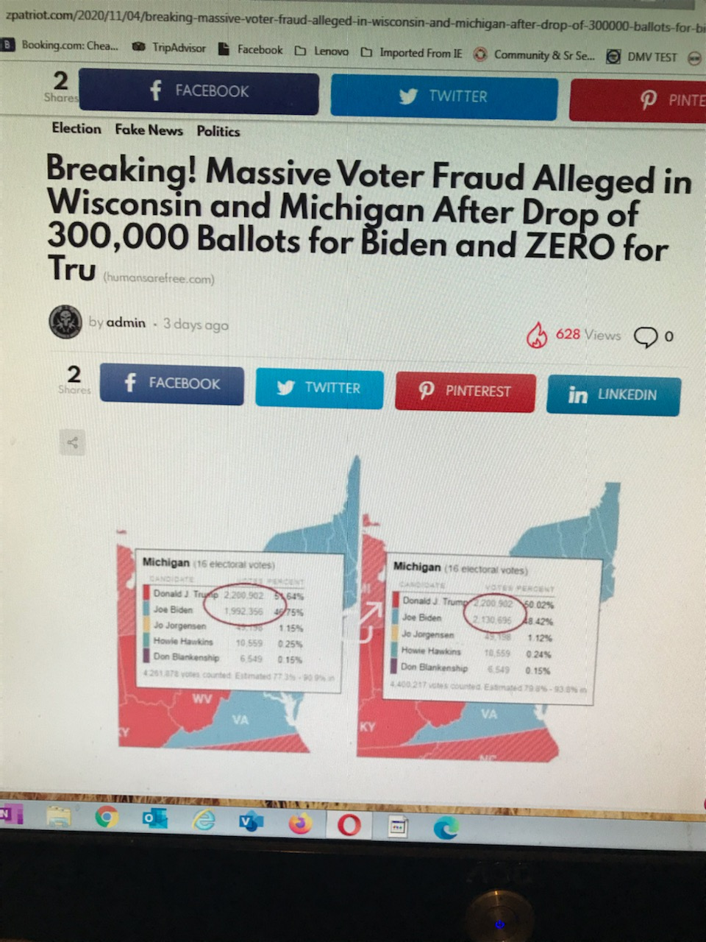

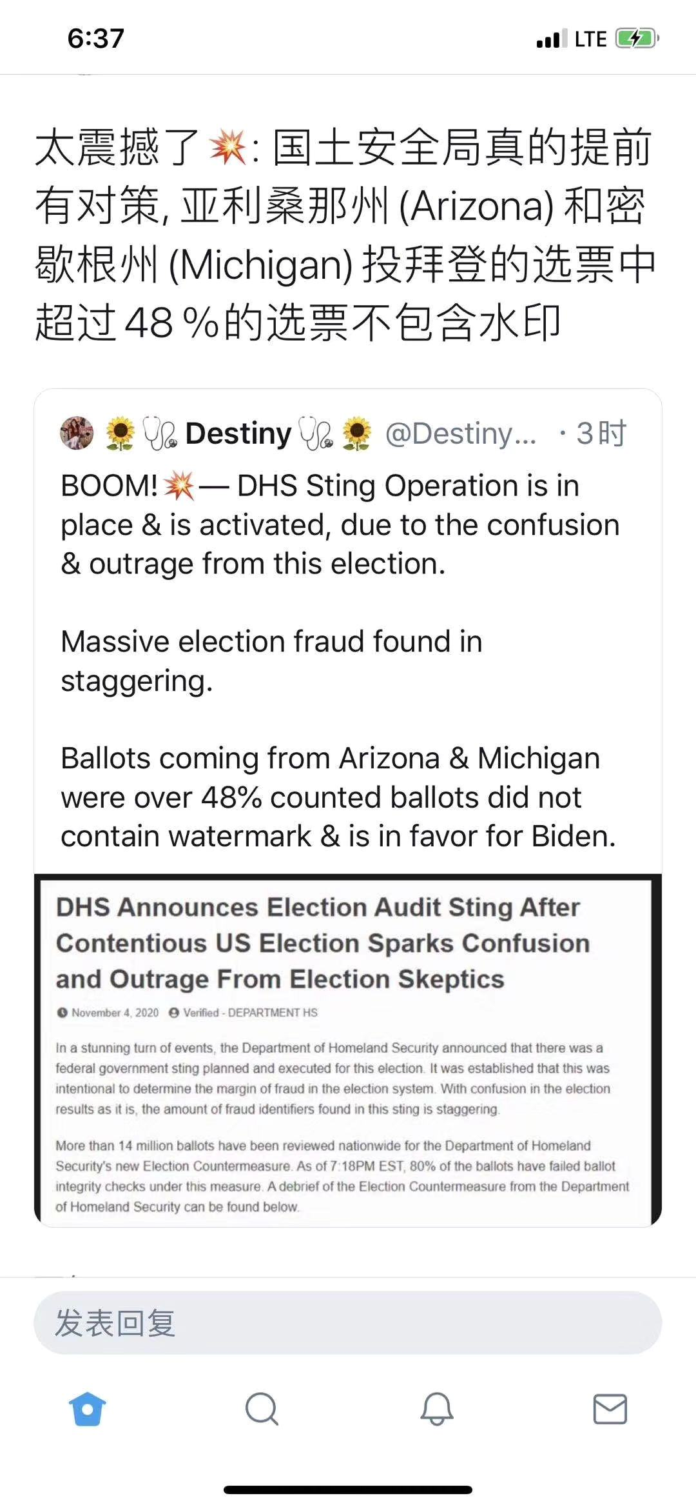

----------------------------------------------------------------------------------------------------------------------------------------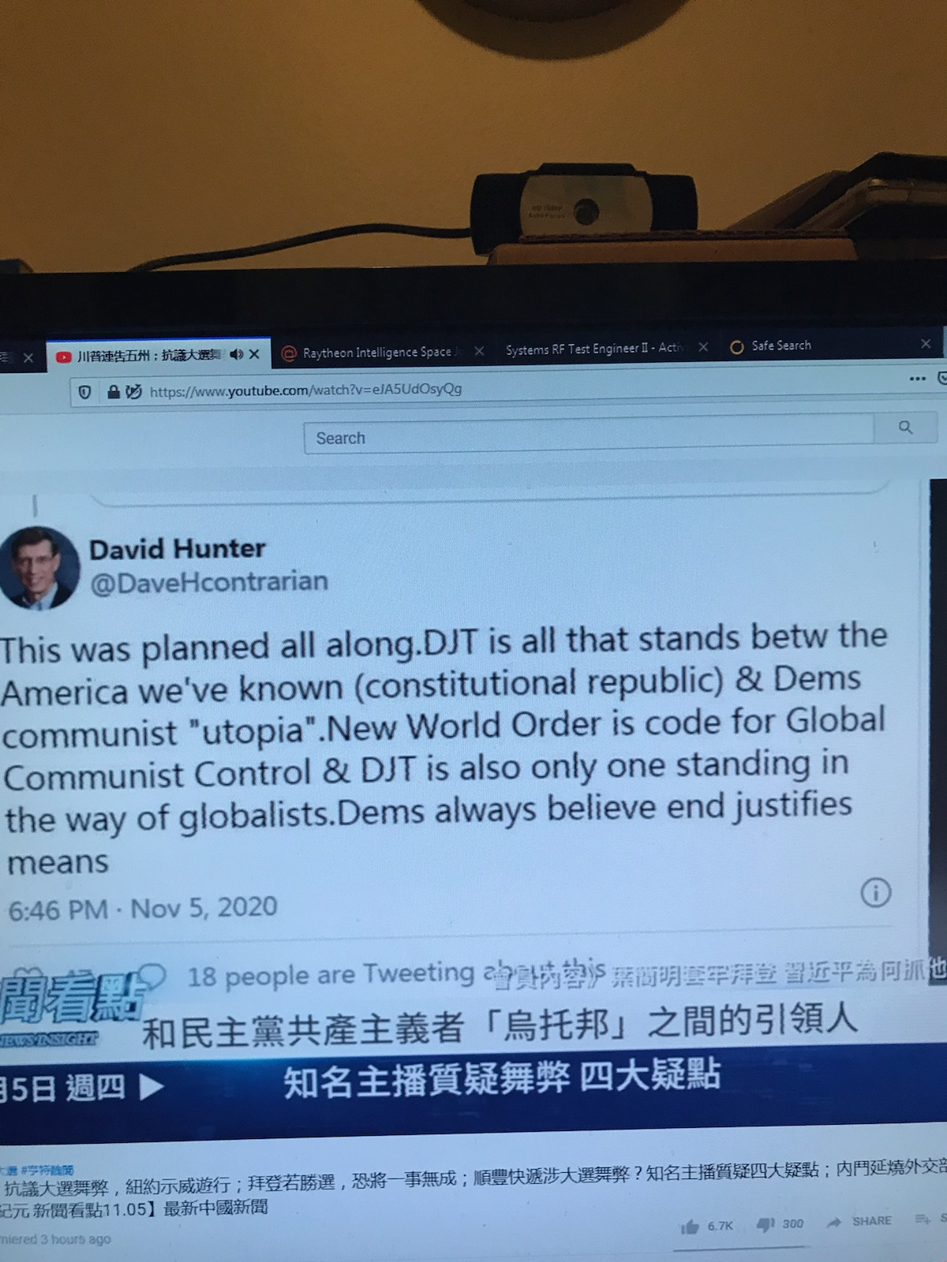
----------------------------------------------------------------------------------------------------------------------------------------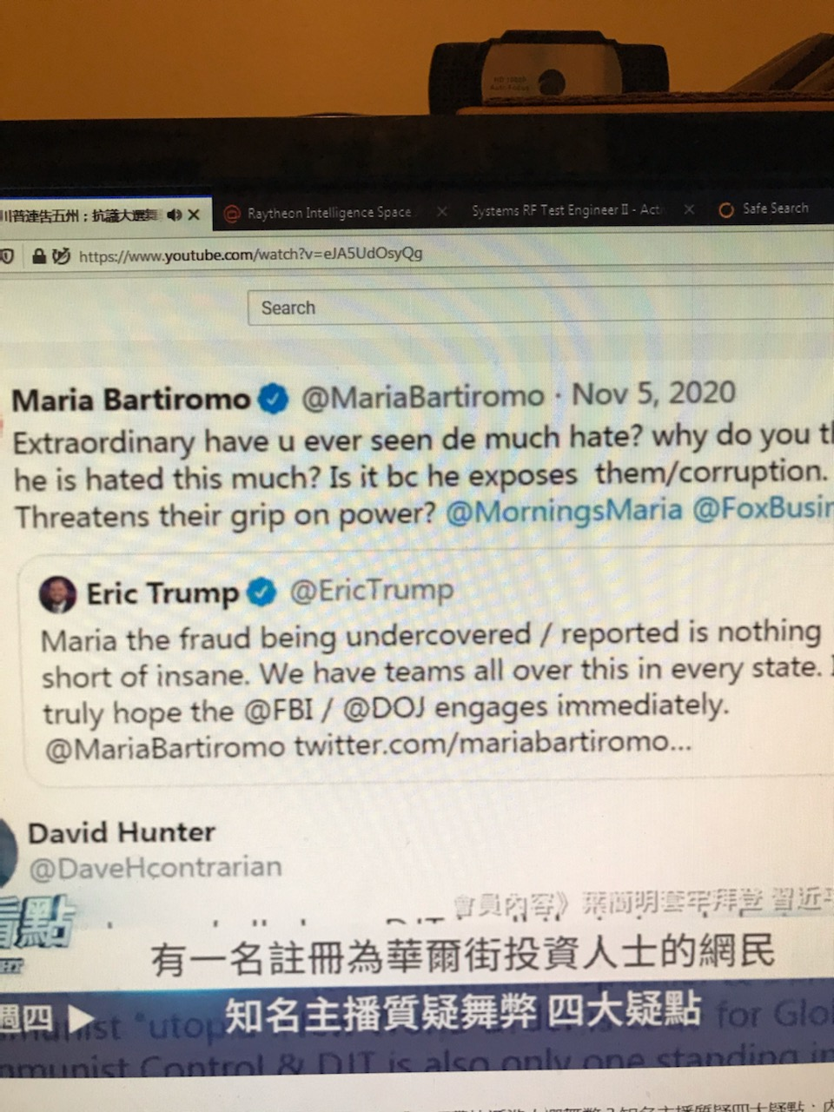
----------------------------------------------------------------------------------------------------------------------------------------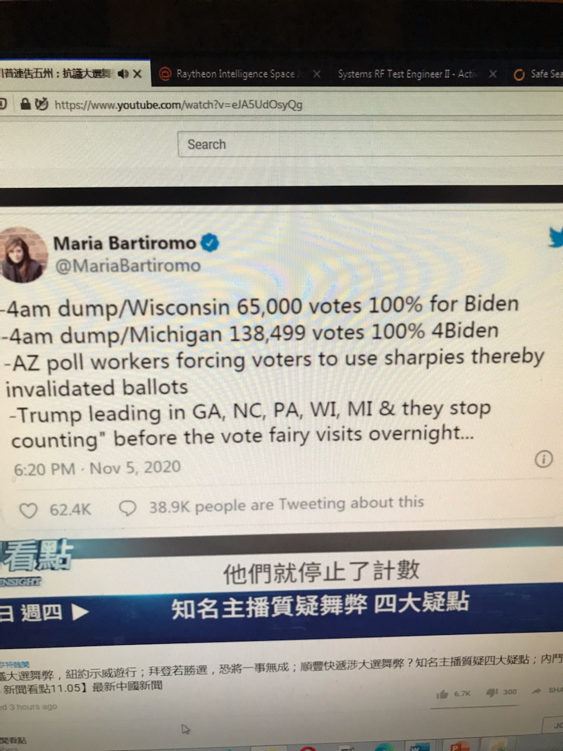
----------------------------------------------------------------------------------------------------------------------------------------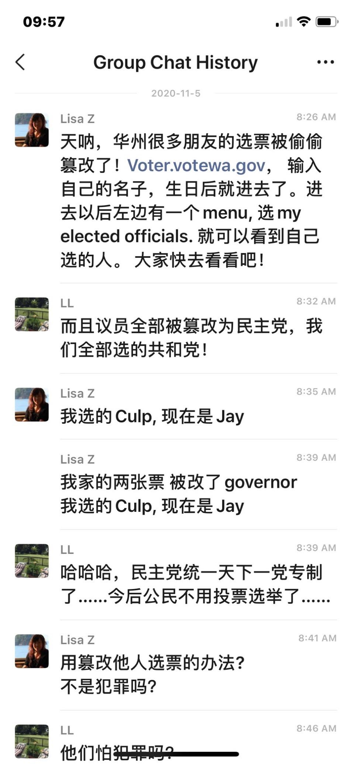
----------------------------------------------------------------------------------------------------------------------------------------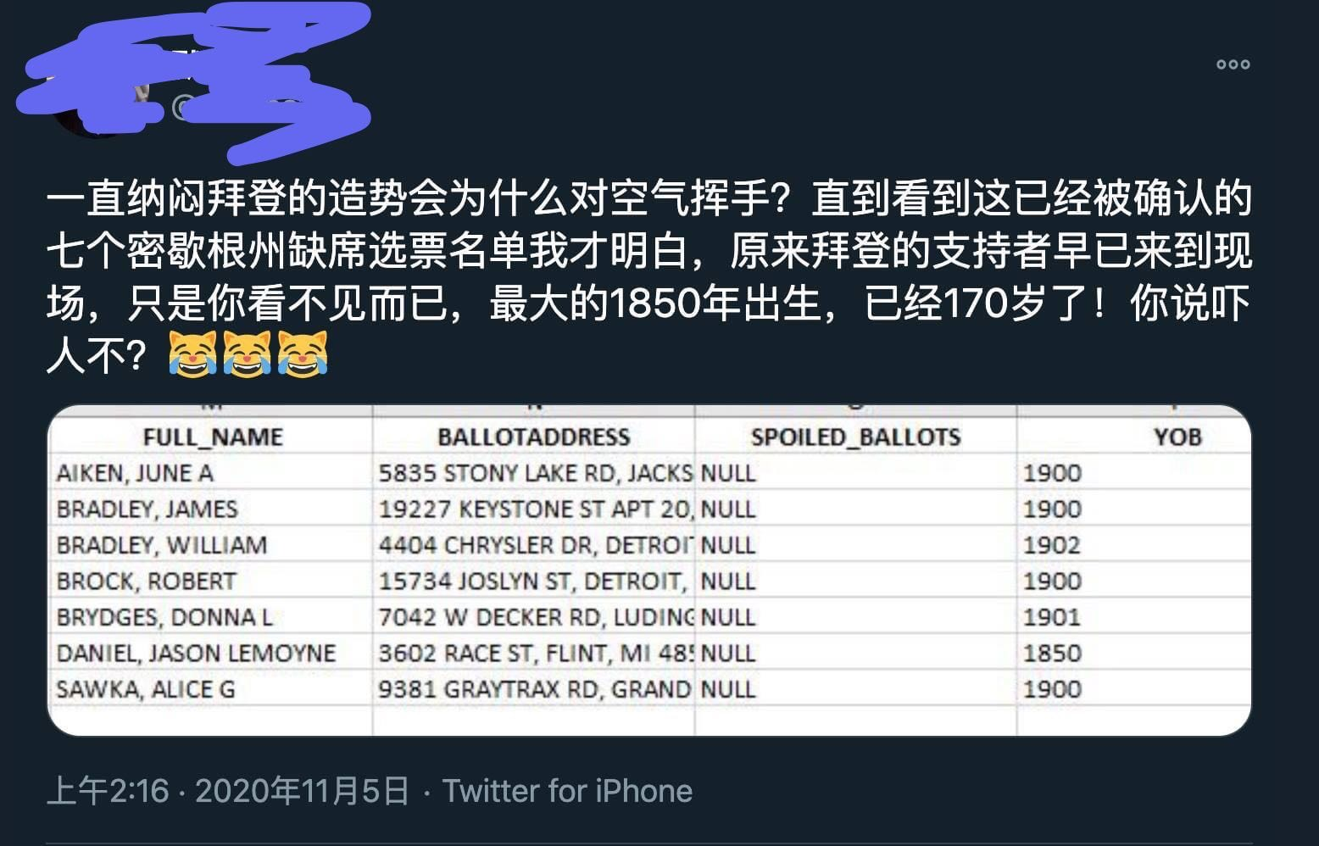
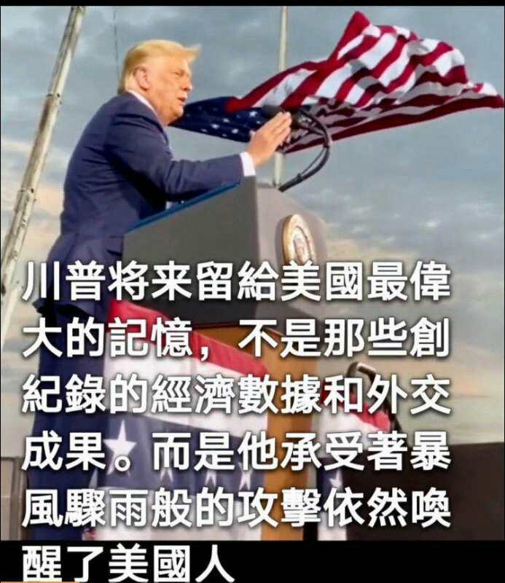
----------------------------------------------------------------------------------------------------------------------------------------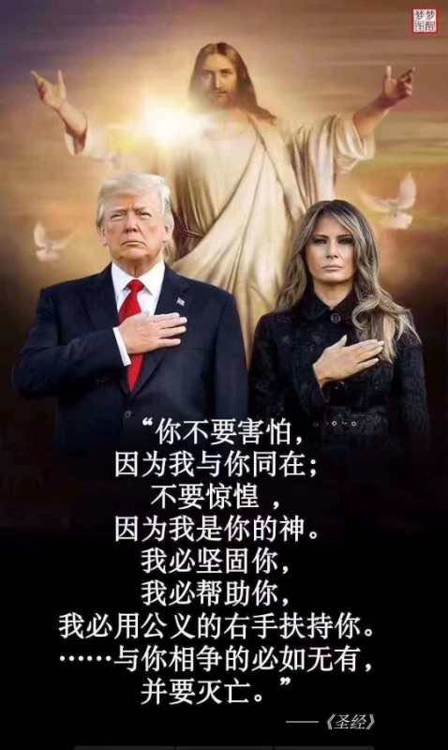

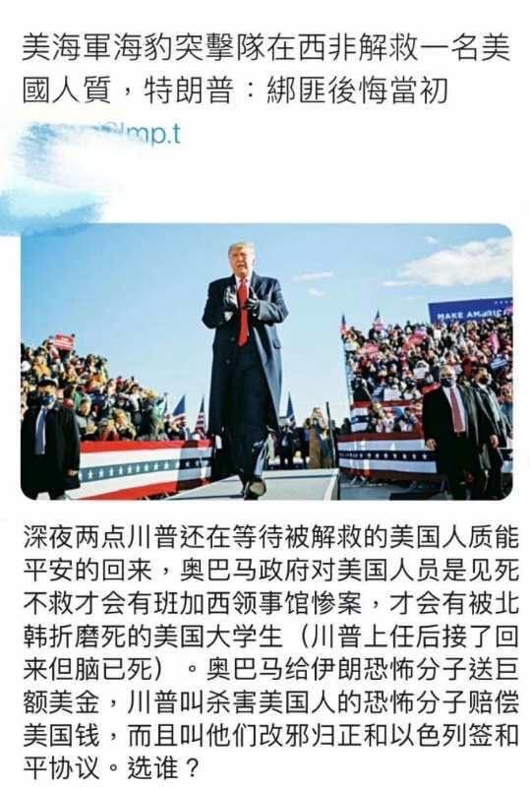
----------------------------------------------------------------------------------------------------------------------------------------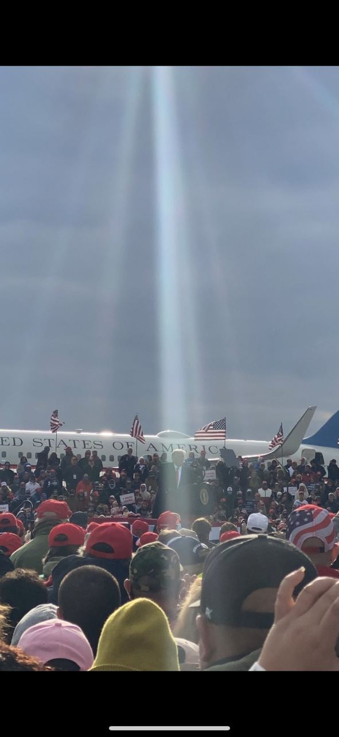
----------------------------------------------------------------------------------------------------------------------------------------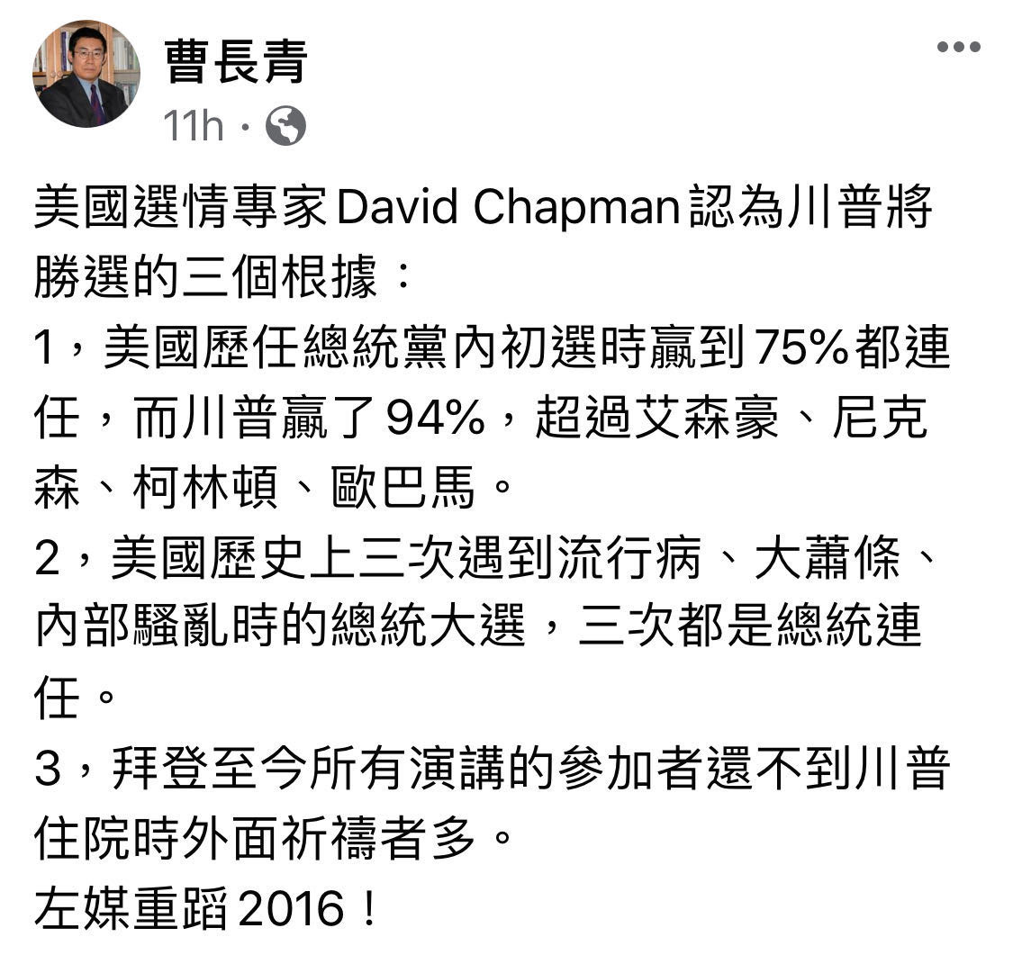

----------------------------------------------------------------------------------------------------------------------------------------谁知道“三个麦琪带来礼物送给生在马槽里的圣婴耶稣”是怎么回事？
据《圣经》记载，麦琪是耶稣出生时从东方前来朝圣送礼的三个贤人，他们的礼物带表了尊贵与圣洁。
在新约第一章《马太福音》里:
麦琪送的礼物是黄金、乳香和没药！
一、黄金是耶稣基督将来作万王之王、万主之主的象徵。
二、乳香是象徵耶稣基督为大祭司。
三、没药是象徵耶稣基督为先知，没药味苦，他在世上教训人脱离罪恶，过圣洁生活。他为著救人，自己喝了父神所预备的苦杯，甘心为人类钉十字架而死。那真是痛苦万分的人生。他被安葬时，尼哥底母带著约一百斤的沉香和没药为殡葬，以防腐及杀菌。
根据圣经的记载，耶稣诞生在犹太的一座小城－－伯利恒。马利亚，也就是耶稣的母亲，因圣灵的感动而怀孕，在梦中天使加百列向她显现，告诉她，她将要生下神的儿子，他要被称为耶稣。就在与丈夫约瑟返往家乡时，所有的旅店客满，因此马利亚被迫在马槽生下耶稣。遥远的东方有三博士得到神的启示，追随天上的一颗明亮星星找到了耶稣，俯伏拜他，揭开宝盒，拿出黄金、乳香、没药为礼物献给他。在伯特利野地的牧差人也听到天使的声音从天上发出，向他们款耶稣降生的佳音
根据圣经的记载，耶稣诞生在犹太的一座小城－－伯利恒。马利亚，也就是耶稣的母亲，因圣灵的感动而怀孕，在梦中天使加百列向她显现，告诉她，她将要生下神的儿子，他要被称为耶稣。就在与丈夫约瑟返往家乡时，所有的旅店客满，因此马利亚被迫在马槽生下耶稣。遥远的东方有三博士得到神的启示，追随天上的一颗明亮星星找到了耶稣，俯伏拜他，揭开宝盒，拿出黄金、乳香、没药为礼物献给他。在伯特利野地的牧差人也听到天使的声音从天上发出，向他们款耶稣降生的佳音
第九日 圣若瑟引领三王朝拜圣婴
一节：耶稣降生后天上出了个异星。有东方的三位贤士，望见这个异星，就想起了先知们的预言，知道有救世主降生在如德亚（犹太）国了，随就起程，带着礼物来朝拜。且说圣若瑟明知耶稣是降生的救世真主，满心希望本国本乡的人都认识他、朝拜他。但耶稣诞生多日，只有几个牧童认识朝拜他，别人都不答不理。圣若瑟很伤心，只得天天加倍热心恭敬圣婴，为赔补别人慢待耶稣圣婴的罪。到了今天，忽有三位贤士来朝拜，一定喜欢至极。他之所以喜欢，是因为耶稣 得了光荣，教外人得了救赎大恩。三王虽然博学显贵人，他们蒙天主拣选，全摆脱了世俗骄傲的毛病，不嫌圣家贫穷，不嫌房屋卑陋，谦谦逊逊地朝拜圣婴，感谢天主拣选的大恩。他们为发显自己的信德，献了三样礼物。献了黄金，认耶稣 为国王；献了乳香，认耶稣为天主；献了殁药，认耶稣为人。圣若瑟见三位贤士的信德，非常喜欢。我们也该同圣若瑟一齐喜欢，并该效法三圣贤献三样礼物，就是：热爱天主的黄金；热心祈祷的乳香；克己苦身的殁药。
二节：三贤士来朝，是谁接待他们呢？圣若瑟是圣家之长，一定是圣若瑟接待他们。他们先见了圣若瑟，若瑟就领他们到耶稣及圣母跟前。那时耶稣圣婴报答了三贤士的信德，赏赐他们圣宠神光，得知天国的密事。圣母也安慰了他们。若说到若瑟怎样接待了三贤，更是我们当效法的表样。若瑟虽然贫穷，却不羞于自己的贫穷。同三贤士往来，只是一片谦和朴实气象，不矜夸，也不粉饰，世俗的浮华一点也没有。我们怎样呢？我们同人交接往来多次不诚实，说话要好听，穿衣要华丽，事事都求虚荣，图人看重。这个心思和大圣若瑟朴实的心恰恰相反。三贤士朝拜以后就大大改变，我们进教以来有改变吗？若仍然贪图虚荣，爱世俗，顺肉情，和教外人一样，这不是白白辜负天主特选我进教的恩典么？
诵句：于谦德为最深者，为我等祈。
敬工：衣服要朴素，断绝浮华；言语要诚实，不可粉饰。
事迹：奥地利国皇帝良保都一世，奉教虔诚，治国有方。就是膝下无儿，将来王位无人接续，为此特别忧愁。后来决定求大圣若瑟赏赐一个太子。于颁布法号，奉圣若瑟为本朝主保，吩咐人铸一尊圣若瑟像供在宫殿里，又命全国臣民在京都各圣堂内一连八天行大礼祈祷。圣若瑟果然允了他的祈求，不久即得了一个太子，皇帝给他起名叫若瑟。又叫人再铸一大圣若瑟像，在京都广场上，作为永久的纪念，以感谢圣若瑟转求之恩。立像那一天，皇帝同文武官员都到圣堂里参与大弥撒，君臣上下无不同心欢喜。
>这篇文章通过写在圣诞节前一天，一对小夫妻互赠礼物，结果阴差阳错，两人珍贵的礼物都变成了无用的东西，而他们却得到了比任何实物都宝贵的东西——他们相濡以沫的爱情，这是神圣的，寓意深远的礼物，告诉人们尊重他人的爱，学会去爱他人，是人类文明的一个重要表现。裁剪精到的构思，对话般亲切的语言，微带忧郁的情调，使这个短篇在缕缕情感的光束中显露出丰厚的内涵，激发读者对爱情、金钱的价值的思考。时而细致入微，时而寥寥数笔，这种寄实于虚，并兼用暗示和略写的手法，是《麦琪的礼物》所独具的。原题为THE GIFT OF THE MAGI,旧译《麦琪的礼物》，麦琪在圣经里是有东方来朝见初生的耶稣的三贤人，他们都带来寓意深远的礼物。
朋友，现在我们要向你说说人生中最重要的事，这个迫不及待、需要解决的问题——人生与永恒的话题。
“你若口里认耶稣为主，心里信神叫祂从死里复活，就必得救。——罗马书10：9”
我们曾经被人说是“迷信”、“唯心”，但我们不承认我们是迷信、唯心的。不信有神的人倒是迷信和唯心的呢！没有的、假的，我们硬说是有、是真，这就是迷信与唯心。明明是有神，但闭起眼睛说“没有”，这不是迷信与唯心又是什么呢？也许你会说：“你这个人太奇怪了，把没有看见的神，说成‘明明有’，还说别人迷信与唯心！”请注意，不信有神的人往往用“看不见”来欺哄自己。试想，看不见的东西有多少？最高的山，最深的海，最北的北极和最南的南极，地球的核心以及千千万万的事物，我们都没有见过，为什么我们信它们是存在的呢？没有看见过的东西，我们怀疑它的存在，这倒不太奇怪，最奇怪的是我们去否定它！
……——点击了解关于《永生之路》

经验分享
谁知道“三个麦琪带来礼物送给生在马槽里的圣婴耶稣”的故事? ： 据《圣经》记载,麦琪是耶稣出生时从东方前来朝圣送礼的三个贤人,他们的礼物带表了尊贵与圣洁.在新约第一章《马太福音》里:麦琪送的礼物是黄金、乳香和没药! 一、黄金是耶稣基督将来作万王之王、万主之主的象徵. 二、乳香是象徵耶稣基督为大祭司. 三、没药是象徵耶稣基督为先知,没药味苦,他在世上教训人脱离罪恶,过圣洁生活.他为著救人,自己喝了父神所预备的苦杯,甘心为人类钉十字架而死.那真是痛苦万分的人生.他被安葬时,尼哥底母带著约一百斤的沉香和没药为殡葬,以防腐及杀菌.
谁知道《麦琪的礼物》简述版?三四百字的那种,拜托拜托~~这是我今天的作业!!_ ： 麦琪的礼物》读后感 他们用自己美丽的心灵赠给对方的是一件无价之宝.而这件无价之宝,确实世间任何自认聪明或富有的人永远不会,也不能给予的礼物. 圣诞节是西方国家最重要的节日之一.每年的12月25日,人们都会在欢乐的气氛中互...
阅读《麦琪的礼物》中的一段文字,回答小题: 那三位麦琪,诸位知... ： ■[美]欧·亨利/著 一元八角七.全都在这儿了,其中六角是一分一分的铜板.这些分分钱是杂货店老板、菜贩子和肉店老板那儿软硬兼施地一分两分地扣下来,直弄得自己羞愧难当,深感这种掂斤播两的交易实在丢人现眼.德拉反复数了三次,...
麦琪的礼物 阅读 答案_ ： 《麦琪的礼物》语段阅读分析题杰姆从大衣口袋里掏出一包东西,把它扔在桌上.＂不要对我有任何误会,德儿,＂他说□不管是剪发□修脸□洗头,我对我的姑娘的爱情是绝不会减低一分的.但是,你一打开那包东西,就会明白,刚才你为什...
请问谁知道耶酥降生的时候,三位麦琪分别都送的什么礼物? ： 黄金,鲁香,莫药.
三位麦琪送给耶稣什么礼物了?分别代表什么意义?_ ： 黄金、乳香和没药...
《麦琪的礼物》 ： 《麦琪的礼物》是美国著名文学家欧·亨利写的一篇短篇小说,它通过写在圣诞节前一天,一对小夫妻互赠礼物,结果阴差阳错,两人珍贵的礼物都变成了无用的东西,而他们却得到了比任何实物都宝贵的东西——爱,告诉人们尊重他人的爱,...
谁有麦琪的礼物_ ： 我有: 欧亨利-麦琪的礼物 一块八毛七分钱.全在这儿了.其中六毛钱还是铜子儿凑起来的.这些铜子儿是每次一个、两个向杂货铺、菜贩和肉店老板那儿死乞白赖地硬扣下来的;人家虽然没有明说,自己总觉得这种掂斤播两的交易未免太吝啬...
相关内容：给耶稣带来礼物的麦琪 、 麦琪的礼物个人感悟 、 麦琪的礼物小说在线阅读 、 麦琪的礼物原文阅读 、 麦琪的礼物 、 麦琪的礼物题目及答案 、 麦琪的礼物批注式阅读 、 麦琪的礼物节选 、 《麦琪的礼物》原文app 、 麦琪的礼物在线阅读 、 麦琪的礼物为什么叫麦琪 、 麦琪的礼物经典语录 、 麦琪的礼物原文英文版 、 麦琪的礼物分几部分 、

---------------------------------------------------------------------------------------------------------------------------------------- Lin Wood tells Mark Levin he believes Trump won ’70 percent-plus landslide … over 400 electoral votes’
November 18, 2020 | Vivek Saxena | Print Article

Get the latest BPR news delivered free to your inbox daily. SIGN UP HERE

CHECK OUT WeThePeople.store for best SWAG!
Powerhouse attorney Lin Wood, the man responsible for Richard Jewell and Nick Sandmann’s successful lawsuits against the establishment media, believes President Donald Trump won the 2020 presidential election in a landslide.
Speaking on conservative commentator Mark Levin’s radio program Tuesday, Wood claimed that all the alleged voter fraud he’s uncovered has him convinced that the incumbent president won over 400 electoral votes in the race.
Enable
11 seconds...
“This election was a fraud. Donald Trump won, I believe, clearly a 70 percent-plus landslide election in the nation. He probably won over 400 electoral votes,” Wood said.
“So we’re uncovering step by step the layers of the onion. And we’re going to get to the truth. And the truth is, Donald Trump has been re-elected by this country to serve as president for four more years. The truth will come out.”
Listen from the 23:42 mark below:
<span data-mce-type="bookmark" style="display: inline-block; width: 0px; overflow: hidden; line-height: 0;" class="mce_SELRES_start">﻿</span>
That’s a bold statement to make, especially given the media’s disputed declaration that Democrat presidential nominee Joe Biden won the 2020 race with 306 electoral votes.
Wood remains confident nevertheless because he, a legendary attorney with decades of experience, genuinely believes the “election was stolen.”
“Donald Trump won by such a large margin that in the middle of the night they had to stop counting. And you’ll see in key states, they started bringing in ballots by the truckload, all of them for Biden, many of them in these mail-in ballots with little bubbles for you to circle over the person you selected all of them for bad[Biden] with perfect circles,” he continued.
“I believe upon examination you’re going to find those perfect circles were made by a computer. This election was stolen, but they got caught.”
But this isn’t some far-flung conspiracy theory to Wood — it’s the “truth.”

----------------------------------------------------------------------------------------------------------------------------------------前英国大律师：军情六处情报证实 拜登窃取美国大选
温妮 | 美丽日报
8 hours ago
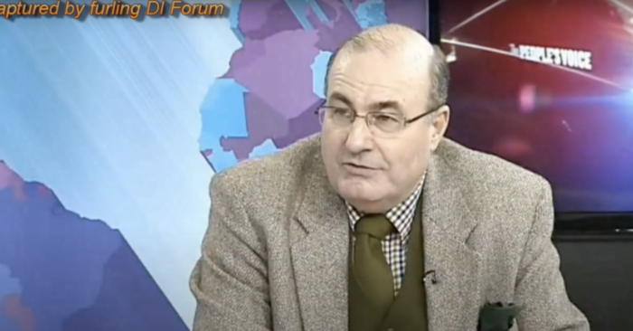
2013年11月27日，前英国大律师迈克尔·史林普顿接受电视专访。（视频截图）
【美丽日报2020年11月21日讯】美国民主党操控大选似乎已经是不争的事实，特别是Dominion服务器的被拿获，一切真相即将水落石出。而针对此次大选舞弊，前英国大律师迈克尔·史林普顿（Michael Shrimpton）披露，早在11月6日，英国军情六处（MI6）就已获得资料，证实本届美国大选确实是一场窃选，拜登不是当选总统，美国正在经历的是有史以来最腐败的总统选举。

----------------------------------------------------------------------------------------------------------------------------------------一起禱告
Jack Jiang |  |  | 5:25 AM (2 hours ago)
11-24-2020
轉：
為美國大選訴訟案的突破與得勝宣告
http://www.kp24-newway.com/prayer/?recordId=20442
我們奉耶穌的名宣告：
˙神必保守法官的心，與神對齊，不受利誘、恐嚇或威脅， 在每起訴訟中，都能做出公正的裁決，並證明川普總統得勝。
˙神必賜給川普總統律師團隊智慧，能蒐集到所有制敵致勝的證據，將所有作奸犯科者繩之以法。
˙神必保守這些參與訴訟的律師或吹哨人免受邪靈或人身的攻擊，賜下平安、光明、真理和法治。
˙神必使搖擺州選票重新審核確實無誤，以主耶穌的寶血破除任何針對訴訟程序所施的巫術或咒語，所有操控電腦和選票的行為都必被揭露和糾正，使川普總統、共和黨參眾議員得到極大支持，並大獲全勝。
(部分改編自WFJM)
˙爭戰得勝在乎耶和華！神必為川普總統伸冤，取得突破性的進展，勝選臨到正義之方！
˙川普總統必要連任，他必作美國的父。神必將大衛家的鑰匙放在他的肩頭上，他開，無人能關；他關，無人能開。神必使川普總統安穩，像釘子釘在堅固處。(賽22:22-23)
˙神必以耶穌的寶血覆蓋川普總統、他的幕僚、律師團隊和他們的家人，破除所有攻擊他們的巫術和咒詛，拯救他們脫離任何暗殺計畫，保守他們出入平安。(賽54:17)
˙釋放混亂的靈進入反川普陣營，使他們彼此相攻，彼此爆料、速速滅亡！作惡之人，心必如蠟消化；使舞弊者大大驚恐、恐懼顫驚，及時悔改自首，並使其陰謀曝光，完全失敗。(詩55:5)
˙神的審判要臨到那些深層政府的首腦爪牙，將他們一網打盡！使他們所有的權勢要癱瘓瓦解，他們的財務也陷入癱瘓失敗， 惡人的財富要轉移到義人的手中！(箴13:22)
˙釋放更多真理的大光進入美國，聖靈澆灌在美國全地，屬靈的大覺醒臨到美國！使矇蔽的不再被矇蔽，瞎眼的不再眼瞎！
---------------------------------------------------------------------------------------------------------------------------------------- Dear Family and Friends,
These links provide undeniable PROOF that our presidential election was massively RIGGED in Biden’s favor. Please watch what you can in one sitting, save the rest, access it again as soon as possible, and continue. Please watch, pray, and get informed. Then share with all your contacts. We can no longer rely on news media or social media to inform the public. Only a vigorous grass roots effort will inform America in time to help. Biden’s team openly advocates stripping away our constitutionally guaranteed, Creator-endowed inalienable RIGHTS, and seeks to punish Trump’s supporters!
Sincerely,
<><
Jim Pamplin

- “INTERVIEW WITH SOURCE ON ELECTRONIC VOTE FRAUD” (https://www.bitchute.com/video/scUpSRkNoj9g/) This is a 58 minute interview with Russell Ramsland, co-founder of Allied Security Operations Group*. It describes how ASOG became involved when someone brought them the electronic logs of an election in Dallas, Texas, and asked them to investigate. It goes on to share the shocking results of that and ongoing investigations.
*(ASOG is a group of globally engaged professionals who come from various disciplines to include Department of Defense, Secret Service, Department of Homeland Security, and the Central Intelligence Agency. . .)
- “Election Fraud – Our Democracy is Under Threat and It Impacts Your Money, Your Livelihood and Your Way of Life” https://www.economicwarroom.com/myvote This link also features Russell Ramsland in three videos:
o Election Fraud Update 2019 – Kentucky
o Election Fraud Overview Video (Election Fraud Exposed – Part 1)
o Election Fraud 2020 Update Video (Election Fraud Exposed – Part 2)
- “Fraud PhD” https://everylegalvote.com/phd. This article details numerous types and examples of voter fraud and election fraud witnessed in the current election.
- “Big Tech and Political Manipulation” https://www.youtube.com/watch?v=wqtKQgTps_g&feature=youtu.be This is a talk by Dr. Robert Epstein, Senior Research Psychologist for the American Institute for Behavioral Research and Technology. It reveals the frightening influence Google, Facebook, and others exert in manipulating public opinion, and thereby shaping the outcomes of elections.
- “Election 2020: Trump Election Fraud Press Conference - November 19, 2020” https://www.youtube.com/watch?v=yMJXhhsVja0 This is an hour and 31 minute press conference featuring Rudy Giuliani, Sydney Powell, and Jenna Ellis of President Trump’s legal team, who are challenging the presidential election due to fraud.

----------------------------------------------------------------------------------------------------------------------------------------
INTRODUCING IAGANACK / HKCRM格言 Motto傳講聖經的真確性及權威。Proclaiming the truth and authority of the Bible異象 Vision讓世人得見並尊崇主耶穌基督為世界的創造者及救贖主。To see the Lord Jesus Christ honoured as Creator and Saviour of the world 使命 Mission提供證據，以引證聖經創世記歷史記載的真確性，讓福音宣講更有果效。To support the effective proclamation of the Gospel by providing credible answers that affirm the reliability of the Bible, in particular its Genesis history. Iaganack Productions is an educational/religious nonprofit organization. It was established in Hong Kong in 2005 to translate and publish a particular type of apologetics material into Chinese and other Asian languages, in response to a serious challenge to the very foundations of Christianity and the Gospel of Jesus Christ.極光創作在2005年成立，主要是把特定的護教學材料，翻譯及出版成中文及其他亞洲語言。這個宗教及教育非牟利組織在香港的建立是為要回應當今一些以「科學」為名，對基督信仰的根基及耶穌基督的福音所進行的挑戰。
For since the creation of the world God's invisible qualities —his eternal power and divine nature—have been clearly seen, being understood from what has been made, so that men are without excuse.Romans 1:20自從造天地以來，神的永能和神性是明明可知的，雖是眼不能見，但藉著所造之物就可以曉得，叫人無可推諉。羅馬書1:20 One of the primary evidences for the existence of an incredibly intelligent God—the world He has created and all the living things within it—is today explained away in the name of “science” as the result of natural processes occurring over millions of years: viz, evolution. As a result, the truth and authority of the Bible is being questioned as never before. Is its account of creation in the recent past, followed by a global flood, really true? Maybe it should be “reinterpreted” in the light of the so-called “facts of science”?! 其中一個關於這個滿有智慧的主存在的主要證據——這個籍祂手所造的世界及其中的一切活物——被今天的進化論者解釋為超過數千萬年自然過程的結果。一般人，不論信徒或未信者，基於對科學家的尊敬，也假定了他們和一部份人所不斷推廣的進化論為生命起源的真相。這使得聖經的真確性及權威受到前所未有的挑戰——聖經所載，在不久的過去，世界被創造，然後發生了一場普世大洪水，到底是真的嗎？或許，這需要在所謂的「科學事實」底下「從重新解釋」過嗎？However, in the last few decades, a growing number of scientists and scholars have begun to show that the facts of science better support a straightforward reading of the Bible than they do the millions of years’ evolutionary story. This is important information, as it affects the validity of the Gospel, the effectiveness of our evangelism, as well as strongly confirming the truth of the Bible.然而，在過去的數十年，越來越多的科學家及學者們開始去展示出一些科學事實，更支持聖經的直接解釋，多於所謂數千萬年的進化故事。這對福音的真確性，與及有效傳講福音來說，是非常重要的資訊，也同樣強烈地引證著聖經的真實。More and more of this information is now becoming available to the Chinese world, as we work steadily to translate and publish books, videos, and online articles. The impact of this small but growing ministry has been far-reaching: over 8 million of our DVDs have been distributed all over China, for example.在過去，我們不斷努力堅持去翻譯及出版書籍、影音光碟及網上文章，越來越多這方面的資訊得以在中文世界中出現。感謝主，！這個細小卻不斷成長的事工已經發揮了一些影響力。例如：超過八百萬隻，我們所製作的影音光碟，已經傳播到全中國大部份地區。Always be prepared to give an answer to everyone who asks you to give the reason for the hope that you have. But do this with gentleness and respect.1 Peter 3:15有人問你們心中盼望的緣由，就要常作準備，以溫柔、敬畏的心回答各人彼得前書3:15The role of Iaganack Productions, like that of other Biblical Creation ministries, is to support the church in proclaiming the truth of the Bible and thus its Gospel message. We seek to provide real-world answers to the most-asked questions in the vital area of creation/evolution, where the Bible is most under attack today—Genesis.
極光創作的角色，就像其他的聖經創造論事工一樣，都是為了支持教會宣講聖經記載的真確性及福音信息。我們致力提供一些真實可信的答案，來回應關於創進或進化的常見問題，這關鍵範疇也是現今聖經最常被攻擊的部份——創世紀。Examples of resources produced so far can be seen on: •Our websites www.iaganack.com and www.creation.hk, •Our YouTube channel www.youtube.com/user/IaganackProductions and •Our Facebook pages www.facebook.com/Iaganack and www.facebook.com/creation.hkcrm.我們所製作的創造資源，可在以下地方找到：•www.iaganack.com及 www.creation.hk網站•YouTube頻道 www.youtube.com/IaganackProductions•Facebook頁面 www.facebook.com/Iaganack及 www.facebook.com/creation.hkcrmIn the last few years, we have become increasingly active in outreach to churches, schools, offices, annual book fairs, geological tours and online. Our team members speak on Creation-related topics, screen videos and operate book-tables at most events. Hong Kong Creation Resources Ministry(HKCRM), a department of Iaganack Productions, is the name we use for this outreach ministry. 過去幾年間，極光創作參與越來越多教會教導、學校講座、公司團契、基督教書展、地質導覽及網上活動。我們的團隊舉辦聖經創造論講座、電影分享及舉辦書攤。香港創造科學資源事工（HKCRM）是極光創作外展事工所用的名稱。We would like to invite you to join us in a unique opportunity to strengthen the church and enhance the evangelistic effectiveness of believers at this challenging time in history. As you prayerfully consider your plans for ministry and missions support, please take a moment to ask the Lord if you and/or your church could become part of this important ministry through regular financial support. Even small amounts, together with your prayers, will be a great blessing and encouragement! Please contact us for more information. To donate, go to https://www.creation.hk/tc/donation/我們誠意邀請您參與這個特別的機會，去幫助強化教會及提升信徒在這充滿挑戰的世代中，更有效地傳揚福音。當您或您的教會考量該支持甚麼事工的時候，我們懇請您花一些時間來求問主，是否會該運用主所賜的資源，透過定期奉獻來支持我們這個重要的事工發展。您的奉獻（不論金額的多少）和禱告守望，對我們來說是一個非常大的祝福和鼓勵！如欲了解更多，歡迎聯絡我們！如果您想奉献，請按https://www.creation.hk/tc/donation/Yours in Christ, 主內Rev. Neville Chamberlain 陳伯倫牧師Founder 創辦人

----------------------------------------------------------------------------------------------------------------------------------------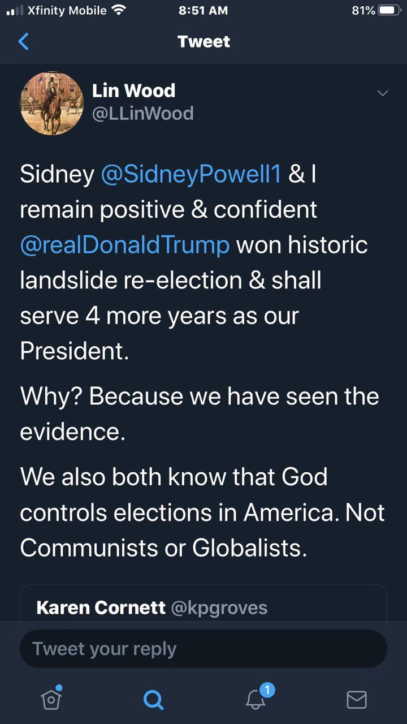

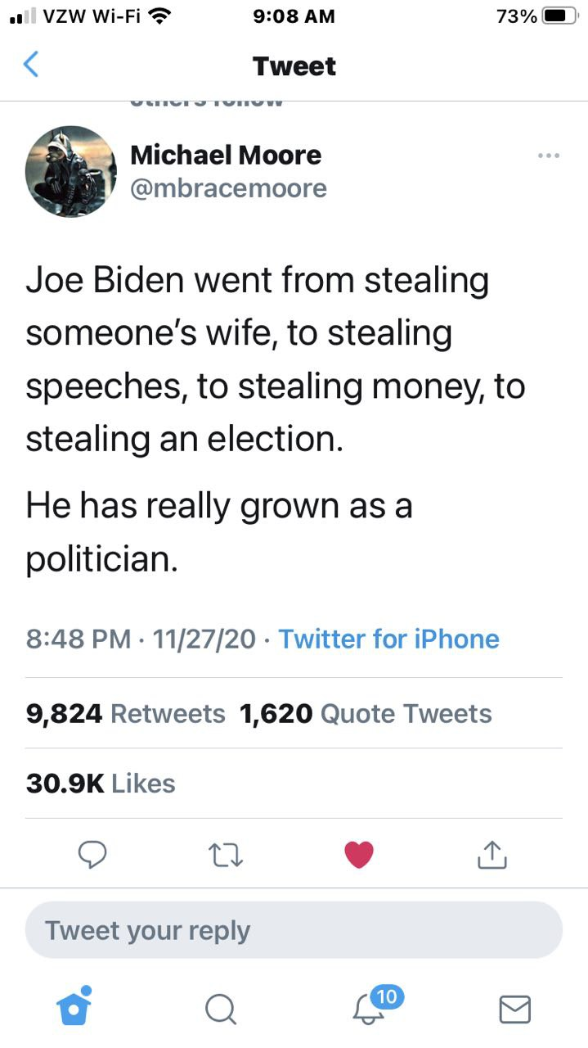
----------------------------------------------------------------------------------------------------------------------------------------

此地无银三百两 | 连浓眉大眼的司法部长巴尔也这么说？
Jerry Zhao 萧笙客 Today 12/6/2020
先是主流媒体众口一词说这次大选是有史以来最安全的大选，任何大选舞弊的指控都是捕风捉影。

再是劈柴哥的公司，Fakebook 和Twister 公司在网上提到大选舞弊的地方都要加上说明说拜登已经赢了大选，任何关于大选舞弊的提法都是有争议的。

最后是浓眉大眼的司法部长 Bill Bar “巴尔” 说他没发现有“可以改变大选结果”的舞弊行为。

这不是三人成虎吗？

最让人崩溃的是教会里有人在群里说川普律师团队的指控是莫须有！我怎么也无法把拜登和岳飞的形象放在一起，倒是想起了通俄和通乌门的闹剧中民主党的做法和秦桧的整岳飞的操作很像。

说起证据，不外乎两种。一种是间接证据（线索），一种是直接证据（实锤）。

比如说县上小张几次下班时，都发现自己太太从隔壁老王家里出来，神情慌张，衣冠不整。

老王理直气壮地说他只是给小张太太补习俄语。小张打听了一下，老王根本没学过俄语，而小张的太太对俄语从来没兴趣。

小张怀疑太太和老王有染，他有没有实锤证据？没有，因为没有抓奸在床。可小张有间接的证据（线索），所以他到派出所报案。

派出所的毕所长对小张的处境比较同情，可人家老王是县人大代表啊，毕所长抬头不见低头见。所以毕所长连走廊上的监控也懒得看，就放话给小区的街坊邻居说没有发现老王和小张老婆通奸的证据。

小张要上法院，他得有有实锤证据。他找私家侦探帮忙，可私家侦探还没来得及在老王家的卧室安装针孔摄像头，小张老婆就抢先一步在老王的陪同下到法院要求离婚，说和小张没感情了。

小张此时的心情大约等于川普在大选后的心情。

但这次大选舞弊案，川普团队不仅有间接证据（线索），更有很多实锤。

由于主流媒体包括狐狸台都选择 忽视任何川普律师团队的诉讼，而各州的法院都像躲瘟神一样躲着，川普的律师团队改变策略，开始带着证人向各州的议会做公开的听证会。

美国的选举是民主集中制，由选民投票，但538张选举人票是由各州的议会来定的。一般议会是会随从民意，但如果议会认为选票有诈，可以自行决定把选举人票给川普。

听证会一方面可以争取议会的支持，也可以造势对法院尤其是最高法院造成舆论上的压力。但我认为听证会最大的作用是让美国人民了解了第一手的选举舞弊证据。
Rudy Guiliani 和 Jenna Ellis 马不停蹄在关键的几个州穿梭，迄今为止已经在宾州（1场），亚利桑那州（1场），乔治亚州（1场），密西根州（2场）举行了听证会。

这是了解大选舞弊的最佳途径，强烈建议观看至少一场。油管上都有，我把链接附在文章的最后。

Rudy 和 Jenna 在密西根的议员前作听证会。一共5 个证人，前后5个小时。因为这次证人较少，每个证人都有充足的时间（不像上次听证会每个人只限3分钟）。油管上这个听证会已经有一百万万的观看量。

第一个证人叫Jessy Jacobs. 她是来自印度的移民在底特律政府某个部门作首席工程师。可以算上是人生赢家， 三个孩子都上医学院。这是她第一次公开作见证。可以看出来，她是挣扎很久才决定出来的。她是一个虔诚的天主教徒，见证过程中她一直握着天主教徒用的念珠。

她心情沉重地告诉大家这次民主党在选举的每个环节全方位作弊。

她和其他几十个人一起被民主党安排在邮寄选票的申请日期上作假，数量高达十几万张。

后面她在投票站工作时发现民主党的志愿者明目张旦诱导选民填拜登，来投票的人没有任何证件而且在签名与花名册上的签名差十万八千里的情况下也可以填选票。
邮寄选票必须在11月三号晚上八点前寄到否则作废，但她发现连四号收到的票都被改为收件日期为二号。

验票时每张桌子上要求有一个民主党和一个共和党监督，可她发现很多桌子上两个人都是民主党人。

她做完见证后，每个议员都可以提问。有个奇葩民主党议员CA Johnson, 对选举的事一个问题都不提，却盘问Jessy 的 名字，Jessy Jacobs 是不是她的真名，有没有中间名，分明是用来人肉的。议会主席赶快提醒不可威胁证人，Jessy 看起来身体很虚弱，但她这时分明把个人安危置之度外，不卑不亢地把她长长的印度中间名报了出来，没有一丝的惧怕！

第二个见证人叫Mellissa Carone, 她是有两个孩子的妈妈，在大名鼎鼎的Dominion 投票机公司的合同工。她在底特律TFC 中心计票站工作，看到计票员把同样的票扫很多遍。她听说有一个地方叫芝加哥仓库，假票都从那里出来。
11月4日凌晨川普领先时，她的主管说有数据丢失，所以要去芝加哥仓库，一去就是几个小时。

Mellissa 是个川粉，政治倾向比较明显，所以对她的见证不是很利。后来无数的左媒对她的人格进行疯狂攻击。

她的指控都是有名有姓，而且她是宣了誓的，也就是说如果和其他人对质证明她的指控有误，她会进监狱的。与其对她进行人格攻击，强大的左媒难道不该去找这些人对质，把她送入监狱吗？

接下来的证人是一男一女两个印度裔的年轻人。女的叫Hema, 男的叫Andrew. 他们看到共和党的监票员被歧视并被民主党人以各种借口赶出去。

他们看到邮寄选票有各种的猫腻，比如很多张连号（邮寄选票寄回来的时候不可能很多张连号，除非有人造假），信封上的号码和选票上的号码不同（应该是一个号码），很多的信封上签名一模一样。
很多邮寄选票上的日期有年份（2020），月份（11月），但日期却是一个空格。

Andrew的重磅证词是4日凌晨4点半时，民主党的主管Mr. Baxter 从后面的地下室拿出大量的选票。五点钟时前一班人下班后，后一半从5点推到6点，而且计票员绝大部分都是民主党人。
这个时候民主党的主管向大家宣告 “现在真正的民主开始了！”

这是四日凌晨最大两批邮寄选票计票结果。3:50AM 那一批计票结果，近六万张票，拜登占92%，6:31AM 那一批计票结果，近14万张票，拜登占96%！

拜登同学的支持率要赶上金正恩同学了。
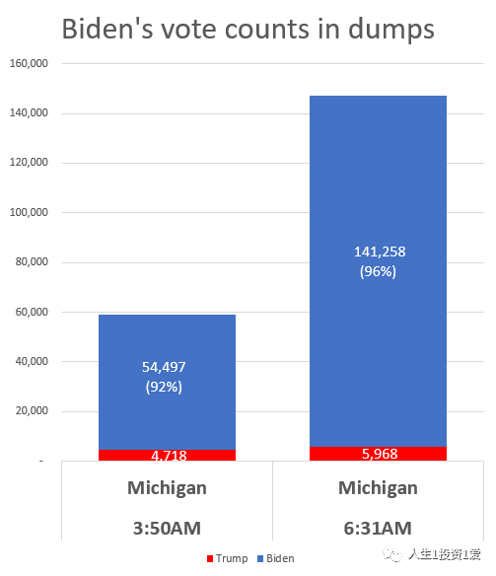
CA Johnson 同学又开始耍泼了，说证人没有宣誓。（密西根州议会听证会不要求证人宣誓）。Hema 毫不胆怯，说她可以马上宣誓！

接下来是一位专家证人叫Phil Walden。他的团队做了仔细的调查分析：
- 11月4日凌晨的计票数量超出了计票机的最大计票能力。
- Dominion 的计票机连接的电脑按规定是要离线，但这些电脑（Windows)的右下角图标显示这些电脑是在网上。另外U盘被用来在电脑间传输数据，而U盘极易被用来黑客。
- 有一个县把6000张的川普票算作拜登的，说是文书错误（Clerical Error), 但Phill 认为可能是算法上的猫腻，因为前后两次打印出来的计票单不一致。

另外一个是实锤。我们知道死人出现在选民登记表上不奇怪，因为很多县的选民登记表很多年没清理了。可死人投票就有问题了，大量死人投票肯定是选举欺诈了。
Phill 团队中的专家利用公开的讣告信息（报纸和社交媒体）发现密西根州投票的选民中有一万七千三百二十七人是死人！

最后一位作证的是大名鼎鼎的Monica Pallmer，她是Wayne County (底特律所在的县）选举委员会的主席。

11月20号她发现70% 的选区（Precincts) 现场选举的选票数量平衡不了（比如这个区有106张空白票，100张被选民正确填好，3张未用的空白票，3张填错的废票），当时她拒绝对此次选举签发合格证明。

后面她收到死亡威胁，而且民主党的律师告她，要挟她辞职。迫于压力，她为这次选举签发了合格证，但前提是要进行审计。当然，民主党压根就没想要审计。
我真心希望她能像那几个证人一样不在压力下屈服，我们的软弱常常是对手的破口！

最后回到老王和小张的纠纷上，你要是住在那县上，要不要参加老王和小张媳妇的婚礼？

佐治亚州听证会：https://www.youtube.com/watch?v=Ur4vl5UTN8g
密西根听证会:1：https://www.youtube.com/watch?v=eZXkAv7yKgw
密西根听证会:2：https://www.youtube.com/watch?v=ZPrV_QPTtrk
宾州听证会：https://www.youtube.com/watch?v=ohe2dQbNJwM
亚利桑那州听证会：https://www.youtube.com/watch?v=KXyOtzADUCU

---------------------------------------------------------------------------------------------------------------------------------------- Teachers in San Diego volunteer for 'white privilege' training where they are told they're racist and to accept the US is built on stolen land - then asked to commit to becoming 'anti-racist' activists
- San Diego Unified School District said training is voluntary for district teachers
- In the training, the teachers are asked to discuss how they would feel if they are called racist and asked to acknowledge that they meet on land stolen
- The teachers are also asked to commit to developing 'anti racist' practices
- The district said so far hundreds of teachers have attended the training session
By Dailymail.com Reporter
Published: 14:39 EST, 6 December 2020 | Updated: 10:22 EST, 7 December 2020

Hundreds of teachers in San Diego have attended a 'white privilege' training in which they were asked to commit to becoming 'antiracist' and acknowledge that they meet on stolen land taken from Indigenous peoples.
An article written by journalist Christopher F. Rufo, claimed the training is 'mandatory' for all teachers within the San Diego Unified School District.
Initially it was reported that the documents were leaked, but a spokesperson from the San Diego Unified School District told DailyMail.com that the book the session is based on is available on Amazon.
'Following the murder of George Floyd, we provided teachers with voluntary trainings from the Racial Healing Handbook. The contents were not secret,' a spokesperson for the district said.
According to the district, 'the training was not mandatory' and 'hundreds of teachers participated voluntarily'.
As part of the training, the teachers are to discuss how they would feel if they were told: 'You are racist.'
Teachers were also asked to discuss how they'd feel if they were told: 'You are upholding racist ideas, structures, and policies.'
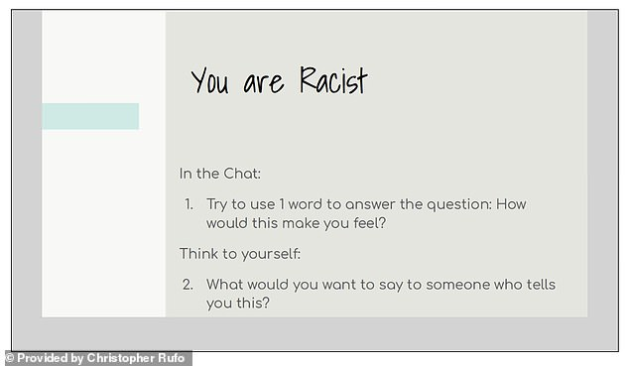
+8
Hundreds of teachers in San Diego have attended a 'white privilege' training in which they were asked to commit to becoming 'antiracist' and acknowledge that they meet on stolen land taken from Indigenous peoples
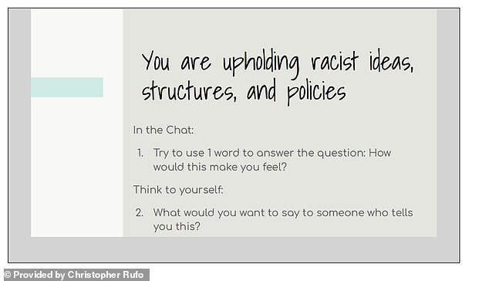
+8
As part of the training, the teachers discussed how they would feel if they were told: 'You are racist'
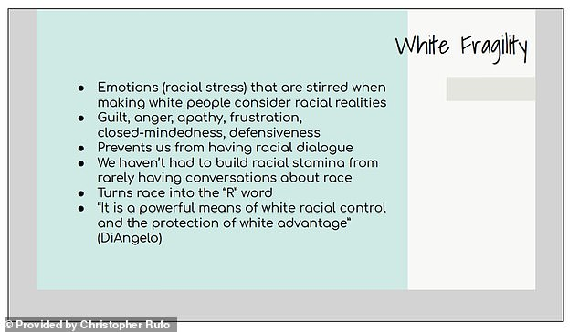
+8
The documents show the outline of the discussion and the talking points, including 'how to become antiracist' and defining 'white fragility'
'We are a majority minority district with a majority white teacher workforce. The ability to hold honest conversations about race with grace is important, which is why we offered the training and why so many teachers elected to enroll,' the spokesperson told DailyMail.com.
'Our students benefit from being able to talk about race and other difficult issues, regardless of their background. Most of all, we believe every open and sincere conversation about race -- no matter how it begins -- provides an opportunity to learn from one another, for hearts to open, and for minds to grow,' the statement continued.
According to the spokesperson, the district also created a tool 'to help families talk about race and to help students who have been hurt by racism'
The documents show the outline of the discussion and the talking points, including 'how to become antiracist' and defining 'white fragility'.
In addition to the aforementioned, the seminar also included a section on 'land acknowledgement'.

----------------------------------------------------------------------------------------------------------------------------------------川普胜选的宪法途径已经明确
Original 方位 方位观察 2 days ago 12-9-2020

美国大选争端经过了一个多月的发酵之后，12月8日正式进入法律诉讼的决战阶段。

先是，川普的律师团队和以独立身份提起诉讼的鲍威尔律师一边搜集证据、一边在美国六个摇摆州对民主党大选舞弊发起诉讼，先后汇集了一万多名证人证词，但在实际诉讼中却屡遭地方法院的拒绝受理或判决败诉。

就在整个世界几乎都以为川普在这次大选中已经大势已去，拜登将顺利入主白宫的时候，形势突然发生了惊人的逆转——

当地时间12月7日，川普总统和彭斯副总统作为原告，起诉被告拜登和贺锦丽等人。川普和彭斯都签署了在威斯康星州密尓沃基巡回法院提起的诉讼，要求法官推翻该州密尔沃基县和戴恩县的选举结果！

当地时间12月8日，美国国会“（总统）就职典礼委员会”以3:3的票数否决了众议员多数党（民主党）领袖Steny Hoyer提出了一项旨在确认拜登为当选总统并启动就职准备典礼的动议。由于美国众议院是宪法规定最终确认当选总统的权威机构，因此，这次“确认拜登为当选总统并启动就职准备典礼的动议”被否决，就意味着到目前为止，这次美国大选还未确认两个总统竞选人当中的任何一人成为胜选者。

同日，美国德克萨斯州总检察长办公室官网发布的消息，德克萨斯州检察长肯·帕克斯顿今天直接在美国最高法院对乔治亚州、密歇根州、宾夕法尼亚州和威斯康星州提起四州选举违宪诉讼。

诉讼书指出，这四个州利用新冠疫情大流行，无视联邦和州选举法律，非法修改大选邮寄选票截止日期，从而歪曲了2020年大选的结果。

起诉书强调：“信任我们选举程序的完整性是神圣不可侵犯的，它将我们的公民和联邦的各州联系在一起。乔治亚州、密歇根州、宾夕法尼亚州和威斯康星州摧毁了这种信任，并损害了2020年选举的安全性和完整性。它们（四个州）违反了通过正式选举所产生的立法机构制定的各项法令，从而违反了宪法章程。这些州无视州和联邦法律，不仅损害了所在州公民投票的完整性，而且还损害了德克萨斯州以及举行合法选举的每一个州的完整性。”

美国最高法院官网显示，美国最高法院已接受德州诉四州大选违宪案，并要求被告必须在48小时内回复。

另外，再有10个州加入支持德州的诉讼行列（最新消息：已增加至17个州），认为4大摇摆州违反了宪法的"平等保护条款"。这10个州分别是密苏里州、肯塔基州、路易斯安那州、密西西比州、南卡罗来纳州、南达科他州、阿拉巴马州、阿肯色州、印地安那州和佛罗里达州都。

德州总检察长向联邦最高法院提出这项诉讼的关键点在于：诉讼的发起方无须向最高法院提供被诉的这四个州大选舞弊的证据，被诉的四个州的行政当局由于未能通过州议会决议、直接发布行政命令“修改大选邮寄选票截止日期”，已经构成对美国宪法的侵害，属于非法行为，从而对德州（也包括美国其他州）的宪法权利造成侵害。

宪法的“选举人条款”规定，州议会（立法机构）是制定有关选举人任命和选举规则的唯一合法机构，行政官员未经州议会批准、擅自修改选举规则，即构成对宪法的违背。

川普阵营的大招原来藏在这里！

最高法院受理此案，并不是要判定川普和拜登谁能赢得选举，而只是简单地判定被诉的这四个州的行政当局未经议会批准修改选举规则是否构成违宪。

现在，最高法院要求被诉的四个州的行政当局在48小时之内证明修改选举规则的合法性。如果四个州的行政当局无法向最高法院提供修改选举规则的法律依据，那么四个州的行政当局则必输无疑。这也就意味着这四个州的总统大选投票均属非法，投票结果无效。

目前，在这四个州阶段性的计票结果中，拜登是领先者。如果他能领先到底，则可获得这四个州的63张选举人票，从而以306张选举人票赢得大选。如果最高法院判定这四个州的行政当局修改选举规则属于非法，那么这63张选举人票就会暂时被搁置，直到依据宪法由立法机构做出最后的裁夺。其路径可能有以下两种。

1、 最高法院判定由这四个州的州议会决定各州的选举人；
2、 最高法院援引美国宪法第十二修正案，在两位总统候选人都未能得到法定当选的270张选举人票的情形下，判定由联邦众议院按照每州一票的选举规则直接选出第46届美国总统。

如果出现第一种判决结果，由于这四个州的州议会均由共和党议员占多数，这四个州共63张选举人票将归属共和党籍的总统候选人川普，川普也将因此赢得295张选举人票，最终胜选连任。

如果出现第二种判决结果，由于共和党议员在众议院占有26个州的多数席位，民主党议员目前占有23个州的多数席位，那么川普将以26:23赢得选举，从而胜选连任。

当然，最高法院还有第三种判决结果的可能性，即判决诉讼方——德州总检察长败诉。不过这种可能性要建立在被诉的这四个州的行政机构能够证明他们未经立法机构批准修改选举规则并不违法美国宪法。从现在显露出来的事实看，这种可能性是几乎不存在的。

到目前为止，美国大选的争端都在法律和宪法的层面上进行，宪法依然是美国选举制度的最后也是最高的保障。

按照目前的形势发展，唐纳德.川普将在美国宪法的护卫下最终当选为第46届美国总统，开启新的四年的连任之旅。

推荐阅读：
新型国家主权之一：金融主权；国家新型主权之二：货币主权；国家新型主权之三：市场主权；给胡锡进讲点军事课（1）；母亲与我；当今世界与春秋战国—静夜读史之二；油腻金的后台是谁；生命的告别期；我的起死回生之路；飞在天上的牛；闲话张召忠； 秋日感恩;中美之间对决的烈度将远超“冷战”/美国会不会制裁清华、北大？/千年契合 ——读老杜《秋兴八首》之四/毛泽东邓小平留下的四大政治遗产/一个闹着退群的人，他凭什么牵动世界？/第二次美国大选辩论谁赢了？/美国大选与世界格局/梁漱溟的风骨与悲凉/美国的新招数/上帝一直都在，祂在看着人间/“临危颂安”的害国学者/突发：老拜登被乌克兰法庭列为刑事案件嫌疑人/看，这头老狮王！/近距离观察美国大选，收获颇丰/硬汉川普，英雄归来/粗俗，也是民主政治的典型特征之一/彭佩奥突访台湾可能会成为未来两个月的大概率事件/川普的新职业/再谈美国大选——民主政治的特点就是生生不息/重磅——美军在西太平洋的新动作/美国真的大乱了吗？/国际重要消息汇总，个个劲爆/每一项科学创新的背后，都有一个自由飞扬的灵魂/美国的真面目——超级稳定/“穷逼”的加拿大，疫情期间突然有钱了！/这是往死里爱呀！/伊朗首席核专家被袭杀真相/
----------------------------------------------------------------------------------------------------------------------------------------
-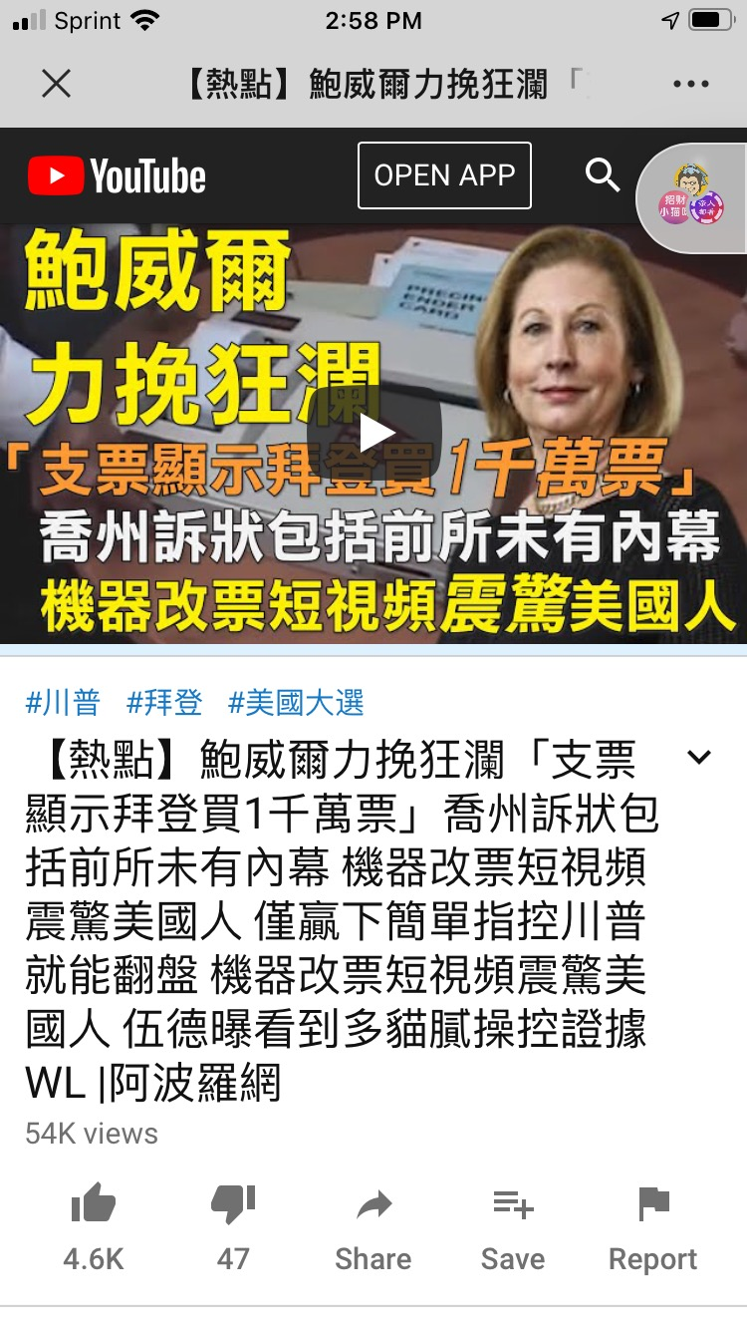
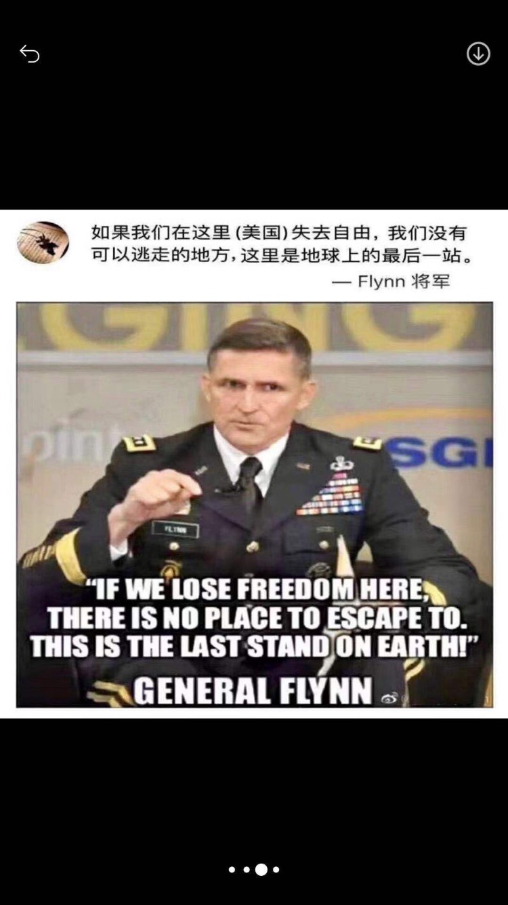
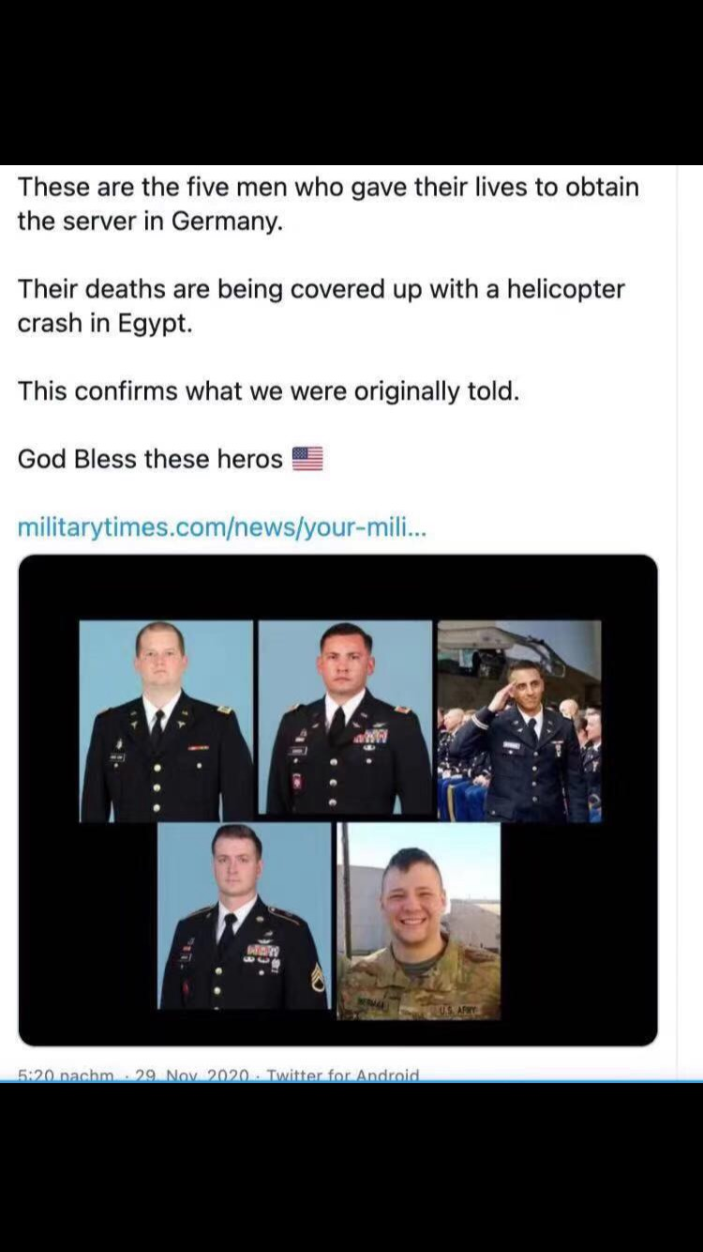
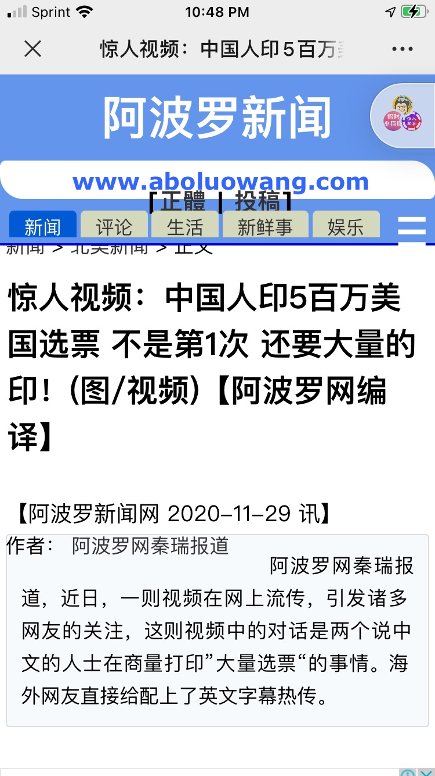
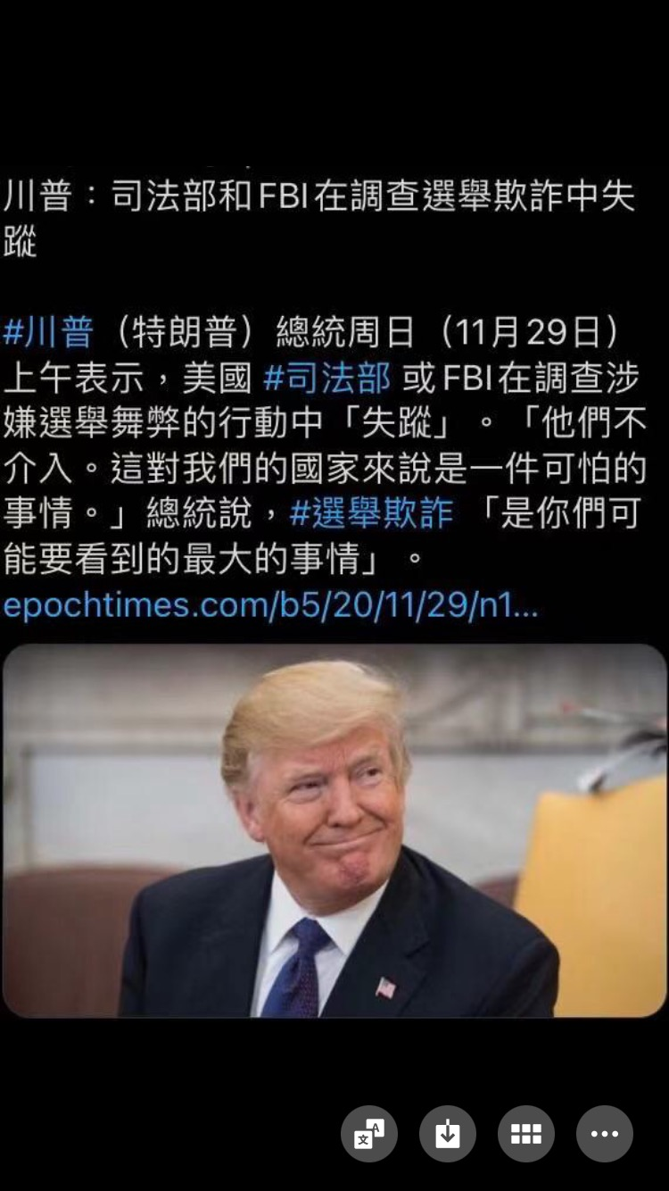
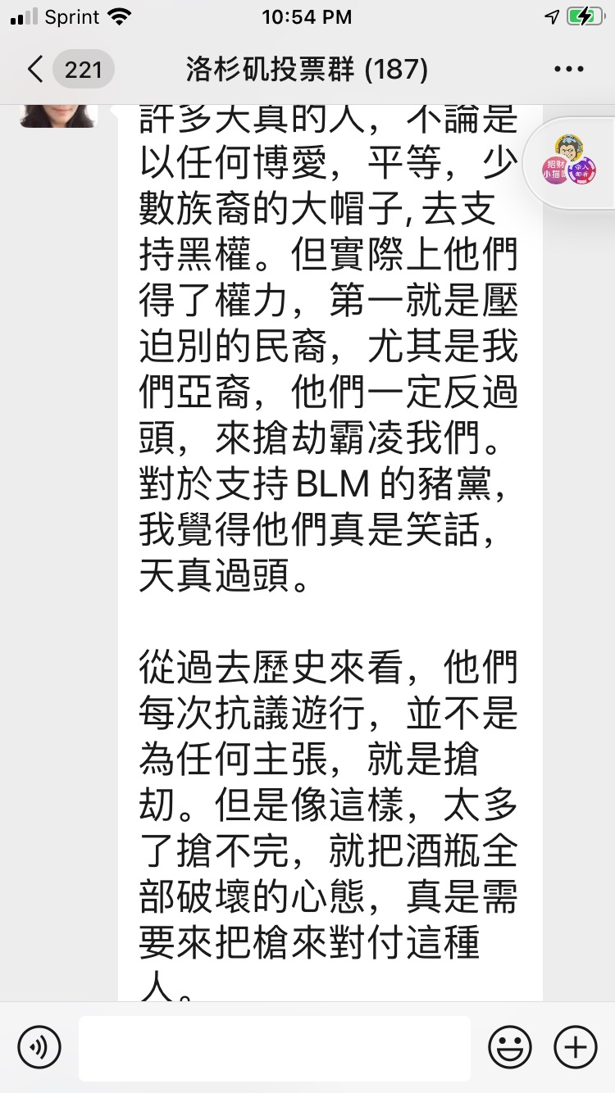
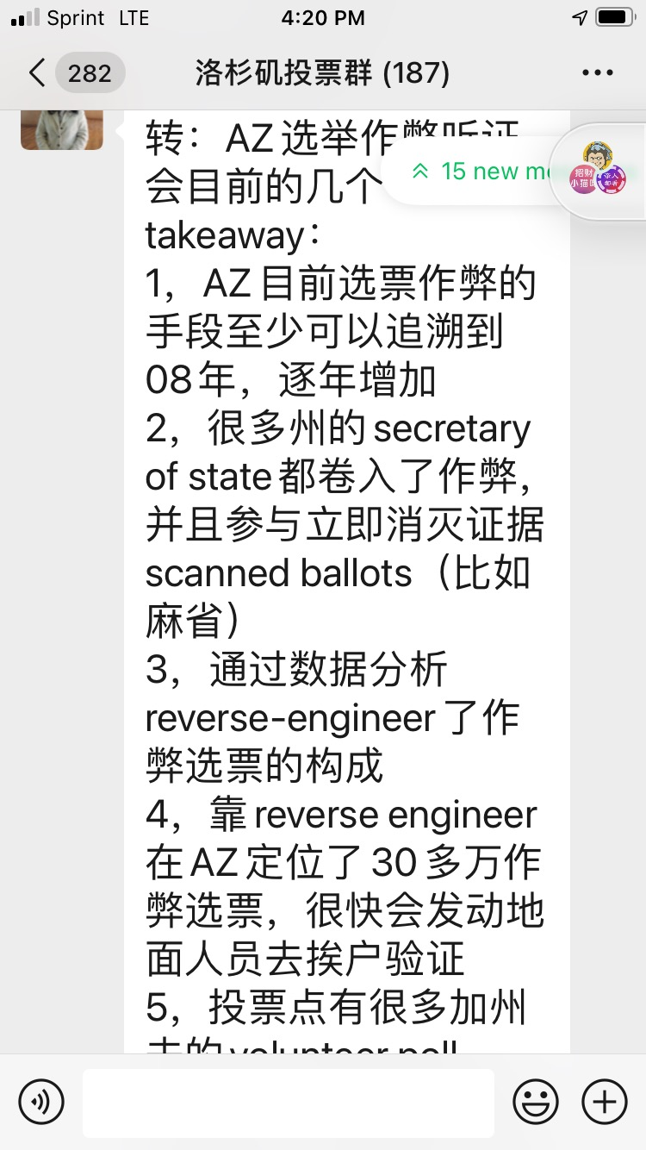
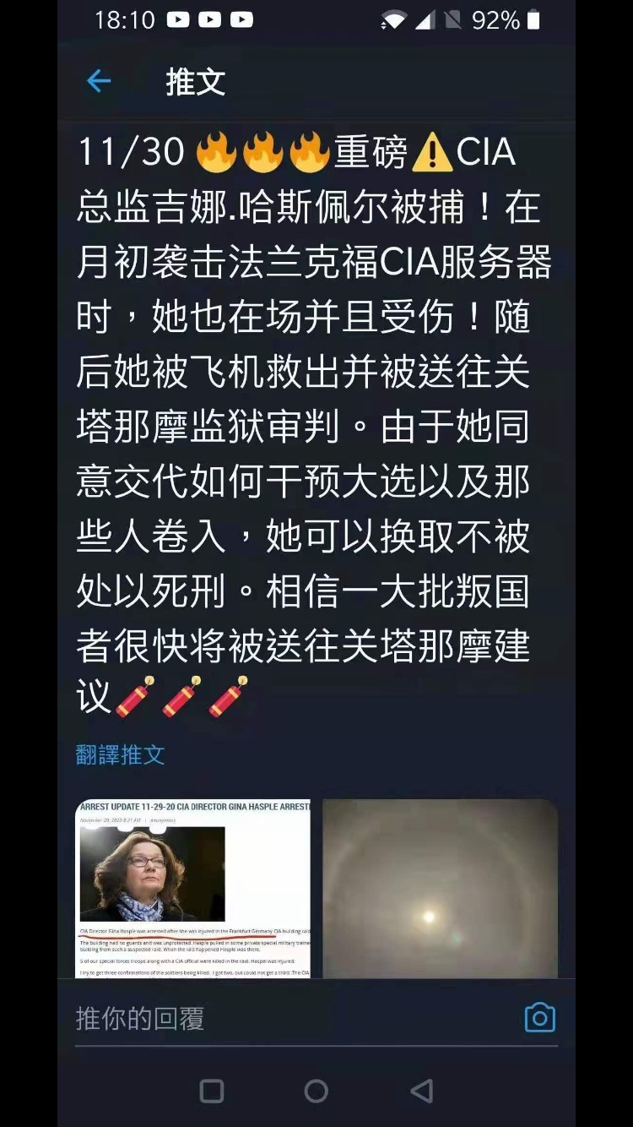
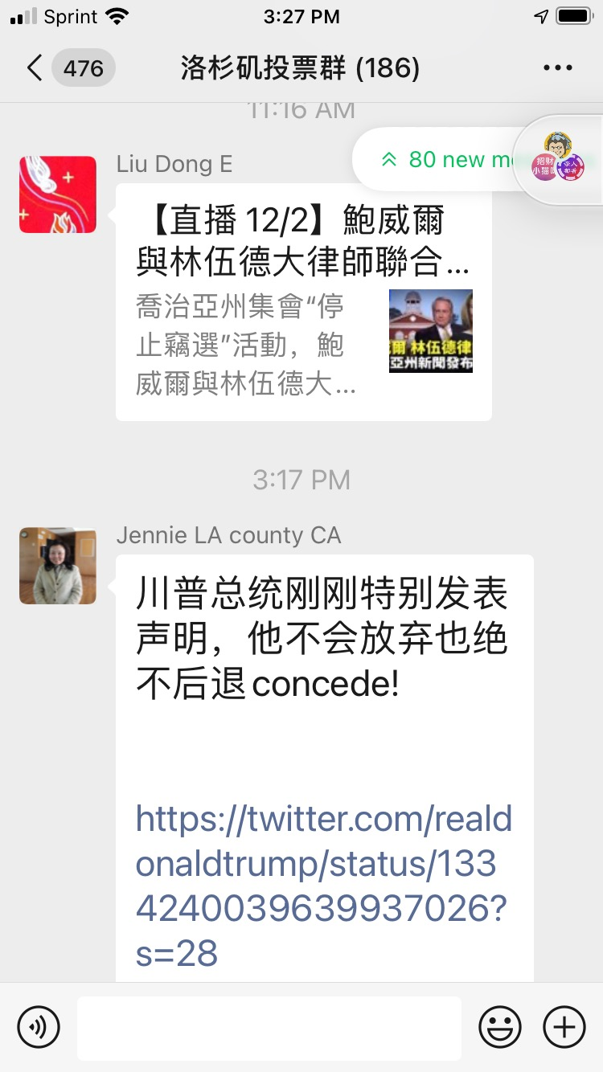
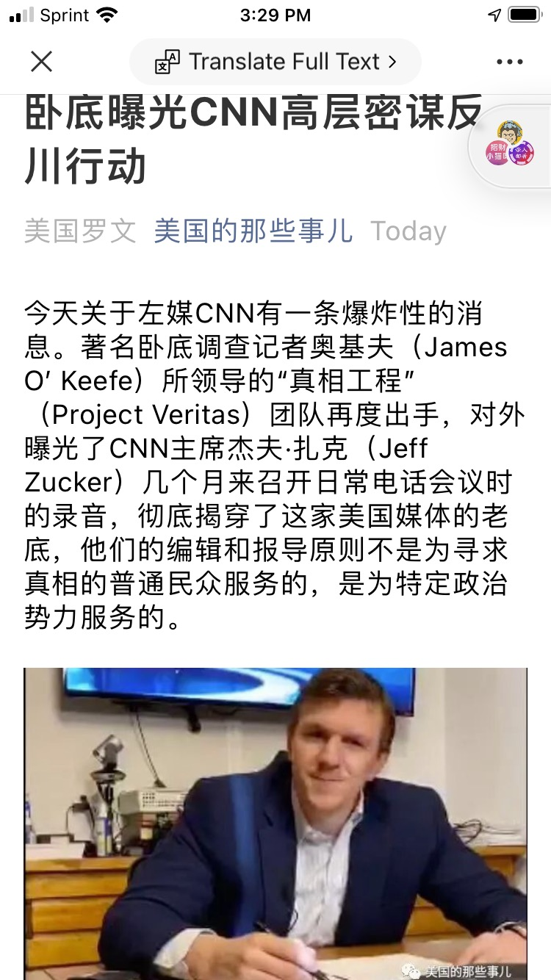
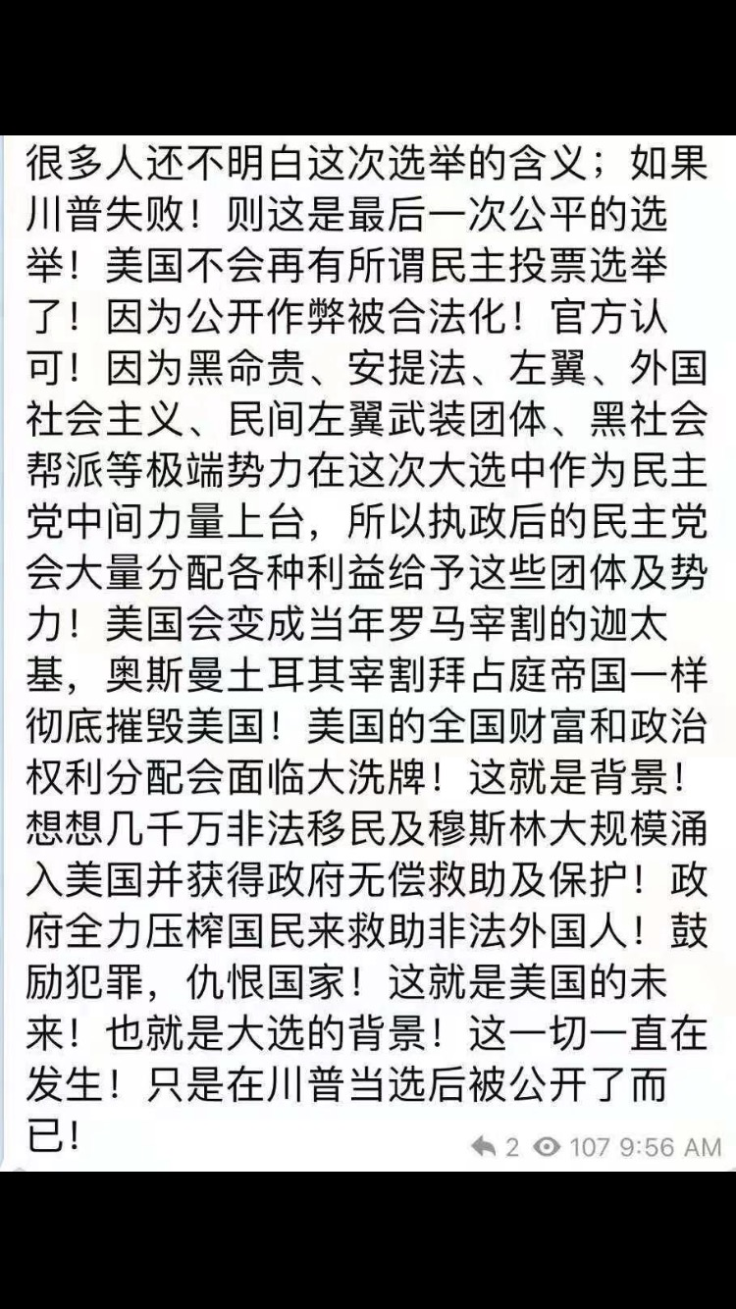
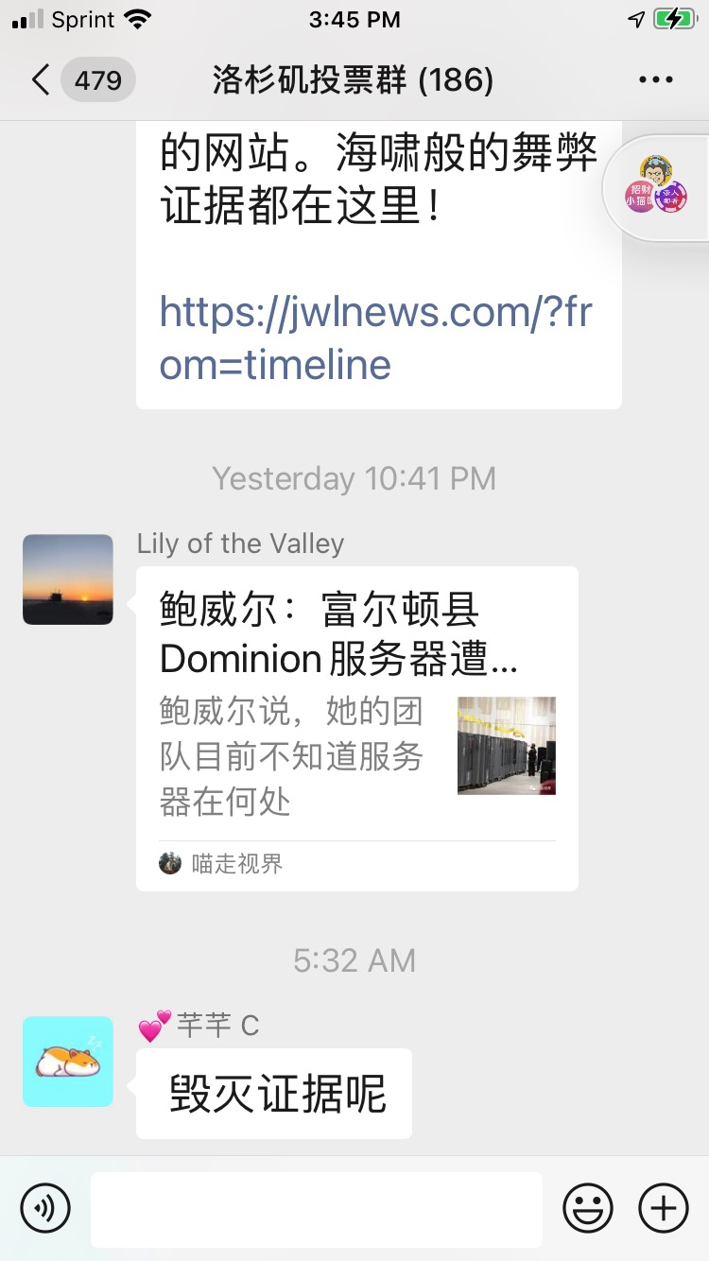
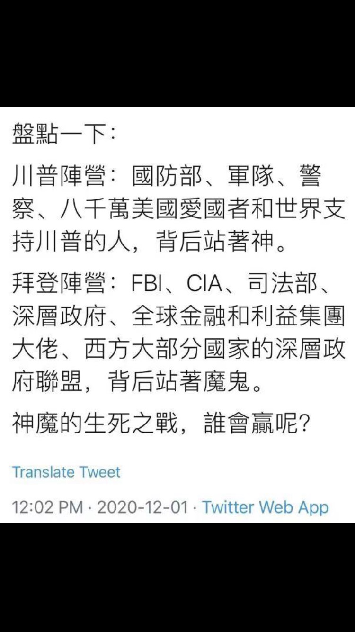
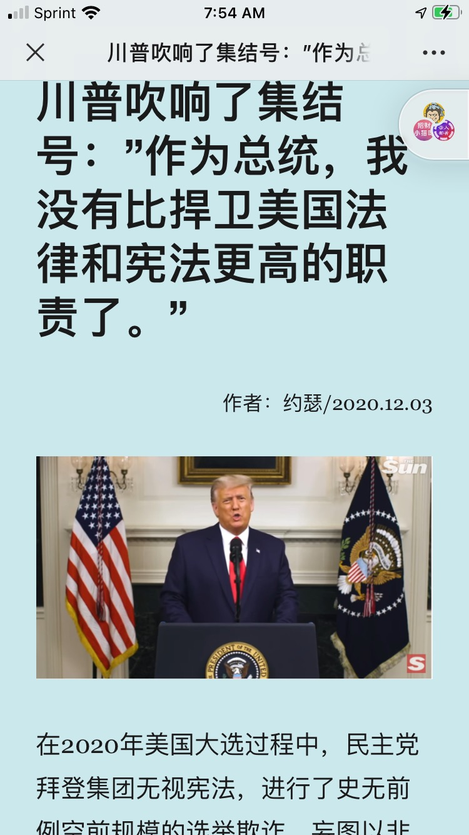
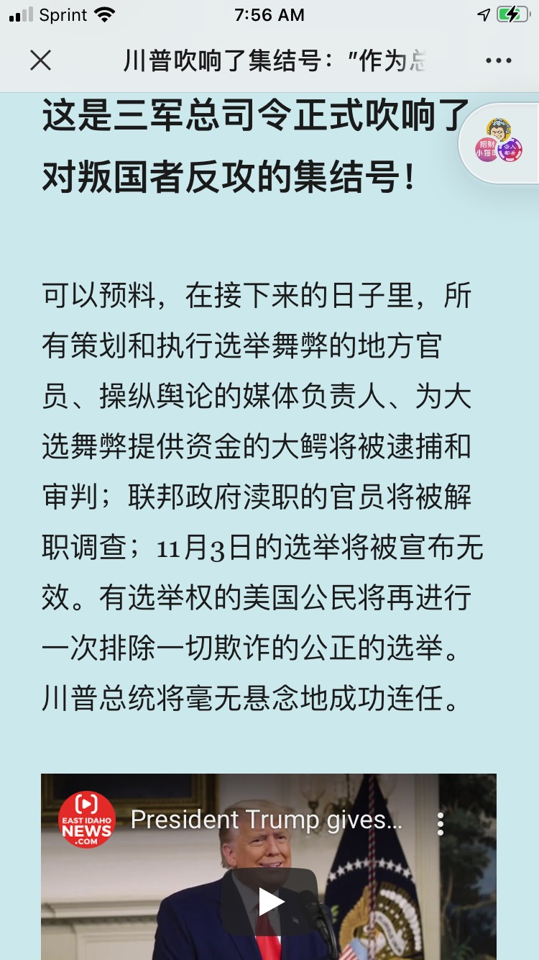
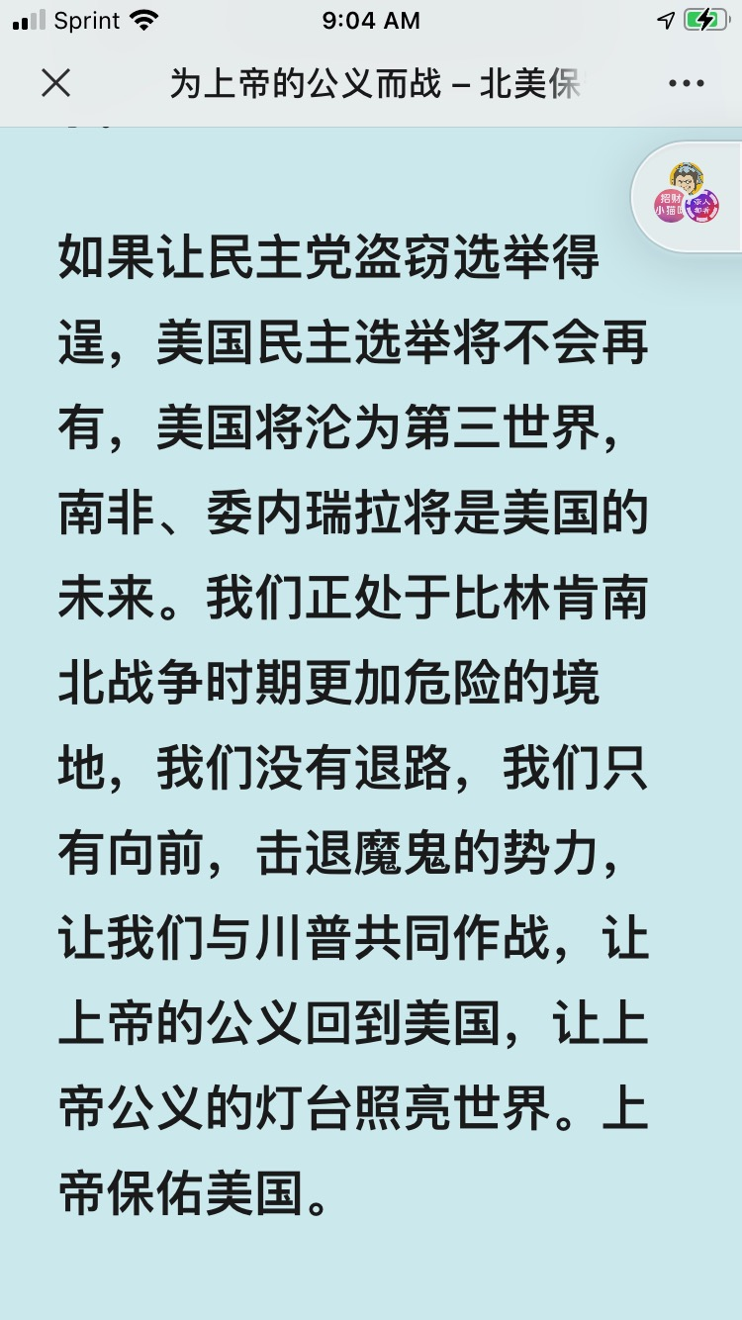
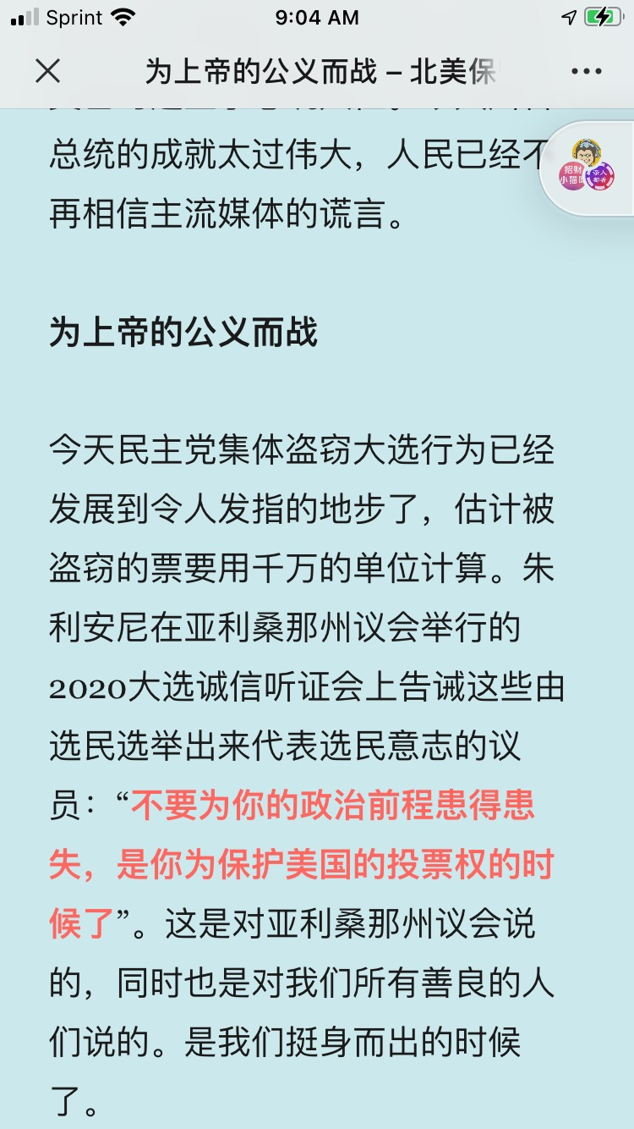
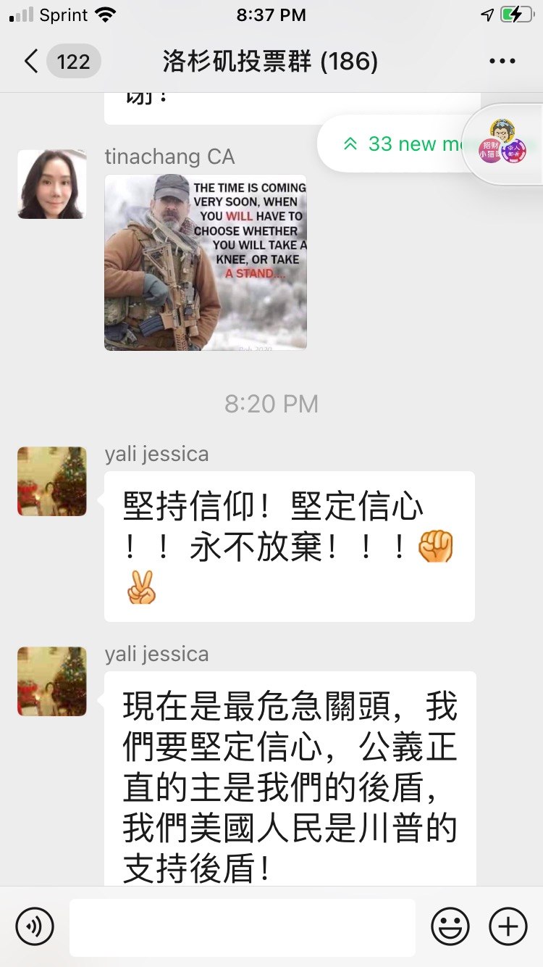
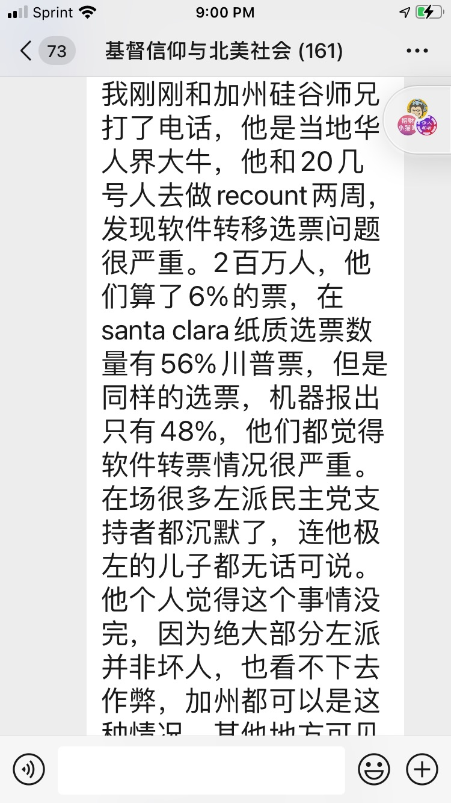
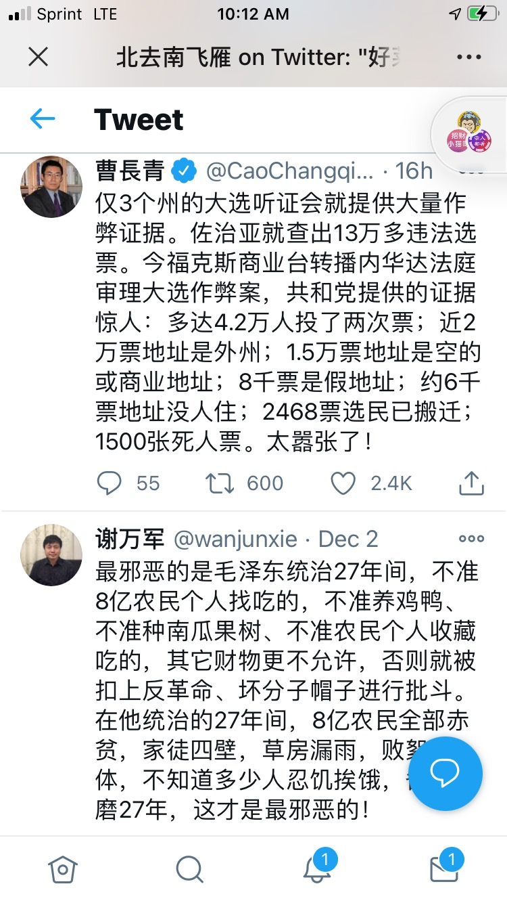
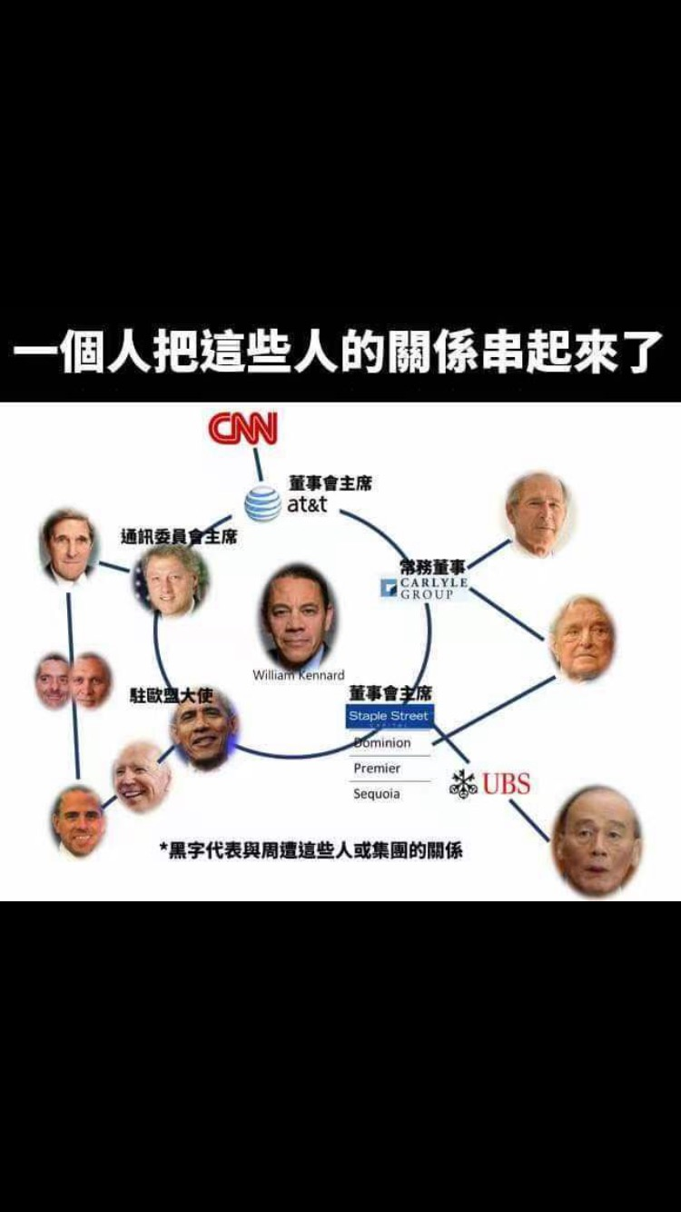
-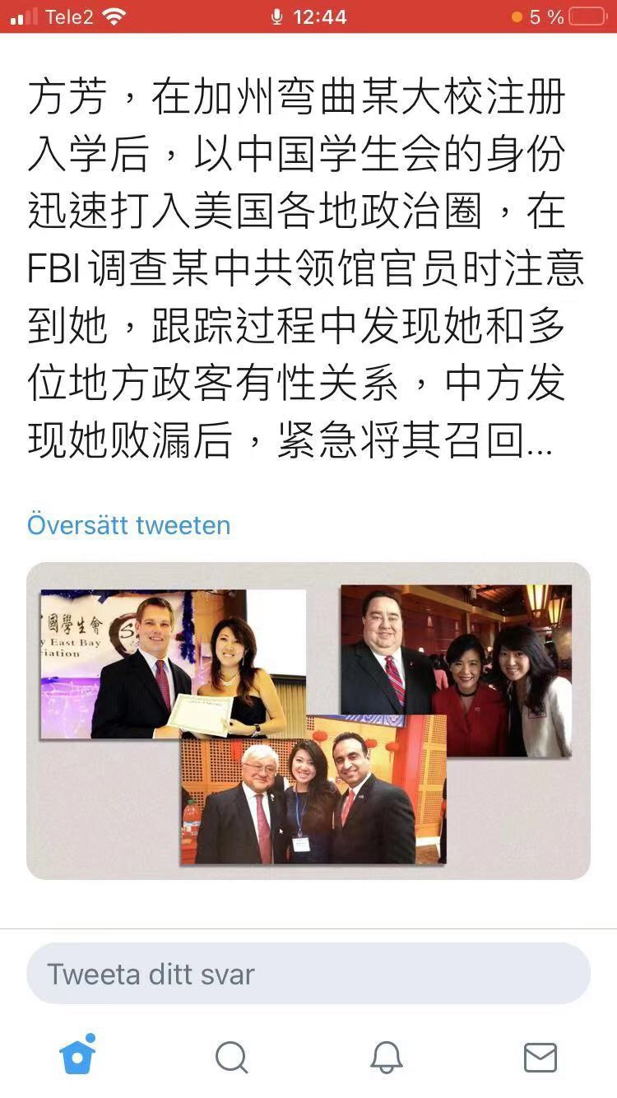
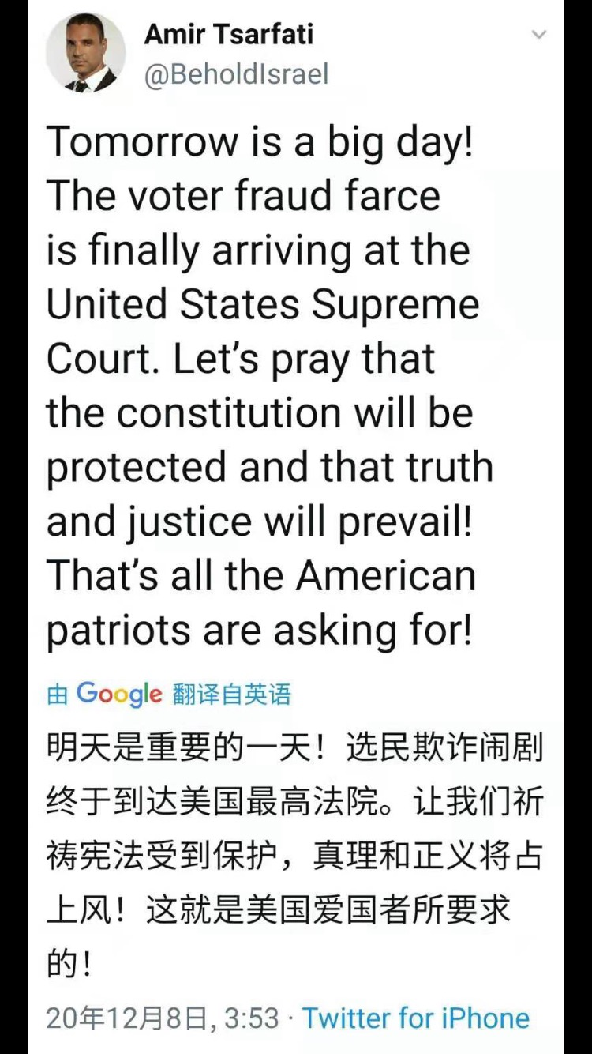
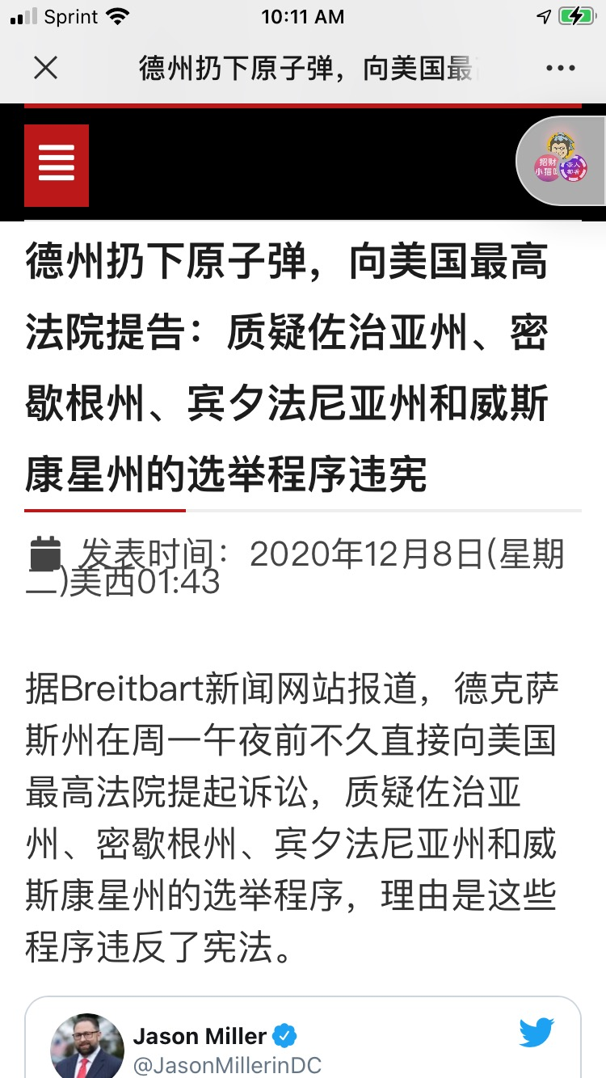
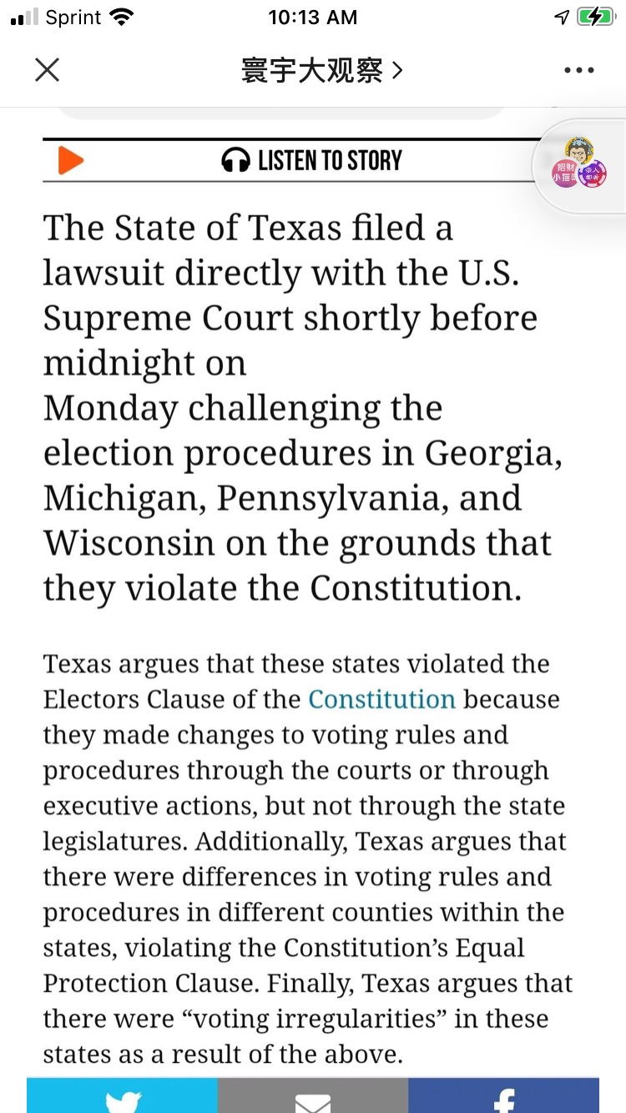
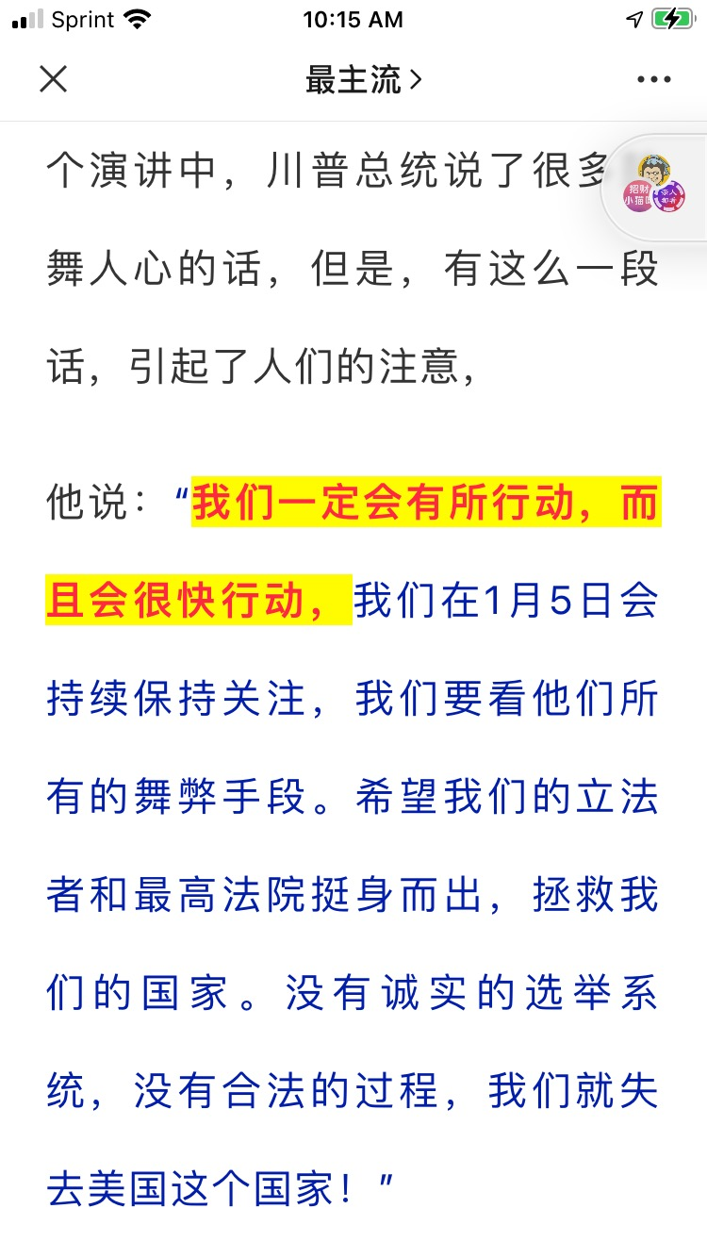
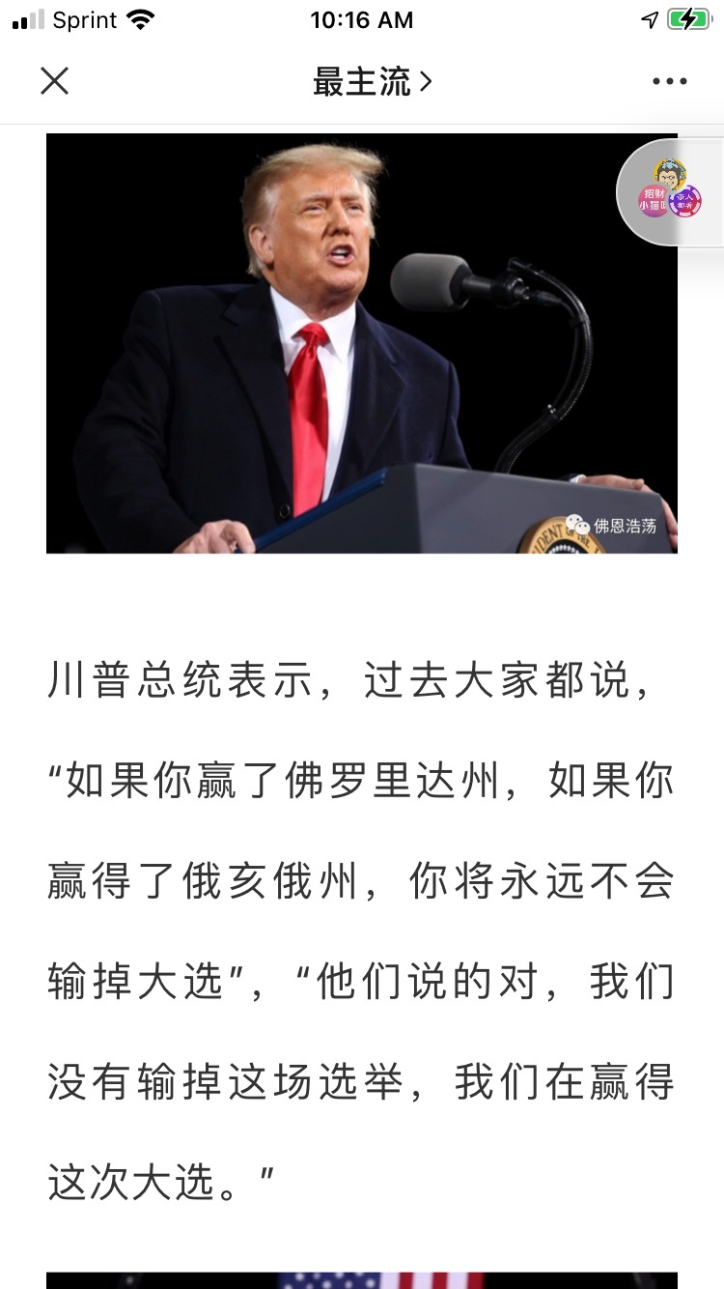

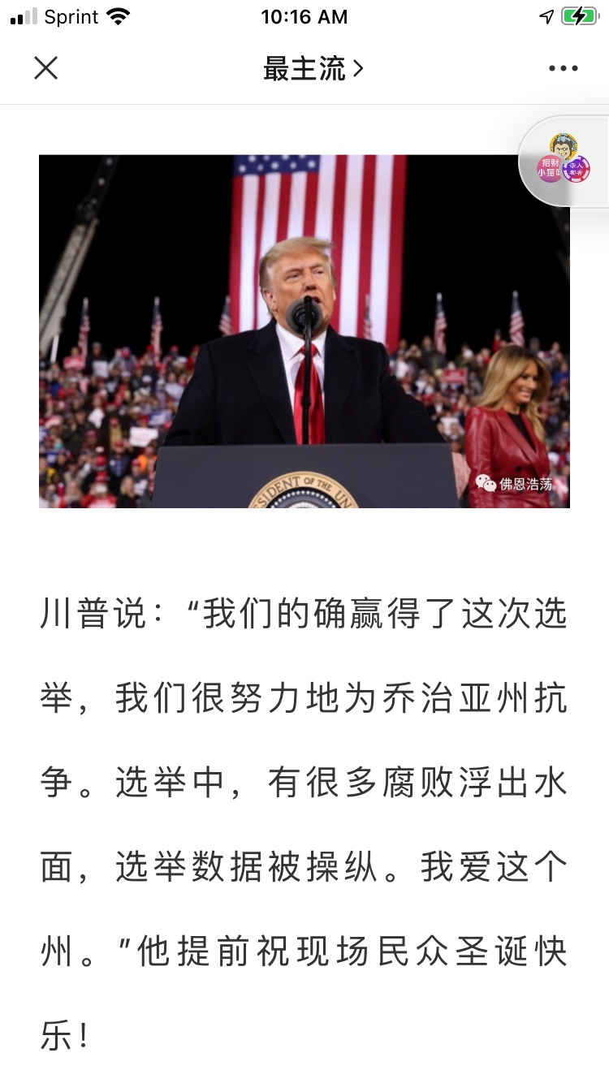
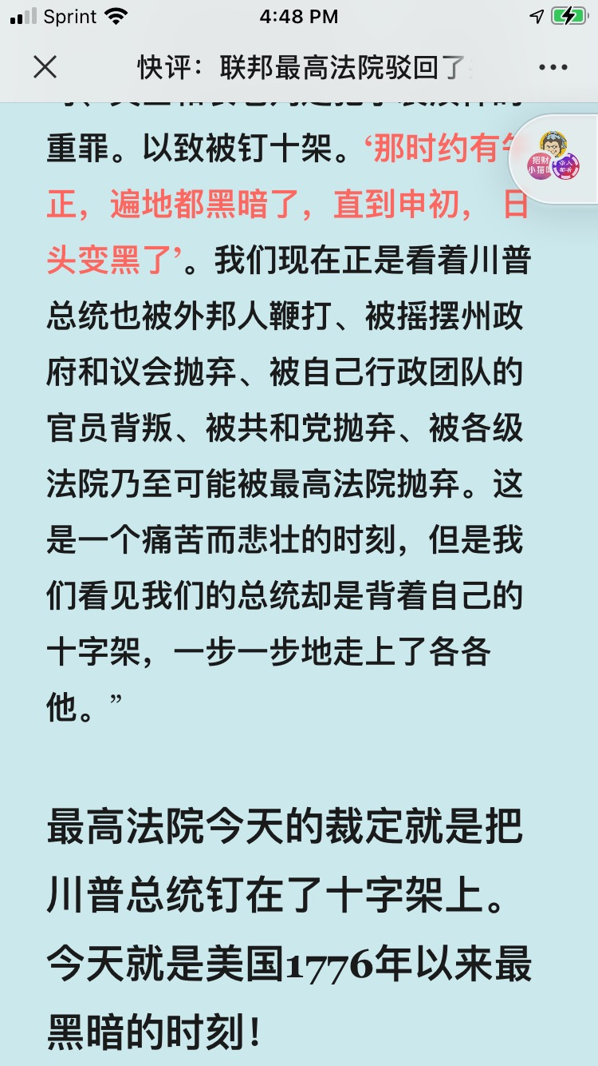
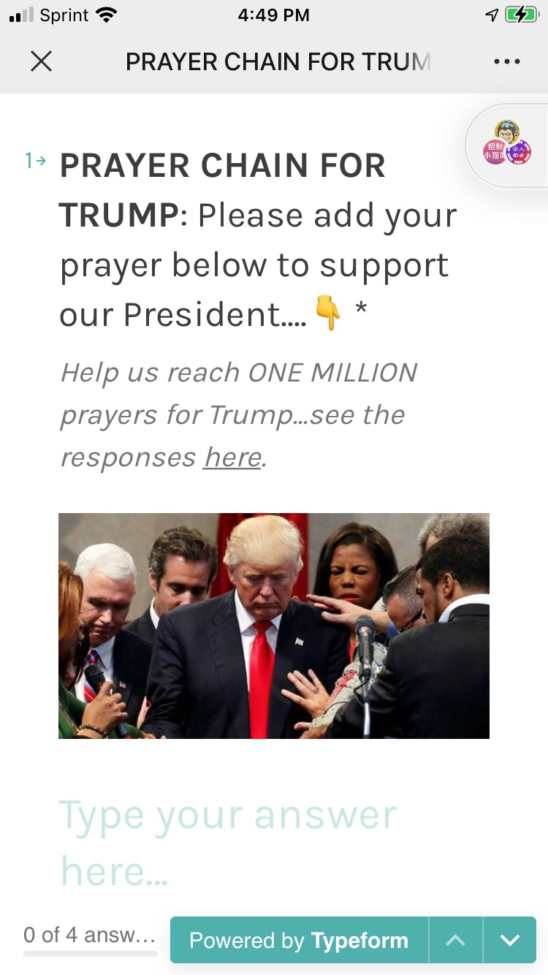
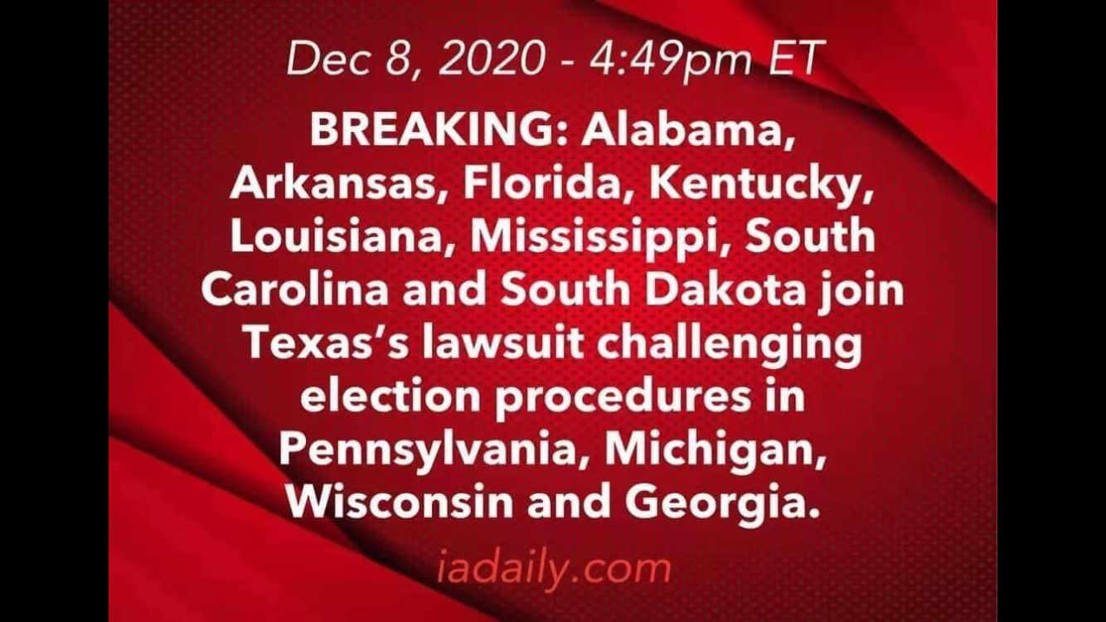
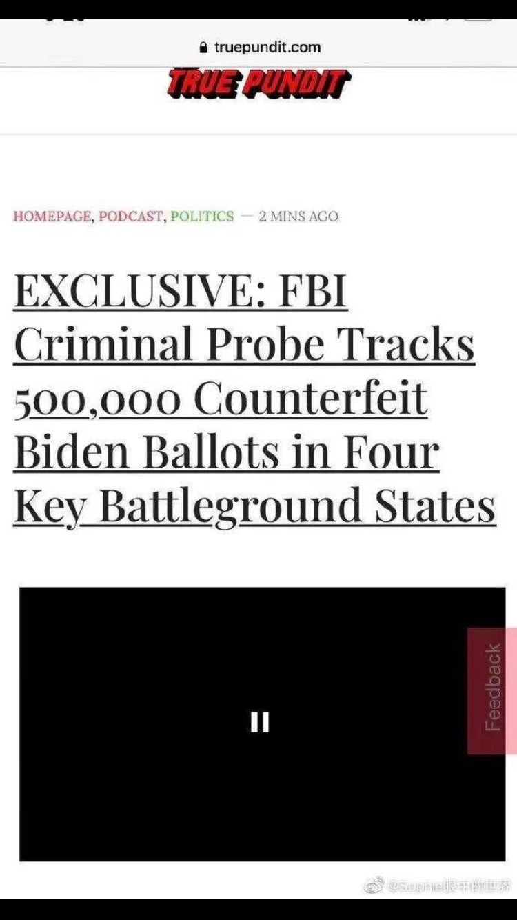
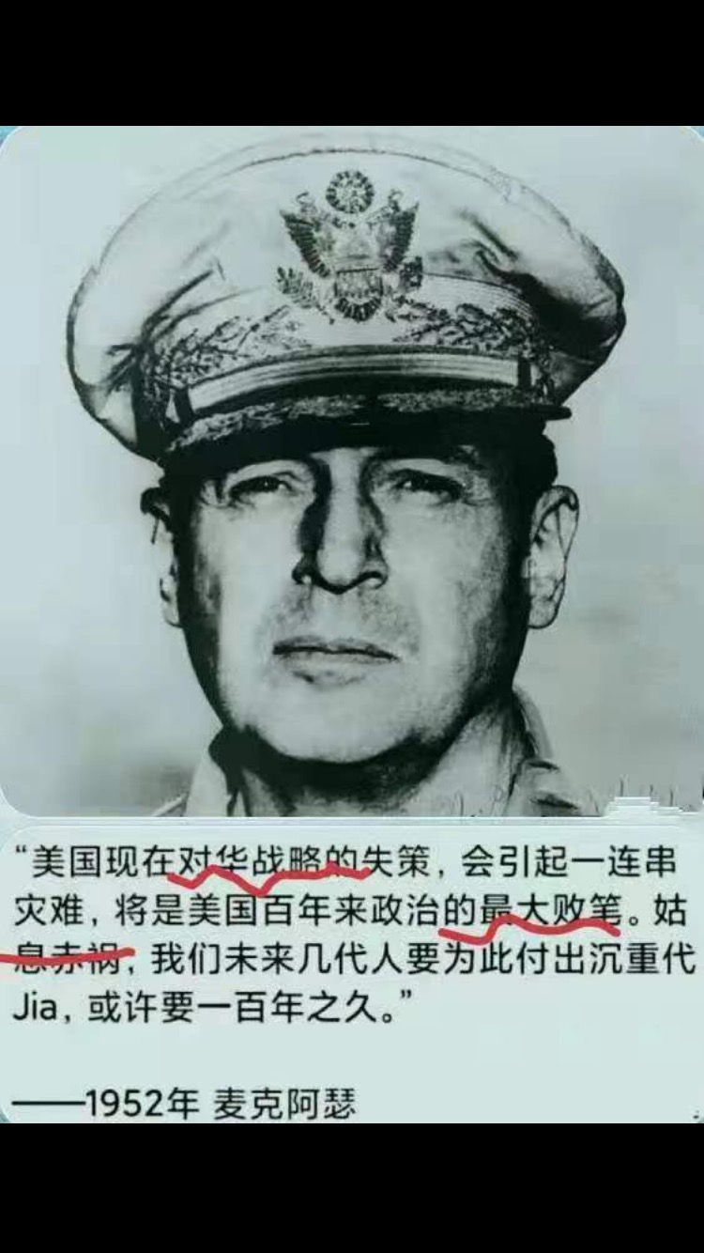
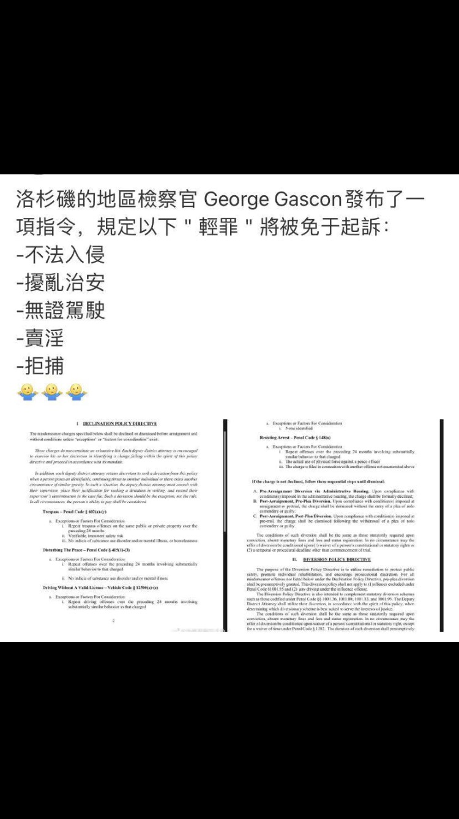
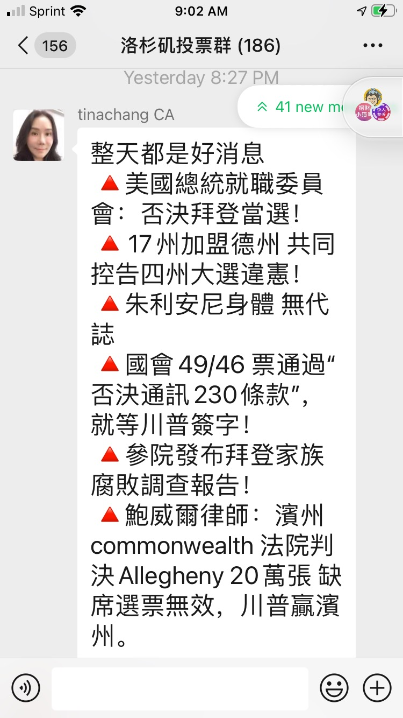
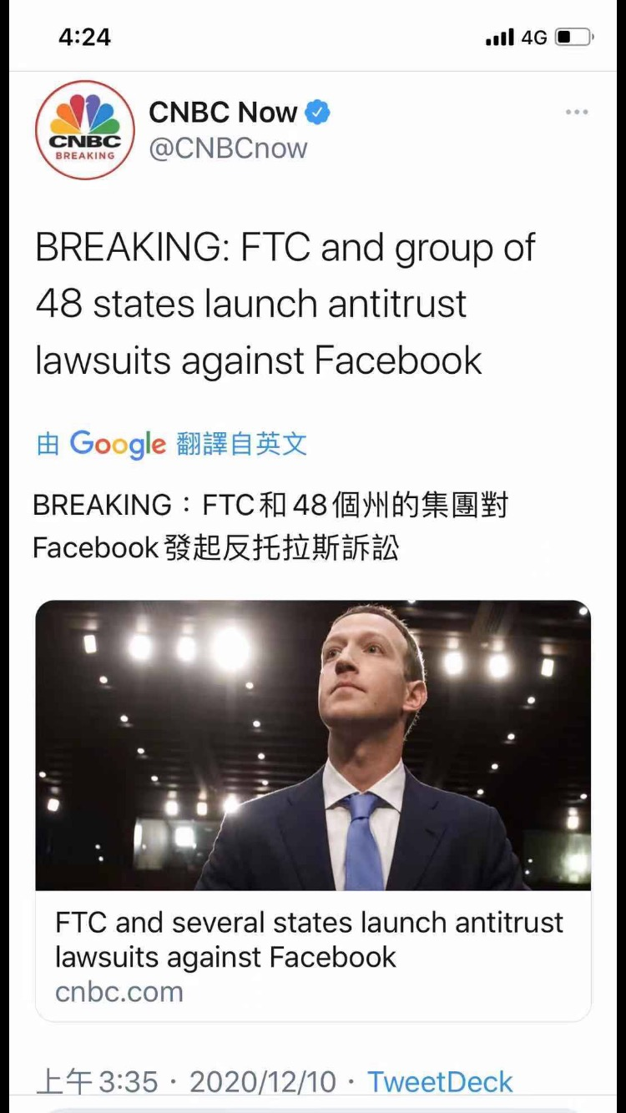
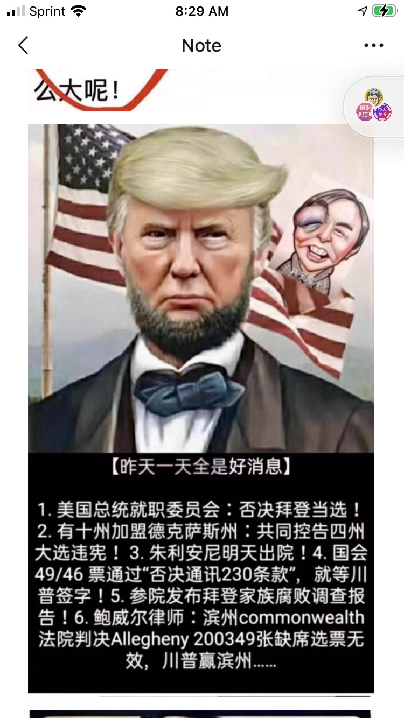
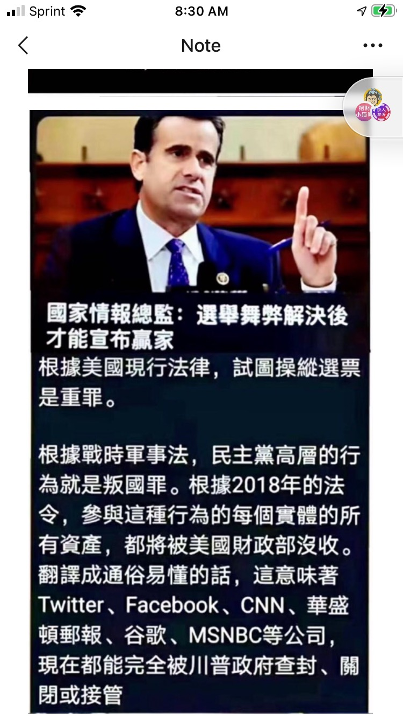
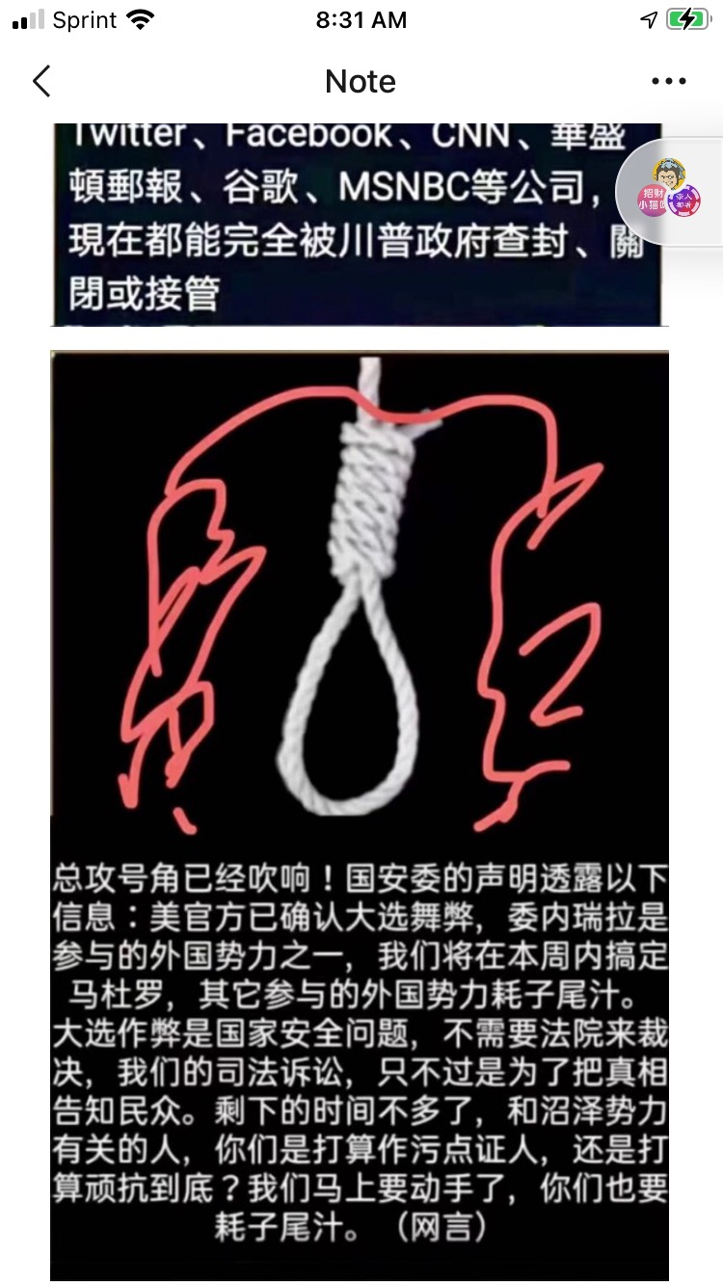
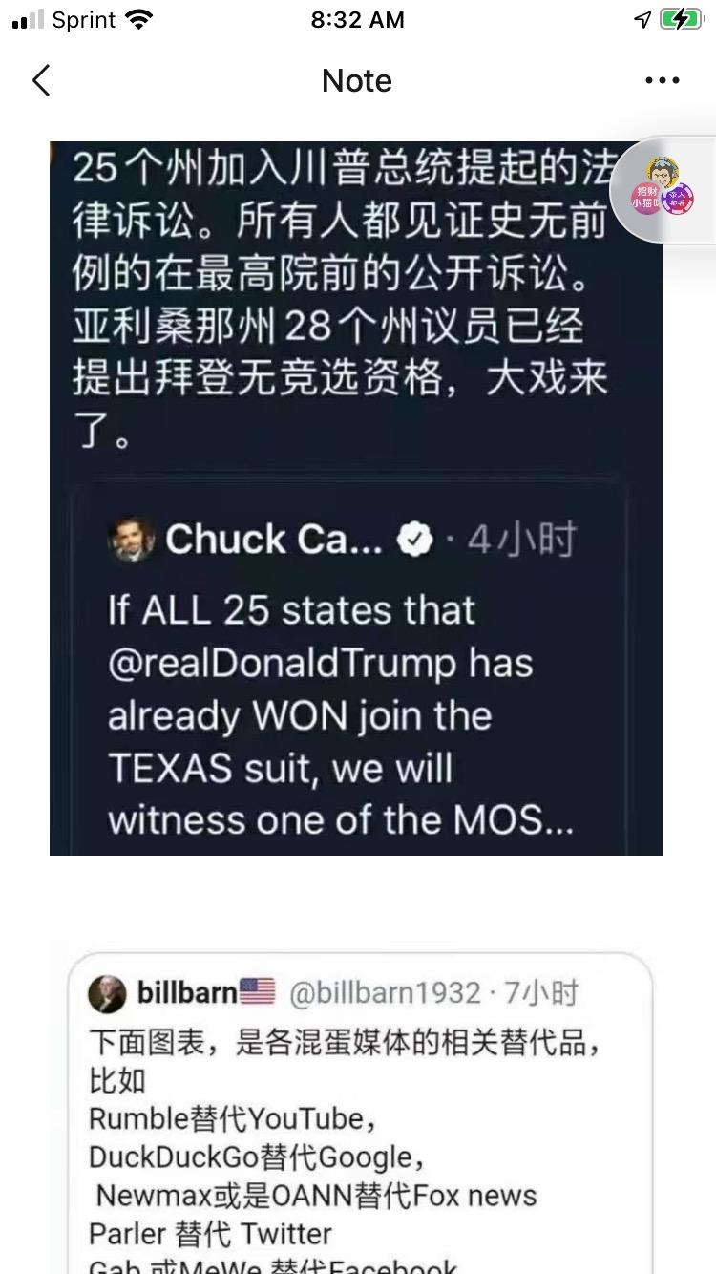
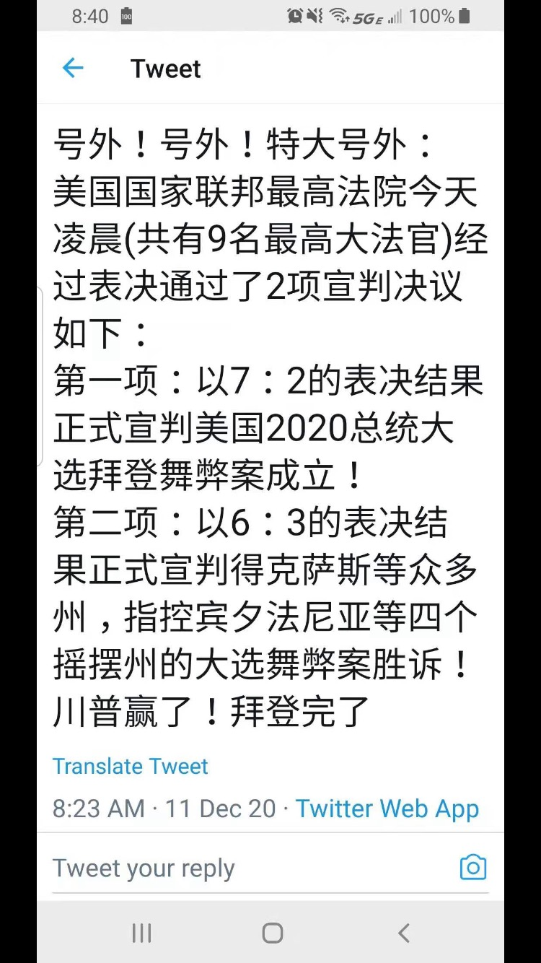
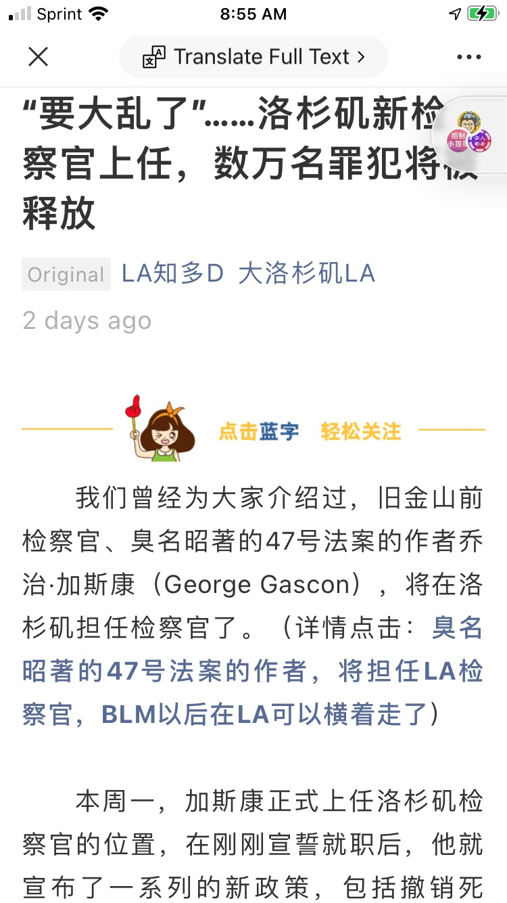
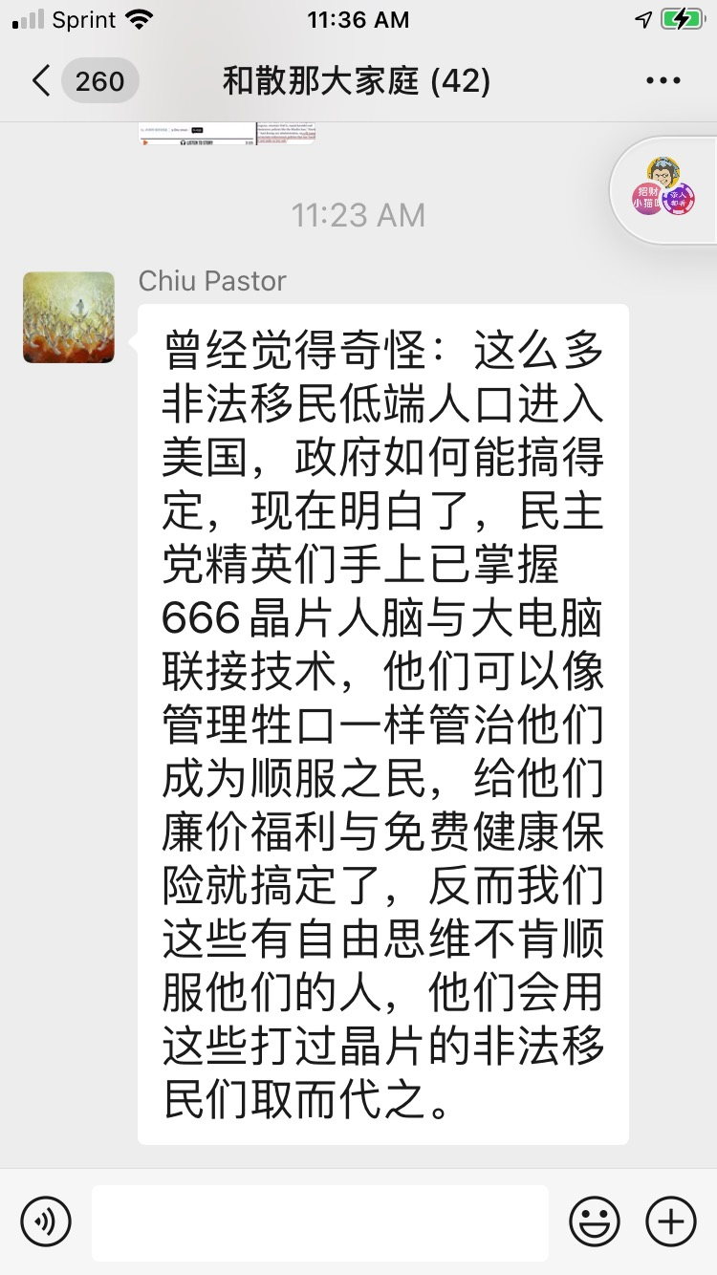

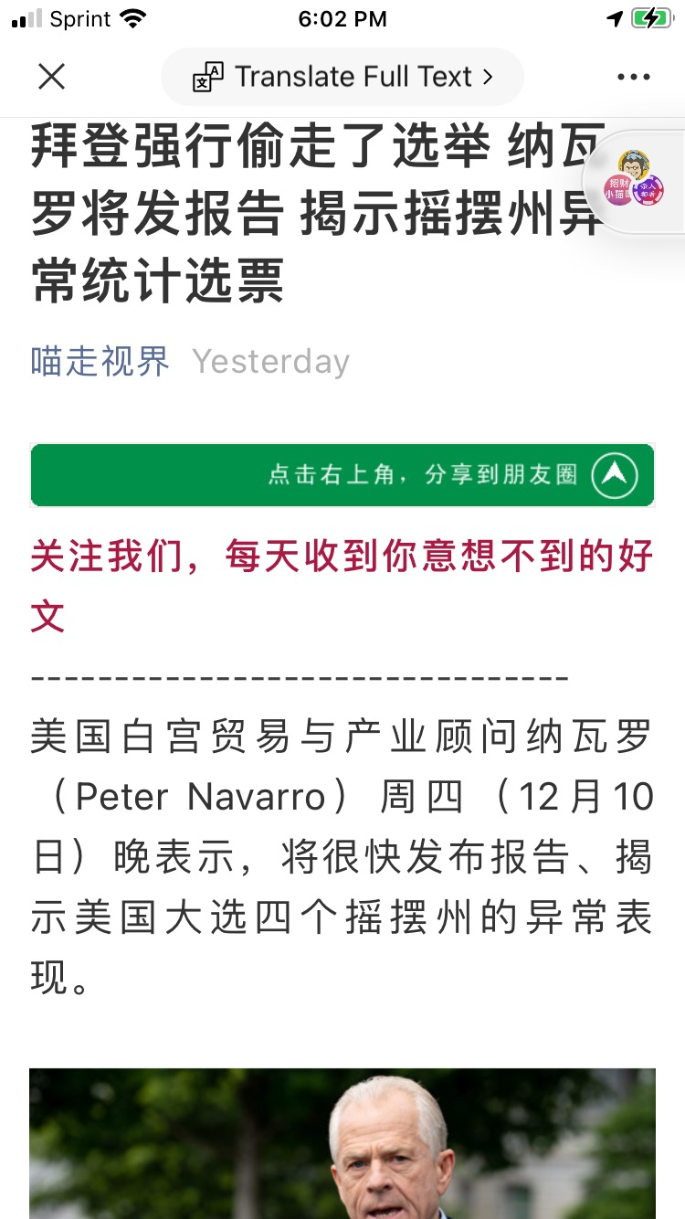
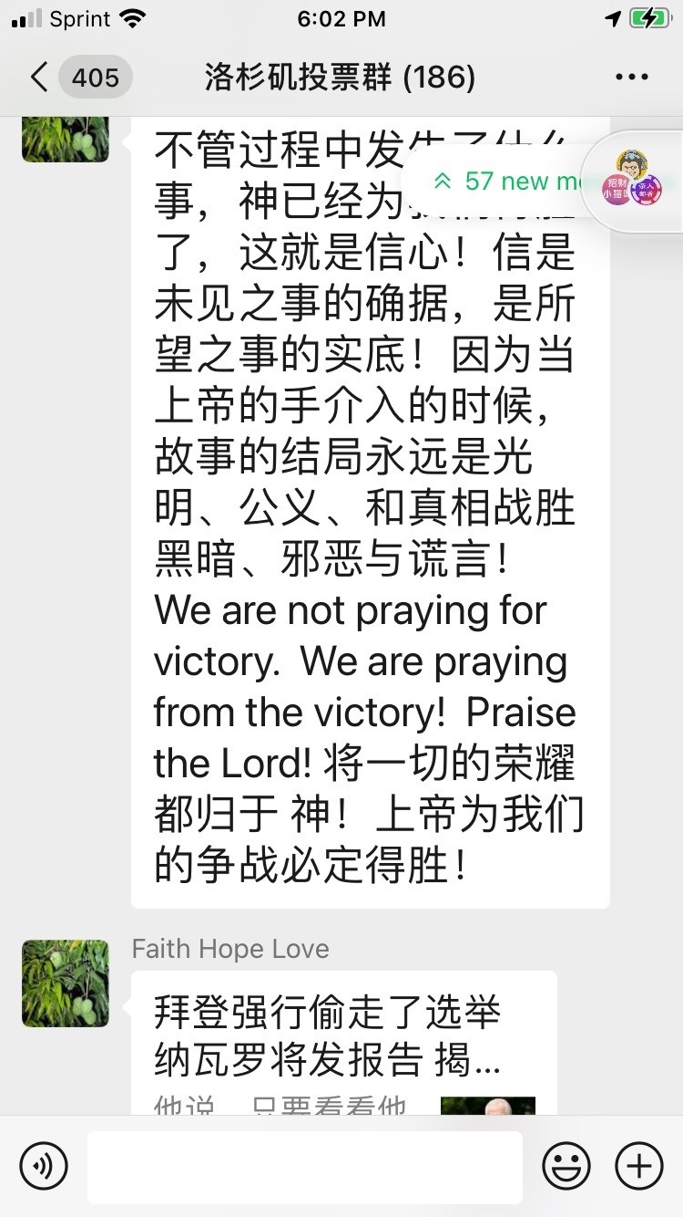
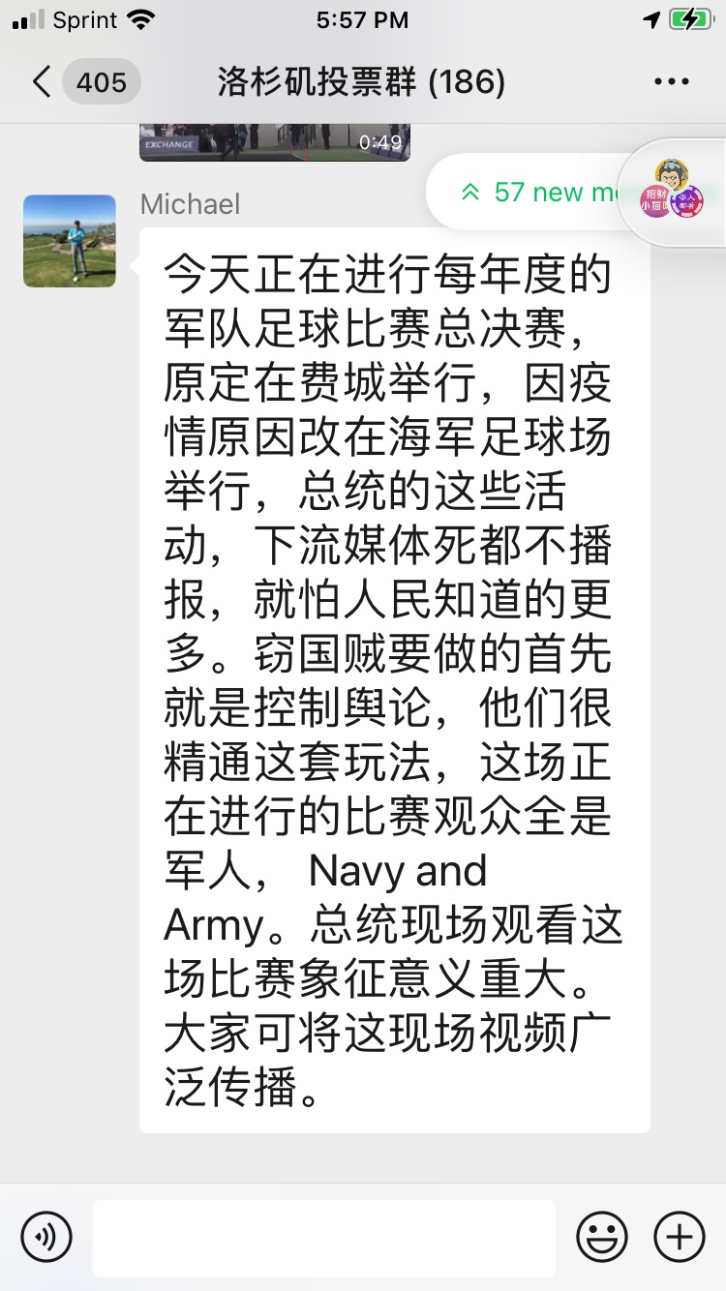
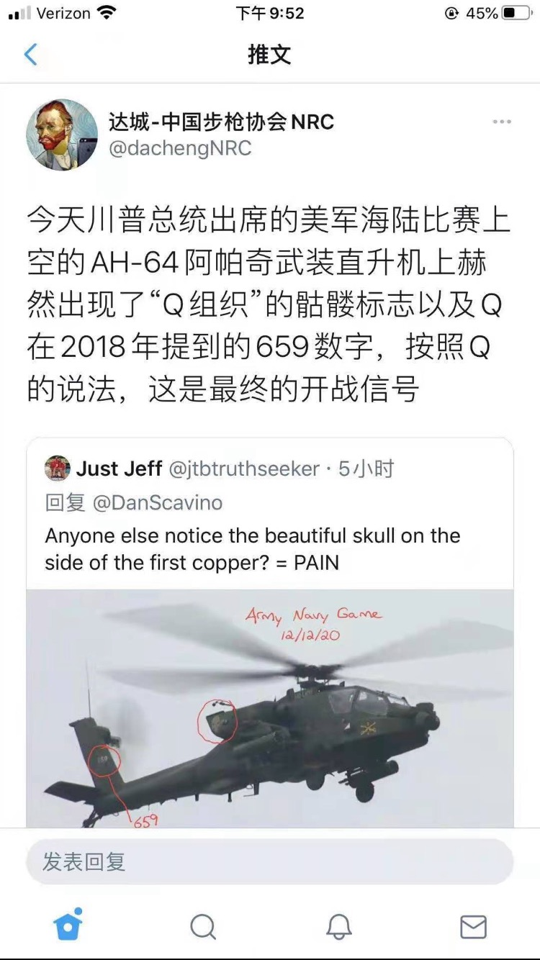
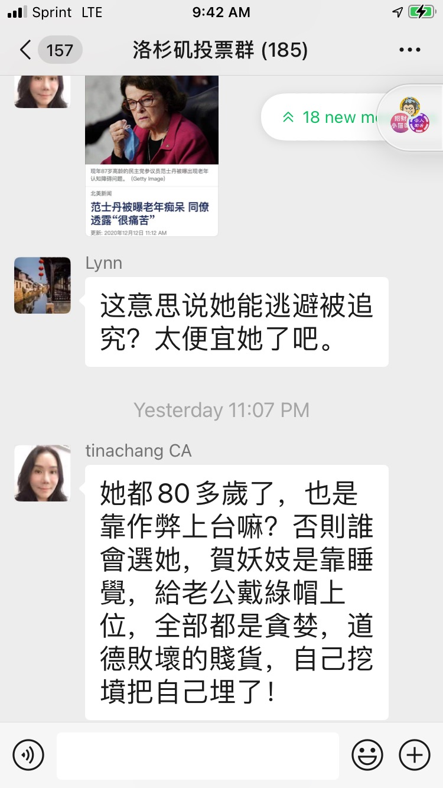
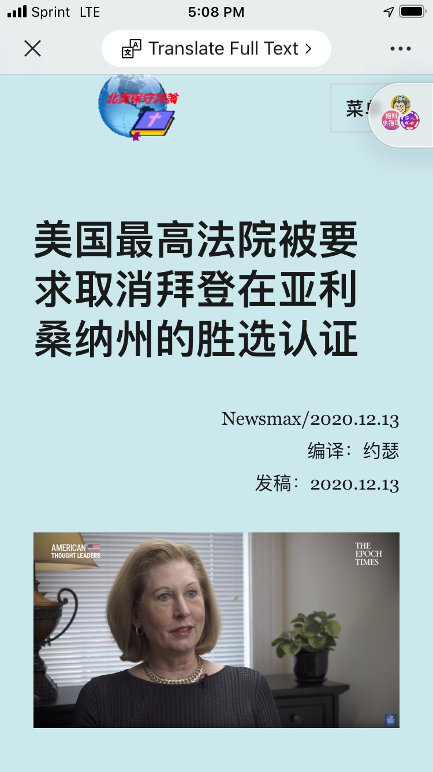
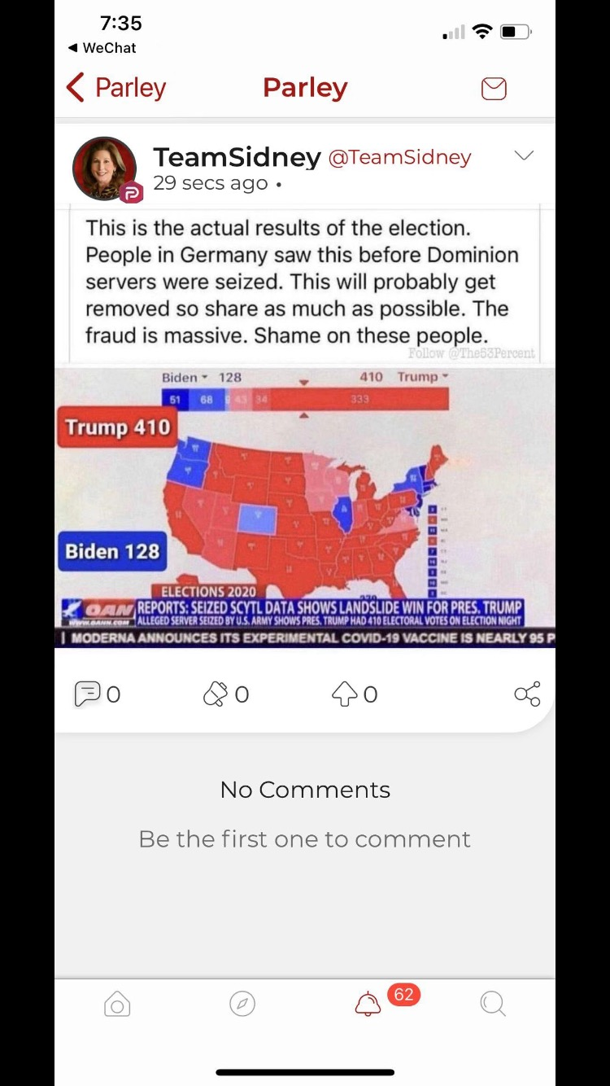
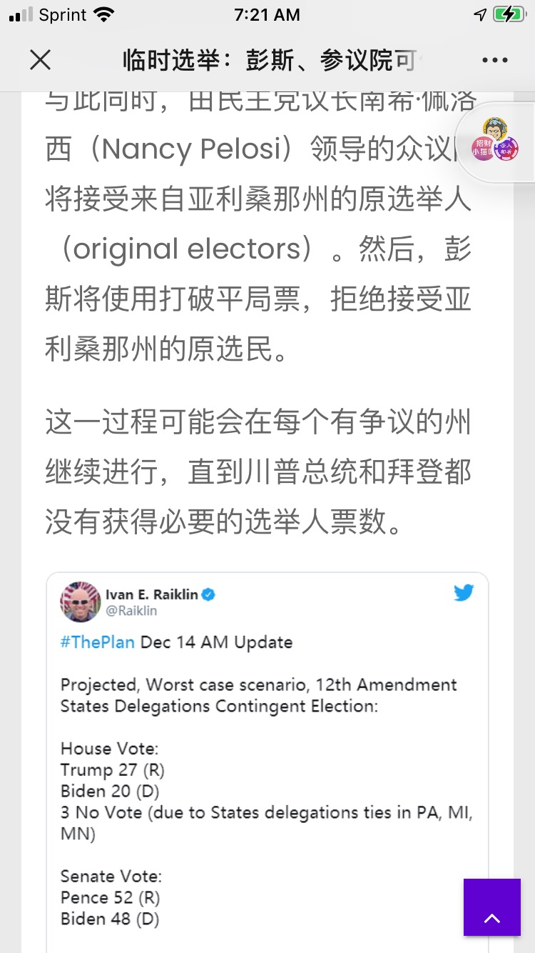

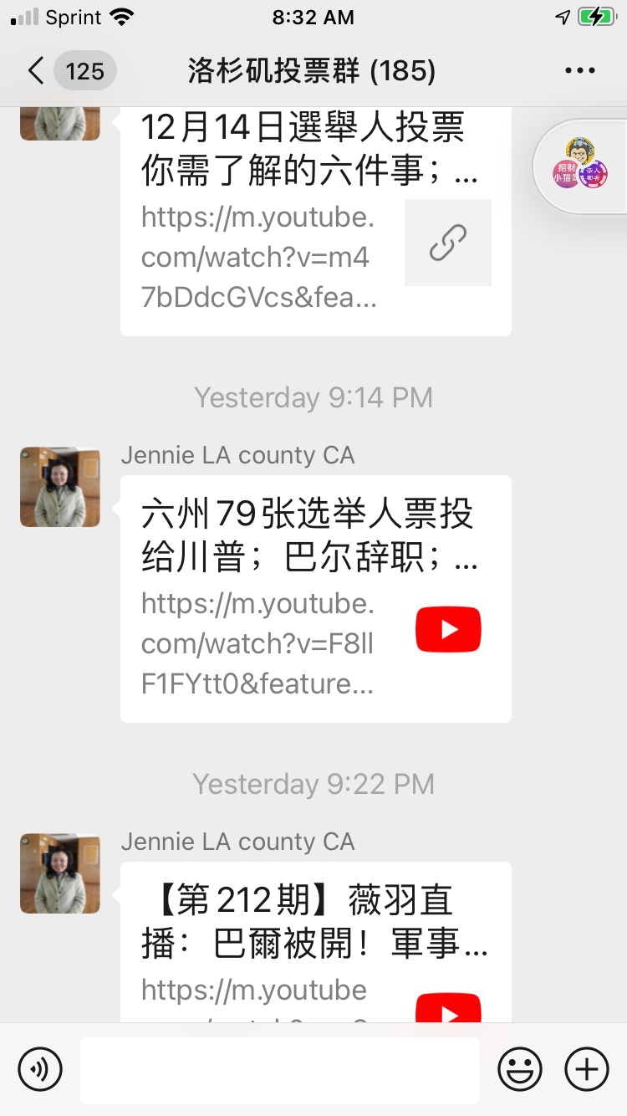

---------------------------------------------------------------------------------------------------------------------------------------

The Sermons from Science for January 2021 contains 15 presentations as follows:

You may choose any of the following to play. Copy the url link:
http://christcentergospel.org/SermonsFromSciencePowerPointSlides.htm
to your browser such as Google Chrome, Firefox, Opera, Explorer, Safari, or Microsoft Edge, and paste the link on the command line.
Select the PowerPoint or the video you want to download. It will take about 30 seconds to 1 minute or more to download a video depending on the speed of your internet provider.

1. Noah's Flood—why?
诺亚的洪水-为什么？. 12 minutes 01" in length.

2. Questions about Noah’s Flood
有关诺亚洪水的问题. 9 minutes 28" in length.

3. The Flood—a designed catastrophe?
洪水-有计划的灾难吗？. 8 minutes 08" in length.

4. Genesis and catastrophe -1
创世纪与大灾难 -1. 22 minutes 07" in length.

5. Genesis and catastrophe -2
创世纪与大灾难 -2. 30 minutes 54" in length.

6. Flood geology vs secular catastrophism
洪水地质与世俗灾难. 13 minutes 52" in length.

7. How could a loving God send a global Flood?
有爱心的上帝怎么能发动全球性的洪水？. 6 minutes 20” in length.

8. Startling evidence for Noah’s Flood-1
诺亚洪水的惊人证据 -1. 12 minutes 23" in length.

9. Startling evidence for Noah’s Flood-2
诺亚洪水的惊人证据 -2. 24 minutes 32" in length.

10. Full-size Noah’s Ark in Hong Kong!
香港的全尺寸的诺亚方舟！. 13 minutes 50" in length.

11. How could Noah get all the animals on the Ark?
诺亚怎样才能把所有的动物都放在方舟上？ 5 minutes 50" in length.

12. How could Noah care for the animals?
诺亚如何照顾动物？. 7 minutes 16" in length.

13. Safety investigation of Noah’s Ark in a seaway
诺亚方舟在海上航行的安全调查. 10 minutes 14" in length.

14. How did the waters of Noah’s Flood drain off the continents?
挪亚洪水的水如何从各大洲中流失？ 14 minutes 31" in length.

15. Massive erosion of continents demonstrates Flood runoff
大陆的大规模侵蚀表明洪水径流. 21 minutes 01" in length.

The PowerPoint slides can be downloaded from the website http://christcentergospel.org/SermonsFromSciencePowerPointSlides.htm

It contains 225 slides. From 2011, we have accumulated 1726 short programs accessible in the previous link on the Christ Center Gospel website. The url link is

http://christcentergospel.org/SermonsFromScienceVIDEO-Jan2021.htm

Copy this link and paste it on the command line.

May God bless you and your family.
Pastor Chui

